Table of Contents

UNITED STATES

SECURITIES AND EXCHANGE COMMISSION

WASHINGTON, D. C. 20549
______________________________________________

FORM 10-K

(MARK ONE)

- ANNUAL REPORT PURSUANT TO SECTION 13 OR 15(d) OF THE SECURITIES EXCHANGE ACT OF 1934 OR
- TRANSITION REPORT PURSUANT TO SECTION 13 OR 15(d) OF THE SECURITIES EXCHANGE ACT OF 1934

________________________________________________________

For the fiscal year ended December 31, 2022 Commission file number 1-2189

 | Abbott Laboratories
An Illinois Corporation |  | 36-0698440
100 Abbott Park Road |  | (I.R.S. employer identification number)
Abbott Park, Illinois 60064-6400 |  | (224) 667-6100
 |  | (telephone number)
 | Securities Registered Pursuant to Section 12(b) of the Act:
Title of Each Class | Trading Symbol(s) | Name of Each Exchange on Which Registered
Common Shares, Without Par Value | ABT | New York Stock Exchange
 |  | Chicago Stock Exchange, Inc.

Indicate by check mark if the registrant is a well-known seasoned issuer, as defined in Rule 405 of the Securities Act.

Yes x No o

Indicate by check mark if the registrant is not required to file reports pursuant to Section 13 or 15(d) of the Act.

Yes o No x

Indicate by check mark whether the registrant (1) has filed all reports required to be filed by Section 13 or 15(d) of the Securities Exchange Act of 1934 during the preceding 12 months (or for such shorter period that the registrant was required to file such reports), and (2) has been subject to such filing requirements for the past 90 days.

Yes x No o

Indicate by check mark whether the registrant has submitted electronically every Interactive Data File required to be submitted pursuant to Rule 405 of Regulation S-T (§ 232.405 of this chapter) during the preceding 12 months (or for such shorter period that the registrant was required to submit such files).

Yes x No o

Indicate by check mark whether the registrant is a large accelerated filer, an accelerated filer, a non-accelerated filer, a smaller reporting company, or an emerging growth company. See the definitions of “large accelerated filer,” “accelerated filer,” “smaller reporting company,” and “emerging growth company” in Rule 12b-2 of the Exchange Act.

Large Accelerated Filer x

Accelerated Filer o

Non-Accelerated Filer o

Smaller reporting company o

Emerging growth company o

If an emerging growth company, indicate by check mark if the registrant has elected not to use the extended transition period for complying with any new or revised financial accounting standards provided pursuant to Section 13(a) of the Exchange Act. o

Indicate by check mark whether the registrant has filed a report on and attestation to its management’s assessment of the effectiveness of its internal control over financial reporting under Section 404(b) of the Sarbanes-Oxley Act (15 U.S.C. 7262(b)) by the registered public accounting firm that prepared or issued its audit report. x

Indicate by check mark whether the registrant is a shell company (as defined in Rule 12b-2 of the Act).

Yes o No x

The aggregate market value of the 1,712,885,837 shares of voting stock held by nonaffiliates of the registrant, computed by reference to the closing price as reported on the New York Stock Exchange, as of the last business day of Abbott Laboratories’ most recently completed second fiscal quarter (June 30, 2022), was $186,105,046,190. Abbott has no non-voting common equity. Number of common shares outstanding as of January 31, 2023: 1,737,946,233

DOCUMENTS INCORPORATED BY REFERENCE

Portions of the 2023 Abbott Laboratories Proxy Statement are incorporated by reference into Part III. The Proxy Statement will be filed on or about March 17, 2023.

Table of Contents
 |  | Table of Contents
PART I. |  |  | Page
Item 1. |  | Business | 1
Item 1A. |  | Risk Factors | 9
Item 1B. |  | Unresolved Staff Comments | 15
Item 2. |  | Properties | 15
Item 3. |  | Legal Proceedings | 16
Item 4. |  | Mine Safety Disclosures | 16
PART II.
Item 5. |  | Market for Registrant’s Common Equity, Related Shareholder Matters and Issuer Purchases of Equity Securities | 20
Item 6. |  | [Reserved] | 20
Item 7. |  | Management’s Discussion and Analysis of Financial Condition and Results of Operations | 21
Item 7A. |  | Quantitative and Qualitative Disclosures About Market Risk | 38
Item 8. |  | Consolidated Financial Statements and Supplementary Data | 40
Item 9. |  | Changes in and Disagreements with Accountants on Accounting and Financial Disclosure | 78
Item 9A. |  | Controls and Procedures | 78
Item 9B. |  | Other Information | 78
Item 9C. |  | Disclosure Regarding Foreign Jurisdictions that Prevent Inspections | 78
PART III.
Item 10. |  | Directors, Executive Officers and Corporate Governance | 79
Item 11. |  | Executive Compensation | 79
Item 12. |  | Security Ownership of Certain Beneficial Owners and Management and Related Shareholder Matters | 79
Item 13. |  | Certain Relationships and Related Transactions, and Director Independence | 80
Item 14. |  | Principal Accountant Fees and Services | 80
PART IV.
Item 15. |  | Exhibit and Financial Statement Schedules | 81
Item 16. |  | Form 10-K Summary | 88
Signatures |  |  | 89

Table of Contents

PART I

ITEM 1. BUSINESS

GENERAL DEVELOPMENT OF BUSINESS

Abbott Laboratories is an Illinois corporation, incorporated in 1900. Abbott’s* principal business is the discovery, development, manufacture, and sale of a broad and diversified line of health care products.

NARRATIVE DESCRIPTION OF BUSINESS

Abbott has four reportable segments: Established Pharmaceutical Products, Diagnostic Products, Nutritional Products, and Medical Devices.

Established Pharmaceutical Products

These products include a broad line of branded generic pharmaceuticals manufactured worldwide and marketed and sold outside the United States in emerging markets. These products are generally sold directly to wholesalers, distributors, government agencies, health care facilities, pharmacies, and independent retailers from Abbott-owned distribution centers or public warehouses, depending on the market served. Certain products are co-marketed or co-promoted with, or licensed from, other companies.

The principal products included in the broad therapeutic area portfolios of the Established Pharmaceutical Products segment are:

- gastroenterology products, including Creon™, for the treatment of pancreatic exocrine insufficiency associated with several underlying conditions, including cystic fibrosis and chronic pancreatitis; Duspatal™ and Dicetel™, for the treatment of irritable bowel syndrome or biliary spasm; Heptral™, Transmetil™, and Samyr™, for the treatment of intrahepatic cholestasis (associated with liver disease) or depressive symptoms; and Duphalac™, for regulation of the physiological rhythm of the colon;

- women’s health products, including Duphaston™, for the treatment of many different gynecological disorders; and Femoston™, a hormone replacement therapy for postmenopausal women;

- cardiovascular and metabolic products, including Lipanthyl™ and TriCor™, for the treatment of dyslipidemia; Teveten™ and Teveten™ Plus, for the treatment of essential hypertension, and Physiotens™, for the treatment of hypertension; and Synthroid™, for the treatment of hypothyroidism;

- pain and central nervous system products, including Serc™, for the treatment of Ménière’s disease and vestibular vertigo; Brufen™, for the treatment of pain, fever, and inflammation; and Sevedol™, for the treatment of severe migraines; and

- respiratory drugs and vaccines, including the anti-infective clarithromycin (sold under the trademarks Biaxin™, Klacid™, and Klaricid™); and Influvac™, an influenza vaccine.

The Established Pharmaceutical Products segment directs its primary marketing efforts toward building strong brands with key stakeholders, including consumers, pharmacists, physicians, and other healthcare providers. Government agencies are also important customers.

Competition in the Established Pharmaceutical Products segment is generally from other health care and pharmaceutical companies. In addition, the substitution of generic drugs for the brand prescribed and introduction of additional forms of already marketed established products by generic or branded competitors may increase competitive pressures.

________________________________________________________

- As used throughout the text of this report on Form 10-K, the term “Abbott” refers to Abbott Laboratories, an Illinois corporation, or Abbott Laboratories and its consolidated subsidiaries, as the context requires.

1

Table of Contents

Diagnostic Products

These products include a broad line of diagnostic systems and tests manufactured, marketed, and sold worldwide. These products are generally marketed and sold directly to blood banks, hospitals, commercial laboratories, clinics, physicians’ offices, retailers, government agencies, alternate care testing sites, and plasma protein therapeutic companies from Abbott owned distribution centers, public warehouses or third party distributors.

The principal products included in the Diagnostic Products segment are:

- core laboratory and transfusion medicine systems in the areas of immunoassay, clinical chemistry, hematology, and transfusion serology testing, including the Alinity® family of instruments along with the ARCHITECT® and Cell-Dyn® systems. These systems are used for screening and/or diagnosis for cancer, cardiac and metabolic disorders, drugs of abuse, thyroid function, fertility, neurologic and general chemistries, infectious diseases such as hepatitis and HIV, therapeutic drug monitoring, and a suite of SARS-CoV-2 serology assays;

- molecular diagnostics polymerase chain reaction (PCR) instrument systems, including Alinity® m and m2000™ that automate the extraction, purification, and preparation of DNA and RNA from patient samples, and detect and measure infectious agents including HIV, hepatitis, HPV, sexually transmitted infections, SARS-CoV-2 and influenza A & B, and respiratory syncytial virus (RSV); and products for oncology with the Vysis® FISH product line of genomic-based tests;

- point of care systems, including the i-STAT® and next-generation i-STAT® Alinity® and cartridges for testing blood gas, chemistry, electrolytes, coagulation and immunoassay;

- rapid diagnostics lateral flow testing products in the area of infectious diseases such as SARS-CoV-2, including the BinaxNOW® and Panbio® rapid testing platforms, influenza, HIV, hepatitis, and tropical diseases such as malaria and dengue fever; molecular point-of-care testing for HIV, including the m-PIMA® HIV-1/2 Viral Load Test, and for SARS-CoV-2 and influenza A & B, RSV and strep A, including the ID NOW® rapid molecular system; cardiometabolic testing, including Afinion® and Cholestech LDX® platforms and tests; a toxicology business for drug and alcohol testing; and consumer self-testing; and

- informatics and automation solutions for use in laboratories, including laboratory automation systems such as the GLP systems track™, the RALS® point of care solution, and AlinIQ®, a suite of informatics tools and professional services.

The Diagnostic Products segment’s products are subject to competition in technological innovation, price, convenience of use, service, instrument warranty provisions, product performance, laboratory efficiency, long-term supply contracts, and product potential for overall cost-effectiveness and productivity gains. Some products in this segment can be subject to rapid product obsolescence or regulatory changes. Although Abbott has benefited from technological advantages of certain of its current products, these advantages may be reduced or eliminated as competitors introduce new products.

Nutritional Products

These products include a broad line of pediatric and adult nutritional products manufactured, marketed, and sold worldwide. These products are generally marketed and sold directly to consumers and to institutions, wholesalers, retailers, health care facilities, government agencies, and third-party distributors from Abbott-owned distribution centers or third-party distributors.

The principal products included in the Nutritional Products segment are:

- various forms of infant formula and follow-on formula, including Similac®, Similac® 360 Total Care®, Similac Pro-Advance®, Similac® Advance®, Similac® 360 Total Care® Sensitive, Similac Pro-Sensitive®, Similac Sensitive®, Go & Grow by Similac®, Similac® NeoSure®, Similac® Organic, Similac® Special Care®, Similac Total Comfort®, Similac® Soy Isomil®, Similac® Alimentum®, EleCare®, Gain™, and Grow™;

- adult and other pediatric nutritional products, including Ensure®, Ensure Plus®, Ensure® Enlive®, Ensure® (with NutriVigor®), Ensure® Max Protein, Ensure® High Protein, Glucerna®, Glucerna Hunger Smart®, ProSure™, PediaSure®, PediaSure SideKicks®, PediaSure® Peptide, Juven®, Abound™, Pedialyte® and Zone Perfect®; and

- nutritional products used in enteral feeding in health care institutions, including Jevity®, Glucerna® 1.2 Cal, Glucerna® 1.5 Cal, Osmolite®, Oxepa®, Freego™ (Enteral Pump) and Freego™ sets, Nepro®, and Vital®.

Primary marketing efforts for nutritional products are directed toward consumers or to securing the recommendation of Abbott’s brand of products by physicians or other health care professionals. In addition, nutritional products are also promoted directly to the public by consumer marketing efforts in markets where permitted.

2

Table of Contents

Competition for nutritional products in the segment is generally from other diversified consumer and health care manufacturers. Competitive factors include consumer advertising, formulation, packaging, scientific innovation, price, retail distribution, and availability of product forms. A significant aspect of competition is the search for ingredient innovations. The introduction of new products by competitors, changes in medical practices and procedures, and regulatory changes can result in product obsolescence. In addition, private label and local manufacturers’ products may increase competitive pressure.

Medical Devices

These products include a broad line of rhythm management, electrophysiology, heart failure, vascular and structural heart devices for the treatment of cardiovascular diseases, and diabetes care products for people with diabetes, as well as neuromodulation devices for the management of chronic pain and movement disorders. Medical devices are manufactured, marketed and sold worldwide. In the United States, depending upon the product, medical devices are generally marketed and sold directly to wholesalers, hospitals, ambulatory surgery centers, physicians’ offices, and distributors from Abbott-owned distribution centers and public warehouses. Outside the United States, sales are made either directly to customers or through distributors, depending on the market served.

The principal products included in the Medical Devices segment are:

- rhythm management products, including Assurity MRI® and Endurity MRI® pacemaker systems, and Aveir® VR single-chamber VR leadless pacemaker system; Ellipse®, Fortify Assura®, and Gallant® implantable cardioverter defibrillators and Gallant and Quadra Assura MP® implantable cardioverter defibrillator with cardiac resynchronization therapy and MultiPoint™ Pacing technology; and Confirm Rx® and Jot Dx® implantable cardiac monitors;

- electrophysiology products, including the TactiFlex™ and TactiCath® families of ablation catheters, and FlexAbility® irrigated ablation catheters; EnSite® family of cardiac mapping systems; Agilis® NxT and Swartz™ introducer catheters; the Advisor® HD Grid mapping catheter; and ViewFlex™ family of intracardiac echocardiography catheters;

- heart failure related products, including the HeartMate® left ventricular assist device family, the CardioMEMS® HF System pulmonary artery sensor, a heart failure monitoring system, and the CentriMag® System, an acute mechanical circulatory support system;

- vascular products, including the XIENCE® family of drug-eluting coronary stent systems developed on the Multi-Link Vision® platform; StarClose SE®, Perclose ProGlide® and Perclose ProStyle® vessel closure devices, TREK® coronary balloon dilatation products, Hi-Torque Balance Middleweight Universal II® guidewires, Supera® Peripheral Stent System, a peripheral vascular stent system; Acculink®/Accunet® and Xact®/Emboshield NAV6®, carotid stent systems; the OPTIS® integrated systems with Ultreon™ 1.0 Software, compatible with the Dragonfly OPTIS® imaging catheter and PressureWire® fractional flow reserve measurement systems; and the JETi® peripheral thrombectomy systems for clot removal;

- structural heart products, including MitraClip®, a mitral valve transcatheter edge-to-edge repair system; TriClip®, a tricuspid valve transcatheter edge-to-edge repair system; Epic®, a surgical family of aortic valve and mitral valve replacement devices; Portico® and Navitor™ transcatheter aortic heart valves; Regent™ and Masters Series™ mechanical heart valves; Amplatzer® PFO occluders; Amplatzer Amulet® occluder devices; and the Tendyne® transcatheter mitral valve replacement system;

- continuous glucose and blood glucose monitoring systems under the FreeStyle® brand such as the FreeStyle Libre® system, including sensors, data management decision software, test strips, and accessories for people with diabetes; and

- neuromodulation products, including spinal cord stimulators Proclaim® Elite and Proclaim® XR Recharge-free implantable pulse generators (IPG) and Prodigy MRI® IPG, each with BurstDR® stimulation, and Proclaim® DRG IPG, a neurostimulation device designed for dorsal root ganglion therapy, for the treatment of chronic pain disorders; and the Infinity® Deep Brain Stimulation System with directional lead technology for the treatment of movement disorders.

3

Table of Contents

These products are subject to competition in technological innovation, price, convenience of use, service, product performance, long-term supply contracts, and product potential for overall cost-effectiveness and productivity gains. Some products in this segment can be subject to rapid product obsolescence or regulatory changes. Although Abbott has benefited from technological advantages of certain of its current products, these advantages may be reduced or eliminated as competitors introduce new products.

INFORMATION WITH RESPECT TO ABBOTT’S BUSINESS IN GENERAL

Sources and Availability of Raw Materials

Abbott purchases, in the ordinary course of business, raw materials and supplies essential to Abbott’s operations from numerous suppliers in the United States and around the world. Due to disruptions to the global supply chain caused in part by the COVID-19 pandemic and macroeconomic conditions such as inflationary pressures and labor shortages, Abbott has experienced availability issues with some materials and electronic components. To date, Abbott has been able to manage these challenges without significant supply disruptions or shortages for raw materials and supplies. A more detailed discussion on the global supply chain disruptions and its resulting impact on Abbott’s business is contained in Item 1A. Risk Factors and in the "Financial Review” section in Item 7. Management’s Discussion and Analysis of Financial Condition and Results of Operations.

Patents, Trademarks, and Licenses

Abbott is aware of the desirability for patent and trademark protection for its products. Accordingly, where possible, patents and trademarks are sought and obtained for Abbott’s products in the United States and countries of interest to Abbott. Abbott owns or has licenses under a substantial number of patents and patent applications. Principal trademarks and the products they cover are discussed in the Narrative Description of Business on pages 1 through 4. These, and various patents which expire during the period 2023 to 2043, in the aggregate, are believed to be of material importance in the operation of Abbott’s business. Abbott believes that no single patent, license, or trademark is material in relation to Abbott’s business as a whole.

Seasonal Aspects, Customers, and Renegotiation

There are no significant seasonal aspects to Abbott’s business. Abbott has no single customer that, if the customer were lost, would have a material adverse effect on Abbott. No material portion of Abbott’s business is subject to renegotiation of profits or termination of contracts at the election of a government.

Environmental Matters

Abbott believes that its operations comply in all material respects with applicable laws and regulations concerning environmental protection. Regulations under federal, state, and various other countries’ environmental laws impose stringent limitations on emissions and discharges to the environment from various manufacturing operations. Abbott’s capital and operating expenditures for pollution control in 2022 were not material and are not expected to be material in 2023.

Abbott has been identified as one of many potentially responsible parties in investigations and/or remediations at several locations in the United States, including Puerto Rico, under the Comprehensive Environmental Response, Compensation, and Liability Act, commonly known as Superfund. Abbott is also engaged in remediation at several other sites, some of which are owned by Abbott, in cooperation with the Environmental Protection Agency or similar agencies. While it is not feasible to predict with certainty the final costs related to those investigations and remediation activities, Abbott believes that such costs, together with other expenditures to maintain compliance with applicable laws and regulations concerning environmental protection, should not have a material adverse effect on Abbott’s financial position, cash flows, or results of operations.

Human Capital

The sustainability of Abbott’s business depends on attracting, engaging and developing talented people with diverse backgrounds who share Abbott’s mission to help people live their healthiest possible lives. Abbott provides its employees opportunities to grow and develop their careers, market competitive compensation and benefit programs, and the satisfaction of being part of a global company dedicated to improving health in more than 160 countries.

As of December 31, 2022, Abbott employed approximately 115,000 people, 69% of whom were employed outside of the U.S. Women represented 47% of Abbott’s U.S. workforce, 46% of its global workforce, and 41% of its managers.

4

Table of Contents

Talent Management

Abbott has an integrated global talent management process that is designed to identify and assess talent across the organization and provide equal and consistent opportunities for employees to develop their skills. All levels of employees participate in Abbott’s annual performance management process to create development plans that support their particular career objectives, and Abbott provides a broad range of training, mentoring and other development opportunities to help its employees meet these objectives. The board of directors conducts an annual Talent Management Review, focusing on development of talent, diversity, and succession planning for critical positions. Similar reviews take place across Abbott to develop talent and diversity across the organization.

Diversity and Inclusion

Abbott is committed to developing a workplace that is inclusive for all. Abbott ties executive compensation to human capital management, including diversity outcomes, to sustain an inclusive culture and the fair and balanced treatment of Abbott’s employees. In 2022, Abbott released the second edition of its diversity, equity, and inclusion report, providing an update on Abbott’s plans, strategies, and actions to fulfill its commitment to develop an inclusive workplace.

Abbott’s employee networks play an important role in building an inclusive culture across all Abbott operations. A corporate officer serves as a sponsor for each of these networks, helping to align their objectives with Abbott’s business strategies. Abbott has ten such networks, which are: Early Career Network (supporting early career employees), Asian Leadership and Cultural Network, Black Business Network, Flex Network (supporting employees with part-time and flexible schedules), LA VOICE Network (supporting Hispanic and Latino employees), disABILITY Network (supporting employees with disabilities), PRIDE (supporting LGBTQ employees), Veterans Network, Women Leaders of Abbott, and Women in STEM. All networks are open to all Abbott employees.

Abbott offers professional development programs, which provide recent college graduates the opportunity to rotate through different areas of Abbott, often with the chance to work outside their home country. In 2022, 53% of the participants were women. Also, Abbott hosts hundreds of college students for paid internships. In 2022, 58% of the U.S. interns were women and 59% were minorities. Further, Abbott has offered a STEM internship program for high school students in the U.S. since 2012 and since 2021, students who complete the program receive a college credit recommendation from the American Council on Education. The program’s objective is to increase the number of students pursuing STEM-related careers and contribute to a more diverse talent pipeline for Abbott. In 2022, 69% of the STEM interns were women and 78% were minorities.

Health and Safety

The health, safety and wellness of its employees is an Abbott priority embedded at every level of its business. Abbott’s integrated Environmental, Health and Safety organization governs health, safety and wellness at Abbott’s facilities. Abbott also maintains global policies and standards for managing employee health and safety.

Abbott takes a holistic approach to employee well-being. Abbott’s global wellness programs are designed to meet the unique needs of employees across businesses and geographies and offer a wide range of programs, including supporting the mental, financial and physical health of employees and their families. For example, for over 20 years, Abbott has annually offered Exercise Across Abbott, which is a four-week physical wellness program that encourages employees to team up with colleagues and track how many minutes they exercise each day. Over 21,000 Abbott employees across 74 countries took part in 2022.

Compensation and Benefits

Abbott is committed to building, retaining, and motivating a diverse talent pipeline that can meet the current and future needs of its businesses. To that end, Abbott provides market competitive compensation, healthcare benefits, continuing education benefits, pension and/or retirement savings plans, financial support for employees with student loan debt, and several programs to facilitate employees building an ownership stake in Abbott, including a global long-term incentive program for employees generally beginning at the manager level. Abbott also has procedures and processes focused on ensuring employees receive equitable compensation, regardless of race or gender or other personal characteristics.

5

Table of Contents

Regulation

The development, manufacture, marketing, sale, promotion, and distribution of Abbott’s products are subject to comprehensive government regulation by the U.S. Food and Drug Administration (FDA) and similar international regulatory agencies. Government regulation by various international, supranational, federal and state agencies addresses (among other matters) the development and approval to market Abbott’s products, as well as the inspection of, and controls over, research and laboratory procedures, clinical investigations, product approvals and manufacturing, labeling, packaging, supply chains, marketing and promotion, pricing and reimbursement, sampling, distribution, quality control, post-market surveillance, record keeping, storage, and disposal practices. In addition, Abbott’s clinical laboratories and associated testing services are subject to comprehensive government regulation, including registration, certification, and licensure, by federal, state, and local agencies, such as the Centers for Medicare & Medicaid Services, the Drug Enforcement Administration, the Substance Abuse and Mental Health Services Administration, and their respective foreign counterparts. Certain of these agencies require our clinical laboratories to meet quality assurance, quality control, and personnel standards and undergo inspections.

During the COVID-19 public health emergency, many pandemic-related products (including diagnostic tests) were authorized by regulators for emergency use solely during the pandemic. In addition, many governments enacted policies to expedite or promote access to health care in order to slow or stop the spread of the virus. Examples include expansion of telehealth coverages and increased reimbursements for diagnostic testing. On January 30, 2023, the U.S. announced that it plans to end the public health emergency on May 11, 2023. Abbott is evaluating the potential impacts of the end of the public health emergency, and it will continue to monitor further regulatory actions from relevant U.S. government agencies and assess potential impacts on pandemic-related government policies and product authorizations.

Abbott’s international operations are also affected by trade and investment regulations in many countries. These may require local investment, restrict Abbott’s investments, or limit the import of raw materials and finished products.

Abbott’s laboratory facilities, home monitoring services, and durable medical equipment suppliers, which provide services, related products and medical devices to consumers, are subject to additional laws and regulations applicable to health care providers and suppliers that submit claims for reimbursement to third-party payors. In the United States, Medicare, Medicaid, and other third-party payors may from time to time conduct inquiries, claims audits, investigations, and enforcement actions relating to the claims or enrollment criteria.

Abbott is subject to laws and regulations pertaining to health care fraud and abuse, including state and federal anti-kickback, anti-self-referral, and false claims laws in the United States. Prescription drug, nutrition, and medical device manufacturers such as Abbott are also subject to taxes, as well as application, product, user, establishment, and other fees. Governmental agencies can also invalidate intellectual property rights.

Compliance with these laws and regulations is costly and materially affects Abbott’s business. Among other effects, health care regulations and significant changes thereto (such as the introduction of the Medical Devices Regulation and the In Vitro Diagnostic Medical Devices Regulation in the European Union) substantially increase the time, difficulty, and costs incurred in developing, obtaining and maintaining approval to market, and marketing newly developed and existing products. Abbott expects this regulatory environment will continue to require significant technical expertise and investment to ensure compliance. Failure to comply can delay the release of a new product or result in regulatory and enforcement actions, the seizure or recall of a product, the suspension or revocation of the authority necessary for a product’s production and sale, suspension or revocation of billing privileges, and other civil or criminal sanctions, including fines and penalties. Similarly, compliance with the laws and regulations governing clinical laboratories and testing services requires specialized expertise. Failure to comply with these regulatory requirements can result in sanctions, including suspension, revocation, or limitation of a laboratory’s certification, which is necessary to conduct business, as well as significant fines or criminal penalties.

Abbott’s business can also be affected by ongoing studies of the utilization, safety, efficacy, and outcomes of health care products and their components that are regularly conducted by industry participants, government agencies, and others. These studies can call into question the utilization, safety, and efficacy of previously marketed products. In some cases, these studies have resulted, and may in the future result, in the discontinuation of marketing of such products in one or more countries, and may give rise to claims for damages from persons who believe they have been injured as a result of their use.

6

Table of Contents

Access to human health care products continues to be a subject of investigation and action by governmental agencies, legislative bodies, and private organizations in many countries. A major focus is cost containment. Efforts to reduce health care costs are also being made in the private sector, notably by health care payors and providers, which have instituted various cost reduction and containment measures. Abbott expects insurers and providers will continue attempts to reduce the cost or utilization of health care products. Many countries control the price of health care products directly or indirectly, through reimbursement, payment, pricing, or coverage limitations. Budgetary pressures on health care payors may also heighten the scope and severity of pricing pressures on Abbott’s products for the foreseeable future. In the United States, the federal government regularly evaluates reimbursement for medical devices, diagnostics, supplies, and other products, as well as the procedures in which these products may be used. The government follows a diagnosis-related group (DRG) payment system for certain institutional services provided under Medicare or Medicaid and has implemented a prospective payment system (PPS) for services delivered in hospital outpatient, nursing home, and home health settings. DRG and PPS entitle a health care facility to a fixed reimbursement based on the diagnosis and/or procedure rather than actual costs incurred in patient treatment, thereby increasing the incentive for the facility to limit or control expenditures for many health care products. Other payment methodology changes have been proposed and implemented from time to time. For example, Medicare implemented a competitive bidding system for certain durable medical equipment (including diabetes products), enteral nutrition products, and supplies. Additionally, the Protecting Access to Medicare Act established a new payment system for clinical laboratory tests in 2018.

Governmental cost containment efforts also affect Abbott’s nutritional products business. In the United States, for example, under regulations governing the federally funded Special Supplemental Nutrition Program for Women, Infants, and Children, all states must have a cost containment program for infant formula. As a result, through competitive bidding states obtain rebates from manufacturers of infant formula whose products are used in the program.

The Patient Protection and Affordable Care Act (the Affordable Care Act) includes provisions known as the Physician Payments Sunshine Act, which requires manufacturers of drugs, devices, and medical supplies covered under Medicare and Medicaid to record any transfers of value to physicians and teaching hospitals and to report this data to the Centers for Medicare & Medicaid Services for subsequent public disclosure. In October 2018, the Substance Use Disorder Prevention that Promotes Opioid Recovery and Treatment for Patients and Communities Act significantly expanded the types of healthcare providers for which reporting is required, beginning with reports filed in 2022. Similar reporting requirements have also been enacted on the state level domestically, and an increasing number of governments worldwide either have adopted or are considering similar laws requiring transparency of interactions with health care professionals. Failure to report appropriate data may result in civil or criminal fines and/or penalties.

Policy changes or implementation of new health care legislation could result in significant changes to health care systems. In the United States, this could include potential modification, including expansion or repeal of all or parts of the Affordable Care Act.

The regulation of data privacy and security, and the protection of the confidentiality of certain personal information (including patient health information, financial information and other sensitive personal information), is increasing. For example, the European Union, China, various other countries, and various U.S. states (e.g., California, Virginia, and Colorado) have enacted data protection laws that contain significant compliance obligations and financial penalties for noncompliance. In addition, regulators with general consumer protection authority, such as the Federal Trade Commission and U.S. states Attorneys General, are focused on how consumer data is used by entities in the health care industry. Further, there are regulations of data privacy and security that are specific to health care companies. For example, the U.S. Department of Health and Human Services has issued rules governing the use, disclosure, and security of protected health information, and the FDA has issued further guidance concerning cybersecurity for medical devices. In addition, certain countries have issued or are considering “data localization” laws, which limit companies’ ability to transfer protected data across country borders. Failure to comply with data privacy and security laws and regulations can result in business disruption and enforcement actions, which could include civil or criminal penalties. Transferring and managing protected information will become more challenging as laws and regulations are enacted or amended, and Abbott expects there will be increasing complexity in this area.

Abbott expects debate to continue at all government levels worldwide over the manufacture, quality assurance requirements, marketing authorization processes, post-market surveillance requirements, availability, method of delivery, and payment for health care products and services, as well as data privacy and security. Abbott believes that future legislation and regulation in the markets it serves could affect the timing and expense associated with bringing health care products or services to market, access to health care products and services, increase rebates, reduce prices or reimbursements or the rate of price increases for health care products and services, change health care delivery systems, create new fees and obligations for the pharmaceutical, nutrition, diagnostic, and medical device industries, or require additional reporting and disclosure. It is not possible to predict the extent to which Abbott or the health care industry in general might be affected by the matters discussed above.

7

Table of Contents

INTERNET INFORMATION

Copies of Abbott’s Annual Report on Form 10-K, Quarterly Reports on Form 10-Q, Current Reports on Form 8-K, and amendments to those reports filed or furnished pursuant to Section 13(a) or 15(d) of the Securities Exchange Act of 1934 are available free of charge through Abbott’s investor relations website (www.abbottinvestor.com) as soon as reasonably practicable after Abbott electronically files the material with, or furnishes it to, the Securities and Exchange Commission (the Commission). These reports and other information are also available, free of charge, at www.sec.gov.

Abbott’s corporate governance guidelines, outline of directorship qualifications, code of business conduct and the charters of Abbott’s audit committee, compensation committee, nominations and governance committee, and public policy committee are all available on Abbott’s investor relations website (www.abbottinvestor.com).

8

Table of Contents

ITEM 1A. RISK FACTORS

In addition to the other information in this report, the following risk factors should be considered before deciding to invest in any of Abbott’s securities. Additional risks and uncertainties not presently known to Abbott, or risks Abbott currently considers immaterial, could also affect Abbott’s actual results. Abbott’s business, financial condition, results of operations, or prospects could be materially adversely affected by any of these risks.

Business and Operational Risks

Disruptions to Abbott’s global supply chain, which is large and complex, could negatively affect Abbott’s results of operations.

Abbott’s operations and performance depend on its ability to manage its large and complex global supply chain. The COVID-19 pandemic has contributed to global supply chain disruptions, which have adversely impacted the cost and availability of certain raw materials, supplies, and services. While Abbott has taken actions to offset some of these inflationary pressures in its supply chain, Abbott may not be able to completely offset all the increases in its operational costs. Further, Abbott has experienced, and may continue to experience, availability issues with some services, operations, and materials used in its products. To date, Abbott has been able to manage the various supply chain challenges without significant supply disruption or shortage for services, raw materials and supplies. The future extent to which supply chain disruptions may have a material effect on Abbott’s operating results is uncertain. A more detailed discussion on the supply chain disruptions impact on Abbott’s business is contained in the “Financial Review” section in Item 7, Management’s Discussion and Analysis of Financial Condition and Results of Operations of this report.

Abbott may acquire other businesses, license rights to technologies or products, form alliances, or dispose of or spin-off businesses, which could cause it to incur significant expenses and could negatively affect profitability.

From time to time, Abbott pursues acquisitions, licensing arrangements, and strategic alliances, or dispose of or spin-off some of its businesses, as part of its business strategy. Abbott may not complete these transactions in a timely manner, on a cost-effective basis, or at all, and may not realize the expected benefits. If Abbott is successful in making an acquisition, the products and technologies that are acquired may not be successful or may require significantly greater resources and investments than originally anticipated. Abbott may not be able to integrate acquisitions successfully into its existing business or transition disposed businesses efficiently, and could incur or assume significant debt and unknown or contingent liabilities. Abbott could also experience negative effects on its reported results of operations from acquisition or disposition-related charges, amortization of expenses related to intangibles and charges for impairment of long-term assets. These effects could cause a deterioration of Abbott’s credit rating, result in increased borrowing costs and interest expense, and decrease liquidity.

Abbott depends on sophisticated information technology systems and maintains protected personal data, and a cyber attack or other breach affecting these information technology systems or protected data could have a material adverse effect on Abbott’s results of operations.

Similar to other large multi-national companies, the size and complexity of the information technology systems on which Abbott relies for both its infrastructure and products make them susceptible to a cyber attack, malicious intrusion, breakdown, destruction, loss of data privacy, or other significant disruption. These systems have been and are expected to continue to be the target of malware and other cyber attacks. In addition, third party hacking attempts may cause Abbott’s information technology systems and related products, protected data, or proprietary information to be compromised or stolen. A significant attack or other disruption could result in adverse consequences, including increased costs and expenses, manufacturing challenges or disruption, problems with product availability, functionality or safety, damage to customer relations, reputational damage, lost revenue, and legal or regulatory penalties.

Abbott also collects, manages and processes protected personal data, including protected health information, in connection with certain medical products and service offerings. Abbott is subject to certain regional and local data protection laws that prohibit or restrict the transfer of protected data across country borders. For additional information concerning data privacy and security regulation, see the discussion in “Regulation” under Item 1, “Business.” A breach of protected personal information could result in adverse consequences, including regulatory inquiries or litigation, increased costs and expenses, reputational damage, lost revenue, and fines or penalties.

9

Table of Contents

Abbott invests in its systems and technology and in the protection of its products and data to reduce the risk of an attack or other significant disruption, and monitors its systems on an ongoing basis for any current or potential threats or vulnerabilities and for changes in technology and the regulatory environment. There can be no assurance that these measures and efforts will prevent future attacks or other significant disruptions to any of the systems on which Abbott relies or that related product issues will not arise in the future. Similarly, there can be no assurance that third party information technology providers or other partners with whom Abbott contracts will not suffer a significant attack or disruption that impacts customers like Abbott. Any significant breach, attack or other disruption involving Abbott’s systems or products could have a material adverse effect on Abbott’s business.

Abbott’s research and development efforts may not succeed in developing commercially successful products and technologies, which may cause Abbott’s revenue and profitability to decline.

To remain competitive, Abbott must continue to launch new products and technologies. To accomplish this, Abbott commits substantial efforts, funds, and other resources to research and development. A risk of failure is inherent in the research and development of new products and technologies. Abbott must make ongoing substantial expenditures without any assurance that its efforts will be commercially successful. Failure can occur at any point in the process, including after significant funds have been invested.

Promising new products and technologies may fail to reach the market or may only have limited commercial success because of efficacy or safety concerns, failure to achieve positive clinical outcomes, inability to obtain necessary regulatory approvals, limited scope of approved uses, excessive costs to manufacture, failure to establish or maintain intellectual property rights, or infringement of the intellectual property rights of others. Even if Abbott successfully develops new products or enhancements or new generations of Abbott’s existing products, they may be quickly rendered obsolete by changing customer preferences, changing industry or regulatory standards, or competitors’ innovations. Innovations may not be accepted quickly in the marketplace because of, among other things, entrenched patterns of clinical practice or uncertainty over third-party reimbursement. Abbott cannot state with certainty when or whether any of its products under development will be launched, whether it will be able to develop, license, or otherwise acquire compounds or products, or whether any products will be commercially successful. Failure to launch successful new products or technologies, or new indications or uses for existing products, may cause Abbott’s products or technologies to become obsolete, causing Abbott’s revenues and operating results to suffer.

The manufacture of many of Abbott's products is a highly exacting and complex process, and if Abbott or one of its suppliers or manufacturers encounters problems manufacturing products, Abbott’s business could suffer.

The manufacture of many of Abbott’s products is a highly exacting and complex process, due in part to strict regulatory requirements. Problems may arise during manufacturing for a variety of reasons, including equipment malfunction, failure to follow specific protocols and procedures, problems with raw materials or the global supply chain, failure to meet product specifications, cyber attacks, natural disasters, and environmental factors. In addition, single suppliers are currently used for certain products and materials. If problems arise during the production of a lot or batch of product, those products may have to be discarded. If problems are not discovered before the product is released to the market, recall and product liability costs may also be incurred. Any of these events could, among other things, lead to increased costs, lost revenue, damage to customer relations, reputational damage, time and expense spent investigating the cause and remediating the problem, if any, a production stoppage at a manufacturing facility, and depending on the cause, similar losses with respect to other lots, batches or products. To the extent Abbott or one of its suppliers or manufacturers experiences significant manufacturing problems, this could have a material adverse effect on Abbott’s revenues and profitability.

Abbott has significant indebtedness, which could adversely affect its business, including decreasing its business flexibility.

As of December 31, 2022, Abbott's consolidated indebtedness was approximately $16.8 billion. This consolidated indebtedness could have the effect, among other things, of reducing Abbott's flexibility to respond to changing business and economic conditions, and reducing funds available for working capital, capital expenditures, acquisitions, and other general corporate purposes.

Further, Abbott may be required to raise additional financing for working capital, capital expenditures, future acquisitions or other general corporate purposes. Abbott's ability to arrange additional financing or refinancing will depend on, among other factors, Abbott's financial position and performance, as well as prevailing market conditions and other factors beyond Abbott's control. Consequently, Abbott cannot assure that it will be able to obtain additional financing or refinancing on terms acceptable to Abbott or at all, which could adversely impact Abbott's ability to make scheduled payments with respect to its consolidated indebtedness and its profitability and financial condition.

10

Table of Contents

Additionally, further borrowing could cause a deterioration of Abbott's credit ratings. Abbott's credit ratings reflect each credit rating agency's then opinion of Abbott's financial strength, operating performance, and ability to meet its debt obligations. Adverse changes in Abbott's credit ratings may result in increased borrowing costs for future long-term debt or short-term borrowing facilities and may limit financing options, including access to the unsecured borrowing market. Abbott may also be subject to additional restrictive covenants that would reduce flexibility.

Legal and Regulatory Risks

Abbott is subject to numerous governmental regulations and it is costly to comply with these regulations and to develop compliant products and processes.

Abbott’s products are subject to rigorous regulation by the FDA and numerous international, supranational, federal, and state authorities. The process of obtaining regulatory approvals to market a drug, medical device, diagnostic product, or nutritional product can be costly and time-consuming, and approvals might not be granted for future products, or additional indications or uses of existing products, on a timely basis, if at all. Delays in the receipt of, or failure to obtain, approvals for future products, or new indications and uses, could result in delayed realization of product revenues, reduction in revenues, and substantial additional costs.

In addition, no assurance can be given that Abbott will remain in compliance with applicable FDA and other regulatory requirements once approval or marketing authorization has been obtained for a product. These requirements include, among other things, regulations regarding manufacturing practices, product labeling, and advertising and postmarketing reporting, including adverse event reports and field alerts. Many of Abbott’s facilities and procedures and those of Abbott’s suppliers are subject to ongoing regulation, including periodic inspection by the FDA and other regulatory authorities. Abbott must incur expense and spend time and effort to ensure compliance with these complex regulations. Possible regulatory actions for non-compliance include warning letters, fines, damages, injunctions, civil penalties, recalls, consent decrees, seizures of Abbott’s products, and criminal prosecution.

These actions could result in, among other things, substantial modifications to Abbott’s business practices and operations; refunds, recalls, or seizures of Abbott’s products; a total or partial shutdown of production in one or more facilities while Abbott or Abbott’s suppliers remedy the alleged violation; the inability to obtain future pre-market approvals or marketing authorizations; and withdrawals or suspensions of current products from the market. Any of these events could disrupt Abbott’s business and have a material adverse effect on Abbott’s revenues, profitability, cash flows, and financial condition. For information on Abbott’s voluntary recall in February 2022 of certain powder infant formula products manufactured at its facility in Sturgis, Michigan, the manufacturing stoppage at such facility, and the consent decree that Abbott entered into with the FDA on May 16, 2022, see the discussion in the “Financial Review” section in Item 7, Management’s Discussion and Analysis of Financial Condition and Results of Operations of this report.

Laws and regulations affecting government benefit programs could impose new obligations on Abbott, require Abbott to change its business practices, and restrict its operations.

Abbott’s industry is subject to various international, supranational, federal, and state laws and regulations pertaining to government benefit program reimbursement, price reporting and regulation, and health care fraud and abuse, including anti-kickback and false claims laws, and international and individual state laws relating to pricing and sales and marketing practices. Violations of these laws may be punishable by criminal and/or civil sanctions, including, in some instances, substantial fines, imprisonment, and exclusion from participation in government health care programs, including Medicare, Medicaid, and Veterans Administration health programs in the U.S. These laws and regulations are broad in scope and they are subject to evolving interpretations, which could require Abbott to incur substantial costs associated with compliance or to alter one or more of its sales or marketing practices. In addition, violations of these laws, or allegations of such violations, could disrupt Abbott’s business and result in a material adverse effect on Abbott’s revenues, profitability, and financial condition.

Changes in the health care regulatory environment may adversely impact the demand for and price of Abbott’s products.

Both in the U.S. and internationally, government authorities may enact changes in regulatory requirements, make legislative or administrative reforms to existing reimbursement programs, make adverse decisions relating to Abbott’s products’ coverage or reimbursement, or make changes to patient access to health care, all of which could adversely impact the demand for and usage of Abbott’s products or the prices that Abbott’s customers are willing to pay for them.

11

Table of Contents

Further, in the U.S., a number of the provisions of the Affordable Care Act and the Health Care and Education Reconciliation Act of 2010 address access to health care products and services. These provisions may be modified, expanded, repealed, or otherwise invalidated, in whole or in part. Future rulemaking could affect rebates, prices or the rate of price increases for health care products and services, or required reporting and disclosure. Abbott cannot predict the timing or impact of any future rulemaking or changes in the law.

For additional information concerning health care regulation, see the discussion in “Regulation” under Item 1, “Business.”

The expiration or loss of intellectual property protection and licenses may affect Abbott’s future revenues and operating income.

Many of Abbott’s businesses rely on patent and trademark and other intellectual property protection. Although most of the challenges to Abbott’s intellectual property have come from other companies, governments may also challenge intellectual property protections. To the extent Abbott’s intellectual property is successfully challenged, invalidated, or circumvented or to the extent it does not allow Abbott to compete effectively, Abbott’s businesses could suffer. To the extent that countries do not enforce Abbott’s intellectual property rights, Abbott’s future revenues and operating income could be reduced. Any material litigation regarding Abbott’s patents and trademarks is described in the section captioned “Legal Proceedings.”

Significant safety concerns could arise for Abbott’s products, which could have a material adverse effect on Abbott’s revenues and financial condition.

Health care products typically receive regulatory approval based on data obtained in controlled clinical trials of limited duration. Following regulatory approval, these products will be used over longer periods of time in many patients. Investigators may also conduct additional, and perhaps more extensive, studies. When new safety concerns are reported, Abbott may be required to amend the conditions of use for a product. For example, Abbott may be required to provide additional warnings on a product’s label or narrow its approved intended use, either of which could reduce the product’s market acceptance. If serious safety concerns arise with an Abbott product, sales of the product have been and could be halted by Abbott or by regulatory authorities. Safety concerns affecting suppliers’ or competitors’ products also may reduce the market acceptance of Abbott’s products.

In addition, in the ordinary course of business, Abbott is the subject of product liability claims and lawsuits alleging that its products or the products of other companies that Abbott promotes have resulted or could result in an unsafe condition for, or injury to, patients. Product liability claims and lawsuits, safety alerts or product recalls, and other allegations of product safety or quality issues, regardless of their validity or ultimate outcome, may have a material adverse effect on Abbott’s business and reputation and on Abbott’s ability to attract and retain customers. Consequences may also include additional costs, a decrease in market share for the products, lower income or exposure to other claims. Product liability losses are self-insured and could have a material adverse effect on Abbott’s profitability, cash flows, and financial condition.

Economic and Industry Risks

Abbott is subject to risks related to public health crises, such as widespread outbreaks of infectious diseases like the COVID-19 pandemic, which has had, and may continue to have, a material effect on Abbott’s business, financial condition and results of operations.

As a global healthcare company, public health crises, such as the widespread outbreaks of infectious diseases like the COVID-19 pandemic, may negatively impact certain of Abbott's operations. Health concerns and significant changes in political or economic conditions caused by such outbreaks can cause, and during the COVID-19 pandemic have caused, significant reductions in demand for certain products, increased difficulty in serving customers, disruptions to manufacturing and supply chains, and negative effects on certain of Abbott’s operations as well as the operations of its suppliers, distributors and other third-party partners. Furthermore, such widespread outbreaks may impact, and during the COVID-19 pandemic have impacted, the broader economies of affected countries, including negatively impacting economic growth, the proper functioning of financial and capital markets, inflation rates (including in the U.S.), foreign currency exchange rates, and interest rates. In addition, the COVID-19 pandemic has contributed to global supply chain disruptions, which have adversely impacted the cost and availability of certain raw materials, supplies, and services.

12

Table of Contents

With regard to COVID-19 diagnostic testing, the FDA issued Emergency Use Authorizations (EUAs) for several COVID‑19 related products in 2020 and 2021, including Abbott diagnostic tests. EUAs are authorized pursuant to an EUA Declaration under the U.S. Food, Drug, and Cosmetic Act and remain in effect until the Secretary of the U.S. Department of Health and Human Services terminates the EUA Declaration or unless sooner terminated or revoked. Abbott is actively pursuing the FDA’s customary regulatory approval process for various COVID-19 diagnostic tests which has uncertainty as discussed in “Abbott is subject to numerous governmental regulations and it can be costly to comply with these regulations and to develop compliant products and processes.” in “Legal and Regulatory Risks” under “Item 1A. Risk Factors.” On January 30, 2023, the U.S. announced that it plans to end the public health emergency on May 11, 2023. Abbott is evaluating the potential impacts of the end of the public health emergency, and it will continue to monitor further regulatory actions from relevant U.S. government agencies and assess potential impacts on pandemic-related government policies and product authorizations. Further, the demand for COVID-19 tests has been volatile over the last two years as the number of COVID-19 cases has fluctuated during the period. Abbott expects the COVID-19 pandemic to shift to an endemic state in 2023, which would likely result in significantly lower demand for COVID-19 tests.

Due to the unpredictability of the COVID-19 pandemic, including how and when it will shift to an endemic state, the extent to which COVID-19 will continue to have a material effect on Abbott’s business, financial condition or results of operations is uncertain. A more detailed discussion on the impact of the COVID-19 pandemic on Abbott’s business is contained in the “Financial Review” section in Item 7, Management’s Discussion and Analysis of Financial Condition and Results of Operations of this report.

Abbott is subject to cost containment efforts that could cause a reduction in future revenues and operating income.

In the United States and other countries, Abbott’s businesses have experienced downward pressure on certain product pricing. Cost containment efforts by governments and private organizations are described in greater detail in the section captioned “Regulation.” To the extent these cost containment efforts are not offset by greater patient access to health care or other factors, Abbott’s future revenues and operating income will be reduced.

Competitors’ intellectual property may prevent Abbott from selling its products or have a material adverse effect on Abbott’s future profitability and financial condition.

In the ordinary course of business, Abbott is the subject of patent litigation, such as competitor claims that an Abbott product infringes their intellectual property. Resolving an intellectual property infringement claim can be costly and time consuming and may require Abbott to enter into license agreements. Abbott cannot guarantee that it would be able to obtain license agreements on commercially reasonable terms. A successful claim of patent or other intellectual property infringement could subject Abbott to significant damages or an injunction preventing the manufacture, sale or use of affected Abbott products. Any of these events could have a material adverse effect on Abbott’s profitability and financial condition.

New products and technological advances by Abbott’s competitors may negatively affect Abbott’s results of operations.

Abbott’s products face intense competition from competitive products. Competitors’ products may be safer, more effective, more effectively marketed or sold, or have lower prices or superior performance features than Abbott’s products. Abbott cannot predict with certainty the timing or impact of the introduction of competitors’ products.

Fluctuation in foreign currency exchange rates has adversely affected and may continue to adversely affect Abbott’s financial statements and its ability to realize projected sales and earnings.

Although Abbott’s financial statements are denominated in U.S. dollars, a significant portion of Abbott’s revenues and costs are realized in other currencies. Sales outside of the United States in 2022 made up approximately 58 percent of Abbott’s net sales. Abbott’s profitability is affected by movement of the U.S. dollar against other currencies. Fluctuations in exchange rates between the U.S. dollar and other currencies may also affect the reported value of Abbott’s assets and liabilities, as well as its cash flows. Some foreign currencies are subject to government exchange controls. While Abbott enters into hedging arrangements to mitigate some of its foreign currency exposure, Abbott cannot predict with any certainty changes in foreign currency exchange rates or its ability to mitigate these risks.

Information on the impact of foreign exchange rates on Abbott’s financial results is contained in the “Financial Review — Results of Operations” section in Item 7, Management’s Discussion and Analysis of Financial Condition and Results of Operations of this report. A discussion of the steps taken to mitigate the impact of foreign exchange is contained in Item 7A, Quantitative and Qualitative Disclosures about Market Risk in Abbott’s 2022 Form 10-K. Information on Abbott’s hedging arrangements is contained in Note 11 to the consolidated financial statements in this report.

13

Table of Contents

Deterioration in the economic condition and credit quality of certain countries may negatively affect Abbott’s results of operations.

Unfavorable economic conditions in certain countries may increase the time it takes to collect outstanding trade receivables. Financial instability and fiscal deficits in these countries may result in additional austerity measures to reduce costs, including health care. Deterioration in the quality of sovereign debt, including credit downgrades, could increase Abbott’s collection risk where a significant amount of Abbott’s receivables in these countries are with governmental health care systems or where Abbott’s customers depend on payment by government health care systems.

The international nature of Abbott’s business subjects it to additional business risks that may cause its revenue and profitability to decline.

Abbott’s business is subject to risks associated with managing a global supply chain and doing business internationally. Sales outside of the United States in 2022 made up approximately 58 percent of Abbott’s net sales. Additional risks associated with Abbott’s international operations include:

- differing local product preferences and product requirements;

- trade protection measures, including tariffs, import or export licensing requirements, other governmental restrictions such as trade sanctions, and changes to international trade agreements;

- difficulty in establishing, staffing, and managing operations;

- differing labor regulations;

- potentially negative consequences from changes in or interpretations of tax laws;

- political and economic instability, including sovereign debt issues;

- restrictions on local currency conversion and/or cash extraction;

- price controls, limitations on participation in local enterprises, expropriation, nationalization, and other governmental action;

- inflation, recession, and fluctuations in interest rates;

- diminished protection of intellectual property; and

- potential penalties or other adverse consequences for violations of anti-corruption, anti-bribery, and other similar laws and regulations, including the Foreign Corrupt Practices Act and the U.K. Bribery Act.

Events contemplated by these risks may, individually or in the aggregate, have a material adverse effect on Abbott’s revenues and profitability.

Other factors can have a material adverse effect on Abbott’s future profitability and financial condition.

Many other factors can affect Abbott’s profitability and its financial condition, including:

- changes in or interpretations of laws and regulations, including changes in accounting standards, taxation requirements, product approval standards, product labeling standards, source and use laws, and environmental laws;

- differences between the fair value measurement of assets and liabilities and their actual value, particularly for pensions, retiree health care, stock compensation, intangibles, goodwill, and contingent consideration; and for contingent liabilities such as litigation, the absence of a recorded amount, or an amount recorded at the minimum, compared to the actual amount;

- changes in the rate of inflation (including the cost of raw materials, commodities, and supplies), interest rates, market value of Abbott’s equity investments, and the performance of investments held by Abbott or Abbott’s employee benefit trusts;

- changes in the creditworthiness of counterparties that transact business with or provide services to Abbott or Abbott’s employee benefit trusts;

- changes in business, economic, and political conditions, including: war, political instability, terrorist attacks, the threat of future terrorist activity and related military action; global climate change, extreme weather and natural disasters; widespread outbreaks of infectious diseases; the cost and availability of insurance due to any of the foregoing events; labor disputes, strikes, slow-downs, or other forms of labor or union activity; and pressure from third-party interest groups;

14

Table of Contents

- changes in Abbott’s business units and investments and changes in the relative and absolute contribution of each to earnings and cash flow resulting from evolving business strategies, changing product mix, changes in tax laws or tax rates both in the U.S. and abroad and opportunities existing now or in the future;

- changes in the buying patterns of a major distributor, retailer, wholesaler, or other customer resulting from buyer purchasing decisions, pricing, seasonality, or other factors, or other problems with licensors, suppliers, distributors, and business partners; and

- legal difficulties, any of which could preclude or delay commercialization of products or adversely affect profitability, including claims asserting statutory or regulatory violations, and adverse litigation decisions.

Many of these factors may manifest individually or collectively, such as Russia’s invasion of Ukraine which resulted in political instability, sanctions, economic and currency volatility, inflation and other operational and supply disruptions. To date, Abbott has been able to manage these disruptions without material impact to its results of operations. However, it is difficult to predict the future implications and consequences of the situation on local, regional or global economies and Abbott’s operations. There could be additional sanctions, economic volatility, cybersecurity threats, political instability, transportation and other supply disruptions, as well as collection default risk or limited availability of resources to conduct essential business processes that could have a material adverse impact to Abbott’s operations and financial condition. The resolution and long-term impact of this matter are uncertain and difficult to predict.

CAUTIONARY STATEMENT REGARDING FORWARD-LOOKING STATEMENTS

This Form 10-K contains forward-looking statements that are based on management’s current expectations, estimates, and projections. Words such as “expects,” “anticipates,” “intends,” “plans,” “believes,” “seeks,” “estimates,” “forecasts,” variations of these words, and similar expressions are intended to identify these forward-looking statements. Certain factors, including but not limited to those identified under “Item 1A. Risk Factors” of this Form 10-K, may cause actual results to differ materially from current expectations, estimates, projections, forecasts, and from past results. No assurance can be made that any expectation, estimate, or projection contained in a forward-looking statement will be achieved or will not be affected by the factors cited above or other unknown or future events. Abbott undertakes no obligation to release publicly any revisions to forward-looking statements as the result of subsequent events or developments, except as required by law.

ITEM 1B. UNRESOLVED STAFF COMMENTS

None.

ITEM 2. PROPERTIES

As of December 31, 2022, Abbott owned or leased properties totaling approximately 43 million square feet, of which approximately 65% is owned by Abbott. Abbott’s principal corporate offices are located in Illinois and are owned by Abbott.

Abbott operates 88 manufacturing facilities globally. Abbott’s facilities are deemed suitable and provide adequate productive capacity. The manufacturing facilities are used by Abbott’s reportable segments as follows:

 |  | Manufacturing
Reportable Segments |  | Sites
Medical Devices |  | 28
Diagnostic Products |  | 22
Established Pharmaceutical Products |  | 24
Nutritional Products |  | 14
Worldwide Total |  | 88

Abbott’s research and development facilities in the United States are primarily located in California, Illinois, Minnesota, New Jersey, and Ohio. Abbott also has research and development facilities in various other countries, including Colombia, India, Singapore, Spain, and the United Kingdom.

There are no material encumbrances on the properties.

15

Table of Contents

ITEM 3. LEGAL PROCEEDINGS

Abbott is involved in various claims, legal proceedings, and investigations, including (as of January 31, 2023) those described below. While it is not feasible to predict the outcome of such pending claims, proceedings, and investigations with certainty, management is of the opinion that their ultimate resolution should not have a material adverse effect on Abbott’s financial position, cash flows, or results of operations.

Abbott is a defendant in numerous lawsuits involving certain of its specialty infant formula products administered to preterm infants. The lawsuits allege that preterm infants developed necrotizing enterocolitis as a result of being administered a cow’s milk-based preterm infant formula product, which resulted in personal injuries or death. As of January 31, 2023, there were 399 lawsuits pending in federal and state courts in which Abbott is a party. The plaintiffs seek various damages, including punitive damages. In April 2022, the U.S. Judicial Panel on Multidistrict Litigation ordered all federal court cases consolidated for pretrial purposes in the U.S. District Court for the Northern District of Illinois. In addition, in December 2021, a purported class of Canadian preterm infants filed suit in British Columbia and, in October 2022, a purported class of Israeli preterm infants filed suit in Tel Aviv, both of which make similar allegations as those made in the United States against Abbott. These plaintiffs seek various damages, including punitive damages. Many of the lawsuits name another infant formula manufacturer as a co-defendant.

In June and July 2021, DexCom, Inc. (DexCom) initiated patent infringement litigation against Abbott over certain of Abbott's continuous glucose monitoring products, including those under the FreeStyle brand, in the U.S. District Court for the Eastern District of Texas and in the Regional Court of Mannheim in Germany. In both jurisdictions, DexCom seeks injunctive relief and monetary damages. In all cases, Abbott asserts that it has a license to each of Dexcom' s asserted patents and that the patents are invalid and not infringed. In July 2021, Abbott sued DexCom for patent infringement over certain of DexCom's continuous glucose monitoring products in the U.S. District Court for the District of Delaware, the Regional Courts of Mannheim and Dusseldorf in Germany, and the High Court of Justice in the United Kingdom. Abbott seeks injunctive relief and monetary damages. In December 2021, Abbott filed a breach of contract suit against DexCom in the U.S. District Court for the District of Delaware alleging that DexCom breached the parties' 2014 Settlement and License Agreement by asserting infringement of patents against Abbott that DexCom previously licensed to Abbott. In the U.S., DexCom’s patent infringement case is stayed pending resolution of Abbott’s breach of license case, which is currently set for trial on July 10, 2023. Abbott’s U.S. patent infringement trial against DexCom is currently scheduled for October 23, 2023.

In November 2022, Abbott learned that the United States Department of Justice, through the United States Attorney’s Office for the Western District of Michigan, is conducting a criminal investigation related to Abbott’s manufacturing of infant formula. In December 2022, Abbott received a subpoena from the Enforcement Division of the Commission requesting information relating to Abbott’s powder infant formula business and related public disclosures. In January 2023, Abbott received a civil investigative demand from the United States Federal Trade Commission seeking information in connection with its investigation of companies who participate in bids for Women, Infants, and Children infant formula contracts. In addition, multiple civil lawsuits have been filed against Abbott regarding Abbott’s manufacturing of certain powder infant formula products.

ITEM 4. MINE SAFETY DISCLOSURES

Not applicable.

16

Table of Contents

INFORMATION ABOUT OUR EXECUTIVE OFFICERS

Executive officers of Abbott are elected annually by the board of directors. Each executive officer holds office until a successor has been duly elected or appointed and qualified or until the officer’s death, resignation, or removal. Vacancies may be filled at any time by the board. Any executive officer may be removed by the board of directors when, in its judgment, removal would serve the best interests of Abbott.

Abbott’s executive officers, their ages as of February 17, 2023, and the dates of their first election as officers of Abbott are listed below. The executive officers’ principal occupations and employment for the past five years and the year of appointment to the earliest reported office are also shown. Unless otherwise stated, employment was by Abbott. There are no family relationships between any executive officers or directors.

Robert B. Ford, 49

2021 to present — Chairman of the Board and Chief Executive Officer, and Director.

2020 to 2021 — President and Chief Executive Officer, and Director.

2018 to 2020 — President and Chief Operating Officer, and Director since 2019.

2015 to 2018 — Executive Vice President, Medical Devices.

Elected Corporate Officer — 2008.

Hubert L. Allen, 57

2013 to present — Executive Vice President, General Counsel and Secretary.

Elected Corporate Officer — 2012.

John M. Capek, 61

2015 to present — Executive Vice President, Ventures.

Elected Corporate Officer — 2006.

Lisa D. Earnhardt, 53

2019 to present — Executive Vice President, Medical Devices.

2008 to 2019 — President, CEO, and Director, Intersect ENT (a medical technology company focused on developing treatments for ear, nose and throat conditions).

Elected Corporate Officer — 2019.

Robert E. Funck, Jr., 61

2020 to present — Executive Vice President, Finance and Chief Financial Officer.

2018 to 2020 — Senior Vice President, Finance and Controller.

2013 to 2018 — Vice President, Controller.

Elected Corporate Officer — 2005.

John F. Ginascol, 64

2019 to present — Executive Vice President, Core Diagnostics.

2008 to 2019 — Vice President, Nutrition, Supply Chain.

Elected Corporate Officer — 2008.

Joseph Manning, 54

2021 to present — Executive Vice President, Nutritional Products.

2017 to 2021 — Senior Vice President, International Nutrition.

Elected Corporate Officer — 2015.

17

Table of Contents

Mary K. Moreland, 56

2019 to present — Executive Vice President, Human Resources.

2013 to 2019 — Divisional Vice President, Compensation, Benefits and HR M&A.

Elected Corporate Officer — 2019.

Daniel Salvadori, 44

2021 to present — Executive Vice President and Group President, Established Pharmaceuticals and Nutritional Products.

2017 to 2021 — Executive Vice President, Nutritional Products.

Elected Corporate Officer — 2014.

Andrea Wainer, 54

2019 to present — Executive Vice President, Rapid and Molecular Diagnostics.

2015 to 2019 — Vice President, Molecular Diagnostics.

Elected Corporate Officer — 2015.

Gregory A. Ahlberg, 56

2020 to present — Senior Vice President, Core Laboratory Diagnostics, Commercial Operations.

2017 to 2020 —Vice President, Diagnostics, Commercial Operations, Europe, Middle East and Africa.

Elected Corporate Officer — 2017.

Christopher J. Calamari, 52

2021 to present — Senior Vice President, U.S. Nutrition.

2017 to 2021 — Vice President, Pediatric Nutrition.

Elected Corporate Officer — 2017.

Michael D. Dale, 63

2019 to present — Senior Vice President, Structural Heart.

2017 to 2019 — Vice President, Structural Heart.

Elected Corporate Officer — 2017.

Sammy Karam, 61

2019 to present — Senior Vice President, Established Pharmaceuticals, Emerging Markets.

2014 to 2019 — Divisional Vice President, Global Marketing Commercial Execution, Established Pharmaceuticals.

Elected Corporate Officer — 2019.

Fernando Mateus, 48

2021 to present — Senior Vice President, International Nutrition.

2018 to 2021 — Divisional Vice President, EURISA, Abbott International Nutrition.

2016 to 2018 — Chief Executive Officer, Exeltis USA, Inc. (a subsidiary of Exeltis, a women’s health company focused on respiratory, dermatology, and endocrinology).

Elected Corporate Officer — 2021.

18

Table of Contents

Louis H. Morrone, 46

2021 to present — Senior Vice President, Rapid Diagnostics.

2017 to 2021 — Vice President, Transfusion Medicine.

Elected Corporate Officer — 2017.

Michael J. Pederson, 61

2021 to present — Senior Vice President, Electrophysiology.

2019 to 2021 — Senior Vice President, Electrophysiology and Heart Failure.

2017 to 2019 — Senior Vice President, Cardiac Arrhythmias and Heart Failure.

Elected Corporate Officer — 2017.

Julie L. Tyler, 53

2021 to present — Senior Vice President, Abbott Vascular.

April 2021 to July 2021 — Divisional Vice President, U.S. Commercial, Abbott Diabetes Care.

2019 to 2021 — Divisional Vice President, Global Marketing, Abbott Vascular.

2017 to 2019 — Divisional Vice President, U.S. Sales and Marketing Endovascular, Abbott Vascular.

Elected Corporate Officer — 2021.

Jared L. Watkin, 55

2015 to present — Senior Vice President, Diabetes Care.

Elected Corporate Officer — 2015.

Alejandro D. Wellisch, 48

2017 to present — Senior Vice President, Established Pharmaceuticals, Latin America.

Elected Corporate Officer — 2017.

Randel W. Woodgrift, 61

2019 to present — Senior Vice President, Cardio Rhythm Management.

2017 to 2019 — Vice President, Global Operations, Cardiovascular and Neuromodulation.

Elected Corporate Officer — 2015.

Philip P. Boudreau, 50

2020 to present — Vice President, Finance and Controller.

2017 to 2020 — Divisional Vice President, Controller, Medical Devices.

Elected Corporate Officer — 2020.

19

Table of Contents

PART II

ITEM 5. MARKET FOR REGISTRANT’S COMMON EQUITY, RELATED STOCKHOLDER MATTERS AND ISSUER PURCHASES OF EQUITY SECURITIES Principal Market

The principal market for Abbott’s common shares is the New York Stock Exchange under the symbol “ABT.” Shares are also listed on the Chicago Stock Exchange and traded on various regional and electronic exchanges. Outside the United States, Abbott’s shares are listed on the SIX Swiss Exchange.

Shareholders

There were 33,984 shareholders of record of Abbott common shares as of January 31, 2023.

Tax Information for Shareholders

The Illinois Department of Commerce and Economic Opportunity (DCEO) designated Abbott as an Illinois High Impact Business (HIB) through June 2023. Abbott intends to apply to the DCEO for a renewal of its HIB designation. Dividends paid by a corporation that is designated as a HIB and conducts business in a foreign trade zone may be eligible for a subtraction from base income for Illinois income tax purposes. Abbott certified that the HIB requirements were met for the calendar year ending December 31, 2022.

If you have any questions, please contact your tax advisor.

Issuer Purchases of Equity Securities

 |  |  |  |  |  |  | (c) Total Number |  | (d) Maximum Number
 |  |  |  |  |  |  | of Shares (or |  |  | (or
 |  |  |  |  |  |  | Units) |  |  | Approximate Dollar
 |  |  |  |  |  |  | Purchased as Part |  |  | Value) of
 |  |  |  |  |  |  | of |  | Shares (or Units) that
 |  | (a) Total Number |  |  |  |  | Publicly |  |  | May
 |  | of Shares |  | (b) Average Price |  |  | Announced |  |  | Yet Be Purchased
 |  | (or Units) |  |  | Paid per Share |  | Plans or |  |  | Under the
Period |  | Purchased |  |  | (or Unit) |  | Programs |  |  | Plans or Programs
October 1, 2022 — October 31, 2022 |  | 2,000,000 (1) |  | $ | 98.258 |  | 2,000,000 |  | $ | 2,919,279,803 | (2)
November 1, 2022 — November 30,
2022 |  | 800,000 (1) |  | $ | 98.103 |  | 800,000 |  | $ | 2,840,797,543 | (2)
December 1, 2022 — December 31,
2022 |  | 3,750,000 (1) |  | $ | 108.455 |  | 3,750,000 |  | $ | 2,434,092,348 | (2)
Total |  | 6,550,000 (1) |  | $ | 104.077 |  | 6,550,000 |  | $ | 2,434,092,348 | (2)

_______________________________________________________

- These shares do not include the shares surrendered to Abbott to satisfy tax withholding obligations in connection with the vesting of restricted stock or restricted stock units.

- On December 10, 2021, Abbott announced that its board of directors authorized the repurchase of up to $5 billion of Abbott common shares, from time to time.

ITEM 6. [RESERVED]

20

Table of Contents

ITEM 7. MANAGEMENT’S DISCUSSION AND ANALYSIS OF FINANCIAL CONDITION AND RESULTS OF OPERATIONS

Financial Review

Abbott’s revenues are derived primarily from the sale of a broad line of health care products under short-term receivable arrangements. Abbott’s primary products are medical devices, diagnostic testing products, nutritional products and branded generic pharmaceuticals. Patent protection and licenses, technological and performance features, and inclusion of Abbott’s products under a contract most impact which products are sold; price controls, competition and rebates most impact the net selling prices of products; and the measurement of net sales and costs is impacted by foreign currency translation. Sales in international markets comprise 58 percent of consolidated net sales.

The coronavirus (COVID-19) pandemic affected Abbott’s diversified health care businesses in various ways over the 2020 through 2022 period. Abbott’s Diagnostics segment experienced the most significant change in sales from 2020 to 2022 as a result of the COVID-19 pandemic. (The Diagnostics segment includes the Rapid Diagnostics, Core Laboratory Diagnostics, Molecular Diagnostics and Point of Care Diagnostics divisions.) In 2020 and 2021, Abbott mobilized its teams across multiple fronts to develop and launch various new diagnostic tests to detect COVID-19. Rapid diagnostic tests developed by Abbott to detect COVID-19 included, among others, the following:

- a molecular test on Abbott’s ID NOW® rapid point-of-care platform launched in March 2020,

- the professional BinaxNOW® COVID-19 Ag Card test, a portable, lateral flow rapid test launched in August 2020, and

- an over-the-counter, non-prescription BinaxNOW COVID-19 Ag Self Test for individuals with or without symptoms launched in March 2021. Each of these tests was launched in the U.S. pursuant to an Emergency Use Authorization (EUA).

Outside the U.S., in September 2020, Rapid Diagnostics launched its Panbio® rapid antigen test to detect COVID-19 pursuant to a CE Mark. In June 2021, Abbott announced that it had received CE Mark for its over-the-counter Panbio COVID-19 Antigen Self-Test for individuals with or without symptoms.

In 2020, Molecular Diagnostics developed and launched molecular tests to detect COVID-19 using polymerase chain reaction (PCR) methods on its m2000® RealTime lab-based platform and its Alinity® m system pursuant to EUAs in the U.S. and CE Marks. Molecular Diagnostics also developed and launched its multiplex molecular test on its Alinity m system to detect COVID-19, influenza A, influenza B, and respiratory syncytial virus (RSV) in one test. This multiplex molecular test was launched pursuant to a CE Mark in December 2020 and an EUA in the U.S. in March 2021.

In 2020 and 2021, Core Laboratory Diagnostics developed and launched various lab-based serology blood tests on its ARCHITECT® i1000SR® and ARCHITECT i2000SR® laboratory instruments and on its Alinity i system for the detection of an antibody to determine if someone was previously infected with the COVID-19 virus. The tests were launched under EUAs in the U.S. and CE Marks.

Abbott’s COVID-19 testing-related sales totaled approximately $8.4 billion in 2022, $7.7 billion in 2021, and $3.9 billion in 2020, led by sales related to Abbott’s BinaxNOW, Panbio and ID NOW rapid testing platforms. The demand for COVID-19 tests has been volatile over the last two years as the number of COVID-19 cases, especially in the U.S., has fluctuated during this period. On January 30, 2023, the U.S. government announced that it plans to end the COVID-19 public health emergency on May 11, 2023. Abbott is evaluating the potential impacts of the end of the public health emergency, and it will continue to monitor further regulatory actions from relevant U.S. government agencies and assess potential impacts on pandemic-related government policies and product authorizations. Abbott expects the COVID-19 pandemic to shift to an endemic state in 2023, which would likely result in significantly lower demand for COVID-19 tests. Due to the unpredictability of the pandemic, including how and when it will shift to an endemic state, the extent to which COVID-19 will have a material effect on Abbott's business, financial condition or results of operations is uncertain.

With respect to other products sold by the Diagnostics segment, demand for routine diagnostic testing generally fluctuated with changes in the number of COVID-19 cases in various geographic regions throughout the 2020 - 2022 period. Across Abbott’s cardiovascular and neuromodulation businesses, procedure volumes were negatively impacted in 2021 and 2022 by surges of COVID-19 in various geographies as well as intermittent COVID-19 lockdown restrictions and healthcare staffing challenges. Despite such challenges, overall volume trends improved in several cardiovascular businesses in 2021 and 2022. While Abbott’s branded generic pharmaceuticals business was also negatively affected by the pandemic in 2020 as COVID-19 spread across emerging market countries, volumes recovered and grew in 2021 and 2022. Abbott’s nutritional and diabetes care businesses were the least affected by the pandemic.

21

Table of Contents

Abbott is continually monitoring the effects of the pandemic on its operations. Throughout the pandemic, Abbott has continued to ensure that its operations throughout the world are aligned with the specific governmental orders and guidelines affecting each location. Abbott has taken aggressive steps to limit exposure to COVID-19 and enhance the safety of facilities for its employees.

While Abbott’s 2022 and 2021 sales were most significantly affected by the COVID-19 pandemic, the increase in total sales since 2020 also reflects the introduction of new products across various businesses as well as higher sales of various existing products. Sales in emerging markets, which represent approximately 35 percent of total company sales, increased 5.6 percent in 2022 and 19.6 percent in 2021, excluding the impact of foreign exchange. (Emerging markets include all countries except the United States, Western Europe, Japan, Canada, Australia and New Zealand.)

In U.S. Pediatric Nutritionals, Abbott initiated a voluntary recall in February 2022 of certain infant powder formula products manufactured at its facility in Sturgis, Michigan and stopped production at the facility. On May 16, 2022, Abbott entered into a consent decree with the U.S. Food and Drug Administration (FDA) on the steps necessary to resume production and maintain the Sturgis facility and operations. On July 1, Abbott restarted partial production at the facility beginning with its specialty formula EleCare® and metabolic formulas. Subsequently, Abbott restarted Similac® production. The consent decree does not affect any other Abbott plants or operations.

In 2022, Abbott took various actions to mitigate the impact of the recall on the supply of formula in the U.S. These actions included the shipment of infant formula powder into the U.S. from Abbott's FDA-registered facility in Ireland; prioritization of infant formula production at its Columbus, Ohio facility; conversion of other liquid manufacturing lines into manufacturing Similac liquid ready-to-feed product; increased production of powder infant formula at its Casa Grande, Arizona manufacturing site; and importation of product from its facility in Spain as permitted by the FDA.

Over the last three years, Abbott’s operating margin as a percentage of sales increased from 15.5 percent in 2020 to 19.6 percent in 2021 and then decreased to 19.2 percent in 2022. The decrease in 2022 from 2021 reflects the impact of the voluntary infant product recall and manufacturing stoppage in U.S. Pediatric Nutritionals and the impact of inflation and supply chain challenges on various manufacturing inputs and transportation costs across Abbott's businesses, partially offset by the favorable impact of margin improvement initiatives. The increase in 2021 from 2020 reflects the impact of sales volume increases for COVID-19 tests in Rapid Diagnostics and growth across virtually all of Abbott’s businesses due, in part, to partial recovery from the COVID-19 pandemic, partially offset by the impact of inflation and supply chain challenges on various manufacturing inputs and transportation costs and an increase in restructuring costs.

In 2022 and 2021, Abbott experienced availability issues with some services and materials used in its products. To date, Abbott has been able to manage the various supply chain challenges without significant supply disruption or shortage for services, raw materials and supplies. The future extent to which inflation, supply chain disruptions, and unfavorable foreign exchange rates may have a material effect on Abbott's operating results is uncertain. While Abbott expects inflationary pressures on various raw materials, packaging materials and transportation costs to continue in 2023, the impact of such cost increases is expected to be at least partially mitigated by price increases in certain businesses and the impact of continued gross margin improvement initiatives. To the extent that supply chain challenges in the industries in which Abbott operates normalize over time, this may lessen inflationary pressures.

With respect to the performance of each reportable segment over the last three years, sales in the Medical Devices segment, excluding the impact of foreign exchange, increased 8.1 percent in 2022 and 19.4 percent in 2021. The sales increase in 2022 was driven by growth in Diabetes Care, Structural Heart, Electrophysiology, and Heart Failure. The sales increase in 2021 was driven by double-digit growth across all of Abbott’s Medical Devices divisions, led by Diabetes Care, Structural Heart and Electrophysiology, due, in part, to a partial recovery from the COVID-19 pandemic.

In 2022, operating earnings for the Medical Devices segment decreased 2.3 percent. Excluding the impact of foreign exchange, Medical Devices operating earnings increased 9.3 percent. The operating margin profile for the Medical Devices segment increased from 25.8 percent of sales in 2020 to 31.4 percent in 2021 and then decreased to 30.0 percent in 2022. The overall increase over the two years reflects the impact of higher sales volumes across the Medical Device businesses, partially offset by continued pricing pressures on drug eluting stents (DES) and other products. The decrease in 2022 from 2021 reflects various factors, including the impacts of inflationary pressures and supply chain challenges related to various manufacturing inputs and processes.

In 2022, key product approvals in the Medical Devices segment included:

- FDA clearance for the EnSite® X EP System with EnSite OT, which leverages the Advisor® HD Grid Catheter to provide a 360‑degree view of the heart without regard to the orientation of the catheter in the heart,

- FDA clearance of the Freestyle Libre® 3 system which automatically delivers up-to-the minute glucose readings and 14-day accuracy in a wearable sensor,

22

Table of Contents

- FDA approval for an expanded indication for the CardioMEMS® HF system, a small implantable pulmonary artery sensor and remote monitoring system that can detect early warning signs of worsening heart failure,

- FDA approval for the Aveir® single-chamber leadless pacemaker for the treatment of patients with slow heart rhythms, and

- FDA approval of the EternaTM rechargeable spinal cord stimulation system for the treatment of chronic pain.

In Abbott’s Diagnostics segment, sales increased 10.4 percent in 2022 and 42.7 percent in 2021, excluding the impact of foreign exchange. As was discussed above, sales growth in 2022 and 2021 was driven by demand for Abbott's portfolio of rapid diagnostics tests for COVID-19 and higher routine diagnostics testing in the core laboratory business, partially offset by lower demand for Abbott’s laboratory-based tests for COVID-19 in the molecular diagnostics business.

In 2022, operating earnings for the Diagnostics segment increased 6.6 percent. The operating margin profile increased from 34.3 percent of sales in 2020 to 40.2 percent in 2022 primarily due to higher sales in Rapid Diagnostics and the impact of increased routine diagnostics testing on Core Laboratory Diagnostics versus 2020 levels.

Abbott has regulatory approvals in the U.S., Europe, China, and other markets for the “Alinity c” and “Alinity i” instruments and has continued to build out its test menu for clinical chemistry and immunoassay diagnostics. Abbott has obtained regulatory approval for the “Alinity h” system for hematology in Europe, Japan and other regions. Abbott has also obtained regulatory approvals in the U.S., Europe and other markets for the “Alinity s” (blood screening) and “Alinity m” (molecular) instruments and several testing assays.

In Abbott’s Nutritional Products segment, total pediatric nutrition sales, excluding the impact of foreign exchange, decreased 16.6 percent in 2022 as a result of the voluntary recall and manufacturing stoppage discussed above as well as challenging market dynamics in Greater China. In December 2022, Abbott initiated steps to exit its pediatric nutrition business in China. Excluding the impact of foreign exchange, total pediatric nutrition sales increased 3.3 percent in 2021 driven by the Pedialyte®, PediaSure® and Similac brands in the U.S. as well as infant and toddler product growth across several international markets, partially offset by challenging market dynamics in the Greater China infant category. Excluding the impact of foreign exchange, total adult nutrition sales increased 4.8 percent in 2022 and 12.8 percent in 2021, led by the continued growth of Ensure®, Abbott’s market-leading complete and balanced nutrition brand, and Glucerna®, Abbott’s market-leading diabetes-specific nutrition brand, across several countries.

In 2022, operating earnings for the Nutritional Products segment decreased 60.0 percent. Operating margins for the worldwide nutritional products business decreased from 22.9 percent in 2020 to 9.5 percent in 2022. The decrease was driven by the impact of the voluntary infant product recall and manufacturing stoppage as well as higher manufacturing and distribution costs, including commodity prices, partially offset by the impact of gross margin improvement initiatives and select product price increases.

The Established Pharmaceutical Products segment focuses on the sale of its products in emerging markets. Excluding the impact of foreign exchange, Established Pharmaceutical sales increased 10.6 percent in 2022 and 10.4 percent in 2021. The sales increases in 2022 and 2021 reflect higher sales in several geographies including India, China, and Brazil. In 2022, operating earnings for the Established Pharmaceutical Products segment increased 18.0 percent. Operating margins increased from 18.5 percent of sales in 2020 to 21.4 percent in 2022 primarily due to the impact of gross margin improvement initiatives and higher selling prices partially offset by inflation on various product inputs.

With respect to Abbott’s financial position, at December 31, 2022 and 2021, Abbott’s cash and cash equivalents and short-term investments total approximately $10.2 billion. Abbott’s long-term debt totals $16.8 billion and $18.1 billion at December 31, 2022 and 2021, respectively.

Abbott declared dividends of $1.92 per share in 2022 and $1.82 per share in 2021, an increase of approximately 5.5 percent. Dividends paid totaled $3.309 billion in 2022 compared to $3.202 billion in 2021. The year-over-year change in the amount of dividends paid reflects the increase in the dividend rate. In December 2022, Abbott increased the company’s quarterly dividend by 8.5 percent to $0.51 per share from $0.47 per share, effective with the dividend paid in February 2023. In December 2021, Abbott increased the company’s quarterly dividend by 4.4 percent to $0.47 per share from $0.45 per share, effective with the dividend paid in February 2022.

On February 8, 2023, Abbott entered into a definitive agreement to acquire Cardiovascular Systems, Inc. (CSI). CSI sells an atherectomy system used in treating peripheral and coronary artery disease. The acquisition, which is expected to add complementary technologies to Abbott’s portfolio of vascular device offerings, is subject to the approval of CSI shareholders and the satisfaction of customary closing conditions, including applicable regulatory approvals. Under the terms of the agreement, Abbott will pay $20 per common share at a total expected equity value of approximately $890 million. The acquisition is expected to be funded with cash on hand.

23

Table of Contents

In 2023, Abbott will also focus on continuing to invest in product development areas that provide the opportunity for strong sustainable growth over the next several years. In its diagnostics business, Abbott's focus will include driving sales growth from its Alinity suite of diagnostics instruments and its portfolio of rapid diagnostic testing systems as well as continuing to meet COVID-19 test demand. In the Medical Devices segment, Abbott will focus on launching various new products and expanding its market position across the various businesses. In its nutritional business, Abbott will continue to focus on executing the actions needed to achieve a recovery in its infant formula business and growth globally. In the established pharmaceuticals business, Abbott will continue to focus on growing its business with the depth and breadth of its portfolio in emerging markets.

Critical Accounting Policies

Sales Rebates — In 2022, approximately 45 percent of Abbott’s consolidated gross revenues were subject to various forms of rebates and allowances that Abbott recorded as reductions of revenues at the time of sale. Most of these rebates and allowances in 2022 are in the Nutritional Products and Diabetes Care businesses. Abbott provides rebates to state agencies that administer the Special Supplemental Nutrition Program for Women, Infants, and Children (WIC), wholesalers, group purchasing organizations, and other government agencies and private entities. Rebate amounts are usually based upon the volume of purchases using contractual or statutory prices for a product. Factors used in the rebate calculations include the identification of which products have been sold subject to a rebate, which customer or government agency price terms apply, and the estimated lag time between sale and payment of a rebate. Using historical trends, adjusted for current changes, Abbott estimates the amount of the rebate that will be paid, and records the liability as a reduction of gross sales when Abbott records its sale of the product. Settlement of the rebate generally occurs from one to six months after sale. Abbott regularly analyzes the historical rebate trends and makes adjustments to reserves for changes in trends and terms of rebate programs. Rebates and chargebacks charged against gross sales in 2022, 2021, and 2020 amounted to approximately $3.9 billion, $3.9 billion, and $3.3 billion, respectively, or 17.6 percent, 17.5 percent, and 20.1 percent of gross sales, respectively, based on gross sales of approximately $22.4 billion, $22.3 billion, and $16.6 billion, respectively, subject to rebate. A one-percentage point increase in the percentage of rebates to related gross sales would decrease net sales by approximately $224 million in 2022. Abbott considers a one-percentage point increase to be a reasonably likely increase in the percentage of rebates to related gross sales. Other allowances charged against gross sales were approximately $280 million, $268 million, and $207 million for cash discounts in 2022, 2021, and 2020, respectively, and $379 million, $211 million, and $232 million for returns in 2022, 2021, and 2020, respectively. Cash discounts are known within 15 to 30 days of sale, and therefore can be reliably estimated. Returns can be reliably estimated because Abbott’s historical returns are low, and because sales returns terms and other sales terms have remained relatively unchanged for several periods.

Management analyzes the adequacy of ending rebate accrual balances each quarter. In the domestic nutritional business, management uses both internal and external data available to estimate the accruals. In the WIC business, estimates are required for the amount of WIC sales within each state where Abbott holds the WIC contract. The state where the sale is made, which is the determining factor for the applicable rebated price, is reliably determinable. Rebated prices are based on contractually obligated agreements generally lasting a period of two to four years. Except for a change in contract price or a transition period before or after a change in the supplier for the WIC business in a state, accruals are based on historical redemption rates and data from the U.S. Department of Agriculture (USDA) and the states submitting rebate claims. The USDA, which administers the WIC program, has been making its data available for many years. Management also estimates the states' processing lag time based on sales and claims data. Management has access to several large customers' inventory management data, which allows management to make reliable estimates of inventory in the retail distribution channel. At December 31, 2022, Abbott had WIC business in 37 states.

Historically, adjustments to prior years’ rebate accruals have not been material to net income. Abbott employs various techniques to verify the accuracy of claims submitted to it, and where possible, works with the organizations submitting claims to gain insight into changes that might affect the rebate amounts. For government agency programs, the calculation of a rebate involves interpretations of relevant regulations, which are subject to challenge or change in interpretation.

24

Table of Contents

Income Taxes — Abbott operates in numerous countries where its income tax returns are subject to audits and adjustments. Because Abbott operates globally, the nature of the audit items is often very complex, and the objectives of the government auditors can result in a tax on the same income in more than one country. Abbott employs internal and external tax professionals to minimize audit adjustment amounts where possible. In accordance with the accounting rules relating to the measurement of tax contingencies, in order to recognize an uncertain tax benefit, the taxpayer must be more likely than not of sustaining the position, and the measurement of the benefit is calculated as the largest amount that is more than 50 percent likely to be realized upon resolution of the benefit. Application of these rules requires a significant amount of judgment. In the U.S., Abbott’s federal income tax returns through 2016 were settled as of December 31, 2022. Undistributed foreign earnings remain indefinitely reinvested in foreign operations. Determining the amount of unrecognized deferred tax liability related to any remaining undistributed foreign earnings not subject to the transition tax and additional outside basis difference in its foreign entities is not practicable.

Pension and Post-Employment Benefits — Abbott offers pension benefits and post-employment health care to many of its employees. Abbott engages outside actuaries to assist in the determination of the obligations and costs under these programs. Abbott must develop long-term assumptions, the most significant of which are the health care cost trend rates, discount rates and the expected return on plan assets. The discount rates used to measure liabilities were determined based on high-quality fixed income securities that match the duration of the expected retiree benefits. The health care cost trend rates represent Abbott’s expected annual rates of change in the cost of health care benefits and are a forward projection of health care costs as of the measurement date. A difference between the assumed rates and the actual rates, which will not be known for years, can be significant in relation to the obligations and the annual cost recorded for these programs. The significant net actuarial gains for these plans in 2022 reflects the impact of higher discount rates on the measurement of plan liabilities, partially offset by lower asset returns during the year. At December 31, 2022, pretax net actuarial losses and prior service costs and (credits) recognized in Accumulated other comprehensive income (loss) were net losses of $2.0 billion for Abbott’s defined benefit plans and net gains of $6 million for Abbott’s medical and dental plans. Actuarial losses and gains are amortized over the remaining service attribution periods of the employees under the corridor method, in accordance with the rules for accounting for post-employment benefits. Differences between the expected long-term return on plan assets and the actual annual return are amortized over a five-year period.

Valuation of Intangible Assets — Abbott has acquired and continues to acquire significant intangible assets that Abbott records at fair value at the acquisition date. Transactions involving the purchase or sale of intangible assets occur with some frequency between companies in the health care field and valuations are usually based on a discounted cash flow analysis. The discounted cash flow model requires assumptions about the timing and amount of future net cash flows, risk, cost of capital, terminal values and market participants. Each of these factors can significantly affect the value of the intangible asset. Abbott engages independent valuation experts who review Abbott’s critical assumptions and calculations for acquisitions of significant intangibles. Abbott reviews definite-lived intangible assets for impairment each quarter using an undiscounted net cash flows approach. If the undiscounted cash flows of an intangible asset are less than the carrying value of an intangible asset, the intangible asset is written down to its fair value, which is usually the discounted cash flow amount. Where cash flows cannot be identified for an individual asset, the review is applied at the lowest group level for which cash flows are identifiable. Goodwill and indefinite-lived intangible assets, which relate to in-process research and development acquired in a business combination, are reviewed for impairment annually or when an event that could result in an impairment occurs. At December 31, 2022, goodwill amounted to $22.8 billion and net intangibles amounted to $10.5 billion. Amortization expense in continuing operations for intangible assets amounted to $2.0 billion in 2022 and 2021 and $2.1 billion in 2020. There was no reduction of goodwill relating to impairments in 2022, 2021, and 2020.

Litigation — Abbott accounts for litigation losses in accordance with Financial Accounting Standards Board (FASB) Accounting Standards Codification (ASC) No. 450, “Contingencies.” Under ASC No. 450, loss contingency provisions are recorded for probable losses at management’s best estimate of a loss, or when a best estimate cannot be made, a minimum loss contingency amount is recorded. These estimates are often initially developed substantially earlier than the ultimate loss is known, and the estimates are refined each accounting period as additional information becomes known. Accordingly, Abbott is often initially unable to develop a best estimate of loss, and therefore the minimum amount, which could be zero, is recorded. As information becomes known, either the minimum loss amount is increased, resulting in additional loss provisions, or a best estimate can be made, also resulting in additional loss provisions. Occasionally, a best estimate amount is changed to a lower amount when events result in an expectation of a more favorable outcome than previously expected. Abbott estimates the range of possible loss to be from approximately $40 million to $50 million for its legal proceedings and environmental exposures. Accruals of approximately $45 million have been recorded at December 31, 2022 for these proceedings and exposures. These accruals represent management’s best estimate of probable loss, as defined by FASB ASC No. 450, “Contingencies.”

25

Table of Contents

Results of Operations

Sales

The following table details the components of sales growth by reportable segment for the last two years:

 |  |  | Components of % Change
 | Total |  | Price |  | Volume |  |  | Exchange
 | % Change |  |  |  |  |  |  | Exchange
Total Net Sales
2022 vs. 2021 | 1.3 |  | (0.3) |  | 6.7 |  |  | (5.1)
2021 vs. 2020 | 24.5 |  | (1.5) |  | 24.4 |  |  | 1.6
Total U.S.
2022 vs. 2021 | 9.0 |  | (0.6) |  | 9.6 |  |  | —
2021 vs. 2020 | 27.8 |  | (1.9) |  | 29.7 |  |  | —
Total International
2022 vs. 2021 | (3.5) |  | — |  | 4.7 |  |  | (8.2)
2021 vs. 2020 | 22.5 |  | (1.3) |  | 21.2 |  |  | 2.6
Established Pharmaceutical Products Segment
2022 vs. 2021 | 4.1 |  | 3.7 |  | 6.9 |  |  | (6.5)
2021 vs. 2020 | 9.6 |  | 4.2 |  | 6.2 |  |  | (0.8)
Nutritional Products Segment
2022 vs. 2021 | (10.1) |  | 7.4 |  | (13.6) |  |  | (3.9)
2021 vs. 2020 | 8.5 |  | 1.0 |  | 6.7 |  |  | 0.8
Diagnostic Products Segment
2022 vs. 2021 | 6.0 |  | (5.5) |  | 15.9 |  |  | (4.4)
2021 vs. 2020 | 44.8 |  | (6.2) |  | 48.9 |  |  | 2.1
Medical Devices Segment
2022 vs. 2021 | 2.2 |  | (0.2) |  | 8.3 |  |  | (5.9)
2021 vs. 2020 | 21.9 |  | (0.9) |  | 20.3 |  |  | 2.5

The increase in Total Net Sales in 2022 reflects growth in demand for Abbott’s rapid diagnostic tests to detect COVID-19 as well as growth in the Established Pharmaceutical Products and Medical Devices segments, partially offset by lower Nutritional Products sales. Abbott’s COVID-19 testing-related sales totaled approximately $8.4 billion in 2022, $7.7 billion in 2021 and $3.9 billion in 2020. Excluding the impact of COVID-19 testing-related sales, Abbott’s total net sales decreased 0.3 percent in 2022. Excluding the impacts of COVID-19 testing-related sales and foreign exchange, Abbott’s total net sales increased 5.1 percent. Abbott’s net sales in 2022 were unfavorably impacted by changes in foreign exchange rates as the relatively stronger U.S. dollar decreased total international sales by 8.2 percent and total sales by 5.1 percent.

The increase in Total Net Sales in 2021 reflects volume growth across all of Abbott's segments. In 2021, excluding the impact of COVID-19 testing-related sales, Abbott’s total net sales increased 15.2 percent. Excluding the impacts of COVID-19 testing-related sales and foreign exchange, Abbott’s total net sales increased 13.7 percent.

The price declines related to the Diagnostic Products segment in 2022 and 2021 primarily reflect lower pricing for COVID-19 tests.

26

Table of Contents

The table below provides detail by sales category for the years ended December 31. Percent changes are versus the prior year and are based on unrounded numbers.

 |  |  |  |  |  |  | Total |  | Impact of |  | Total Change
 | 2022 |  |  |  | 2021 |  | Change |  | Exchange |  | Excl. Exchange
(dollars in millions)
Total Established Pharmaceuticals —
Key Emerging Markets | $ | 3,728 |  | $ | 3,539 |  | 5 % |  | (7)% |  | 12 %
Other |  | 1,184 |  |  | 1,179 |  | — |  | (7) |  | 7
Nutritionals —
International Pediatric Nutritionals |  | 1,919 |  |  | 2,106 |  | (9) |  | (5) |  | (4)
U.S. Pediatric Nutritionals |  | 1,562 |  |  | 2,192 |  | (29) |  | — |  | (29)
International Adult Nutritionals |  | 2,621 |  |  | 2,632 |  | — |  | (8) |  | 8
U.S. Adult Nutritionals |  | 1,357 |  |  | 1,364 |  | (1) |  | — |  | (1)
Diagnostics —
Core Laboratory |  | 4,888 |  |  | 5,128 |  | (5) |  | (7) |  | 2
Molecular |  | 995 |  |  | 1,427 |  | (30) |  | (3) |  | (27)
Point of Care |  | 525 |  |  | 536 |  | (2) |  | (1) |  | (1)
Rapid Diagnostics |  | 10,176 |  |  | 8,553 |  | 19 |  | (4) |  | 23
Medical Devices —
Rhythm Management |  | 2,119 |  |  | 2,198 |  | (4) |  | (6) |  | 2
Electrophysiology |  | 1,927 |  |  | 1,907 |  | 1 |  | (6) |  | 7
Heart Failure |  | 920 |  |  | 889 |  | 4 |  | (2) |  | 6
Vascular |  | 2,483 |  |  | 2,654 |  | (6) |  | (5) |  | (1)
Structural Heart |  | 1,712 |  |  | 1,610 |  | 6 |  | (7) |  | 13
Neuromodulation |  | 770 |  |  | 781 |  | (1) |  | (2) |  | 1
Diabetes Care |  | 4,756 |  |  | 4,328 |  | 10 |  | (7) |  | 17
 |  |  |  |  | 27

Table of Contents

 |  |  |  |  |  |  | Total |  | Impact of |  | Total Change
 | 2021 |  |  |  | 2020 |  | Change |  | Exchange |  | Excl. Exchange
(dollars in millions)
Total Established Pharmaceuticals —
Key Emerging Markets | $ | 3,539 |  | $ | 3,209 |  | 10 % |  | (2)% |  | 12 %
Other |  | 1,179 |  |  | 1,094 |  | 8 |  | 2 |  | 6
Nutritionals —
International Pediatric Nutritionals |  | 2,106 |  |  | 2,140 |  | (2) |  | 1 |  | (3)
U.S. Pediatric Nutritionals |  | 2,192 |  |  | 1,987 |  | 10 |  | — |  | 10
International Adult Nutritionals |  | 2,632 |  |  | 2,228 |  | 18 |  | 1 |  | 17
U.S. Adult Nutritionals |  | 1,364 |  |  | 1,292 |  | 6 |  | — |  | 6
Diagnostics —
Core Laboratory |  | 5,128 |  |  | 4,475 |  | 15 |  | 3 |  | 12
Molecular |  | 1,427 |  |  | 1,438 |  | (1) |  | 2 |  | (3)
Point of Care |  | 536 |  |  | 516 |  | 4 |  | 1 |  | 3
Rapid Diagnostics |  | 8,553 |  |  | 4,376 |  | 95 |  | 2 |  | 93
Medical Devices —
Rhythm Management |  | 2,198 |  |  | 1,914 |  | 15 |  | 2 |  | 13
Electrophysiology |  | 1,907 |  |  | 1,578 |  | 21 |  | 2 |  | 19
Heart Failure |  | 889 |  |  | 740 |  | 20 |  | 1 |  | 19
Vascular |  | 2,654 |  |  | 2,339 |  | 14 |  | 3 |  | 11
Structural Heart |  | 1,610 |  |  | 1,247 |  | 29 |  | 2 |  | 27
Neuromodulation |  | 781 |  |  | 702 |  | 11 |  | 1 |  | 10
Diabetes Care |  | 4,328 |  |  | 3,267 |  | 33 |  | 4 |  | 29

________________________________________________________

In order to compute results excluding the impact of exchange rates, current year U.S. dollar sales are multiplied or divided, as appropriate, by the current year average foreign exchange rates and then those amounts are multiplied or divided, as appropriate, by the prior year average foreign exchange rates.

Total Established Pharmaceutical Products sales increased 10.6 percent in 2022 and 10.4 percent in 2021, excluding the unfavorable impact of foreign exchange. Excluding the impact of foreign exchange, total sales in Key Emerging markets increased 11.8 percent in 2022 and 11.9 percent in 2021 due to higher sales in various geographies including India, China, and Brazil, and several therapeutic areas, including gastroenterology, central nervous system/pain management, and cardiometabolic products. Excluding the impact of foreign exchange, sales in Established Pharmaceuticals’ other emerging markets increased 7.3 percent in 2022 and 6.0 percent in 2021.

Excluding the impact of foreign exchange, total Nutritional Products sales decreased 6.2 percent in 2022 compared to a 7.7 percent increase in 2021. The 28.7 percent decrease in U.S. Pediatric Nutritional sales in 2022 reflects the impact of the voluntary recall and production stoppage of certain infant powder formula products manufactured at Abbott's facility in Sturgis, Michigan, partially offset by increased demand for Abbott’s Pedialyte products. U.S. sales of infant powder formula brands associated with the recall were $479 million and $1.2 billion in 2022 and 2021, respectively. In 2021, U.S. Pediatric Nutritional sales increased 10.3 percent compared to 2020, reflecting growth in Pedialyte, Similac, and PediaSure.

International Pediatric Nutritional sales, excluding the effect of foreign exchange, decreased 3.9 percent in 2022 and 3.2 percent in 2021. The 2022 decrease reflects the impact of challenging market dynamics in the infant category in Greater China, partially offset by higher sales volumes in several countries in Southeast Asia and Latin America. The 2021 decrease reflects lower sales in China, the Middle East and various countries in Southeast Asia, partially offset by higher volumes sold in various countries in Latin America and Europe.

28

Table of Contents

International Adult Nutritional sales, excluding the effect of foreign exchange, increased 7.6 percent in 2022 and 17.0 percent in 2021, reflecting continued growth of the Ensure and Glucerna brands in various countries. In 2022, U.S. Adult Nutritional sales decreased 0.5 percent as continued growth of the Ensure brand was offset by lower sales of other products and the impact of temporarily utilizing liquid manufacturing capacity to manufacture infant formula. In 2021, U.S. Adult Nutritional sales increased 5.6 percent, primarily due to growth of Ensure and Glucerna.

Excluding the effect of foreign exchange, Diagnostics segment sales increased 10.4 percent in 2022 and 42.7 percent in 2021, driven by demand for Abbott’s portfolio of COVID-19 tests in Rapid Diagnostics. Rapid Diagnostics sales increased 22.5 percent and 93.3 percent in 2022 and 2021, respectively, excluding the effect of foreign exchange. The increases reflect COVID-19 test demand across Abbott’s rapid testing platforms, including the Panbio system, the ID NOW platform, and the BinaxNOW COVID-19 Ag Card test. Rapid Diagnostics COVID-19 testing-related sales were $7.9 billion in 2022, $6.6 billion in 2021 and $2.6 billion in 2020.

In 2022, Rapid Diagnostics sales increased 15.8 percent, excluding COVID-19 testing-related sales, and 19.1 percent, excluding the impact of foreign exchange and COVID-19 testing-related sales. These increases reflect higher sales of ID NOW tests for flu, strep, and respiratory syncytial virus (RSV) as well as growth in various other Rapid Diagnostics products. In 2021, Rapid Diagnostics sales increased 10.4 percent, excluding COVID-19 testing-related sales, and 9.2 percent, excluding the impact of foreign exchange and COVID-19 testing-related sales. These increases reflected the recovery of routine diagnostic testing from the 2020 impact of the pandemic.

In Core Laboratory Diagnostics, sales increased 1.9 percent in 2022, excluding the effect of foreign exchange, due to the higher volume of routine diagnostic testing from the continued roll-out of the Alinity platform and an expanded menu of tests. These higher volumes were partially offset by lower sales of Abbott’s laboratory-based tests for the detection of COVID-19 IgG and IgM antibodies as well as intermittent market disruptions in China due to COVID-19 quarantine restrictions in various cities. Core Laboratory Diagnostics COVID-19 testing-related sales on Abbott’s ARCHITECT and Alinity i platforms were $62 million in 2022, $204 million in 2021, and $262 million in 2020. In 2022, Core Laboratory Diagnostics sales decreased 2.0 percent, excluding COVID-19 testing-related sales, and increased 4.8 percent, excluding the impact of foreign exchange and COVID-19 testing-related sales.

In 2021, Core Laboratory Diagnostics sales increased 12.4 percent, excluding the effect of foreign exchange, as a higher volume of routine diagnostic testing performed in hospitals and other laboratories was partially offset by lower sales of tests for the detection of COVID-19 IgG and IgM antibodies.

In Molecular Diagnostics, sales decreased 27.4 percent in 2022 and 2.9 percent in 2021, excluding the effect of foreign exchange. In both years, the decreases were driven by lower demand for Abbott’s laboratory-based PCR molecular tests for COVID-19, partially offset by growth in other areas from the continued roll-out of the Alinity m platform. Molecular Diagnostics COVID-19 testing-related sales were $411 million in 2022, $891 million in 2021, and $1.0 billion in 2020. In 2022, Molecular Diagnostics sales increased 9.0 percent, excluding COVID-19 testing-related sales, and 13.8 percent, excluding the impact of foreign exchange and COVID-19 testing-related sales. In 2021, Molecular Diagnostics sales increased 29.2 percent, excluding COVID-19 testing-related sales, and increased 27.0 percent, excluding the impact of foreign exchange and COVID-19 testing-related sales.

Excluding the effect of foreign exchange, total Medical Devices sales grew 8.1 percent in 2022 and 19.4 percent in 2021. In 2022 and 2021, the increase was driven by growth in Diabetes Care, Structural Heart, Electrophysiology and Heart Failure. The 2022 and 2021 growth in Diabetes Care sales was driven by continued growth of FreeStyle Libre, Abbott’s continuous glucose monitoring system, in the U.S. and internationally. FreeStyle Libre sales totaled $4.3 billion in 2022, which reflected a 22.4 percent increase, excluding the effect of foreign exchange, over 2021. FreeStyle Libre sales totaled $3.7 billion in 2021, which reflected a 36.8 percent increase, excluding the effect of foreign exchange, over 2020 when sales totaled $2.6 billion.

In 2022, while procedure volumes across Abbott’s cardiovascular and neuromodulation businesses were negatively impacted by new surges of COVID-19 in various geographies as well as intermittent COVID-19 lockdown restrictions in China and healthcare staffing challenges throughout the year, overall volumes improved in several businesses versus 2021. In Electrophysiology, the 7.3 percent growth, excluding the effect of foreign exchange, reflects the increase in procedure volumes and the continued roll‑out of Abbott’s EnSite X EP System with EnSite Omnipolar Technology (OT), a new cardiac mapping platform available in the U.S., Japan and across Europe.

29

Table of Contents

Growth in Structural Heart, excluding the effect of foreign exchange, was 13.0 percent in 2022, driven by growth across several areas of the business, including Amplatzer® Amulet® Left Atrial Appendage Occluder, which offers immediate closure of the left atrial appendage, an area in the heart where blood clots can form and MitraClip®, Abbott's market-leading device for the minimally invasive treatment of mitral regurgitation, a leaky heart valve. In Vascular, 2022 sales decreased 1.0 percent, excluding the impact of exchange, as higher endovascular sales were offset by the negative effect of lower average selling prices globally on traditional DES and other coronary products and a lower recovery of percutaneous coronary intervention (PCI) procedures which impacted the coronary business.

In 2021, while procedure volumes across Abbott’s cardiovascular and neuromodulation businesses were negatively impacted early in the year by elevated COVID-19 case rates in certain countries, including the U.S., overall volumes improved over the course of 2021 across various businesses. The year-over-year increases in the various businesses reflect a recovery from the 2020 levels when

the pandemic reduced procedure volumes as well as sales growth from pre-pandemic levels in Structural Heart, Electrophysiology, and Heart Failure, excluding the effect of foreign exchange. The growth in Structural Heart during 2021 was broad-based across several areas of the business, including MitraClip and TriClip®, the world’s first minimally invasive, clip-based device for repair of a leaky tricuspid heart valve.

Abbott’s operations in Russia and Ukraine represent approximately 2 percent of Abbott’s total revenues and net assets, and to date the financial impact of Russia’s invasion of Ukraine has not been material to Abbott’s operations or financial condition. Future implications are difficult to predict, but at present Abbott does not anticipate that the Russia-Ukraine conflict will have a material impact on its operations or financial condition. A more detailed discussion of the risks associated with the Russia-Ukraine conflict is contained in Item 1A. Risk Factors.

Abbott has periodically sold product rights to non-strategic products and has recorded the related gains in net sales in accordance with Abbott’s revenue recognition policies as discussed in Note 1 to the consolidated financial statements. Related net sales were not significant in 2022, 2021, or 2020.

The expiration of licenses and patent protection can affect the future revenues and operating income of Abbott. There are no significant patent or license expirations in the next three years that are expected to materially affect Abbott.

Operating Earnings

Gross profit margins were 51.5 percent of net sales in 2022, 52.2 percent of net sales in 2021, and 50.5 percent in 2020. The decrease in 2022 reflects the impact of the voluntary infant product recall and Sturgis manufacturing stoppage as well as the prioritization of infant formula sales related to the WIC Program in the Nutritional business. The decrease also reflects higher manufacturing and supply chain costs across Abbott's businesses, including inflation, commodities and distribution expenses. In 2021, the increase primarily reflects the effects of higher sales volume, higher manufacturing utilization, and the nonrecurrence of a 2020 impairment of intangible assets, partially offset by increases in various manufacturing costs and the impact of higher restructuring charges.

Research and development (R&D) expenses were $2.9 billion in 2022, $2.7 billion in 2021, and $2.4 billion in 2020. The increase primarily reflects higher spending on various projects to advance products in development as well as the impairment of certain in-process R&D intangible assets partially offset by the favorable impact of foreign exchange. The increase in 2021 R&D spending was primarily driven by higher spending on various projects to advance products in development.

Selling, general and administrative (SG&A) expenses were virtually unchanged in 2022 compared to 2021 as higher selling and marketing spending to drive growth was offset by the favorable impact of foreign exchange. SG&A expenses increased 16.8 percent in 2021 due primarily to higher selling and marketing spending and the nonrecurrence of $100 million of income in 2020 from a litigation settlement. The increase in 2021 also includes charges related to certain litigation.

Restructurings

In 2022, Abbott management approved plans to streamline operations in order to reduce costs and improve efficiencies in its medical devices, nutritional, diagnostic, and established pharmaceutical businesses. Abbott recorded employee-related severance and other charges of approximately $234 million of which approximately $59 million was recorded in Cost of products sold, approximately $36 million was recorded in Research and development and approximately $139 million was recorded in Selling, general and administrative expenses. In addition, Abbott recognized inventory-related charges of approximately $23 million and fixed assets impairment charges of approximately $4 million related to these restructuring plans.

30

Table of Contents

In 2021, Abbott management approved plans to streamline operations in order to reduce costs and improve efficiencies in Abbott's diagnostic, established pharmaceutical, nutritional, and medical device businesses. Abbott recorded employee related severance and other charges of approximately $68 million of which approximately $16 million was recorded in Cost of products sold, approximately $4 million was recorded in Research and development and approximately $48 million was recorded in Selling, general and administrative expenses.

On May 27, 2021, Abbott management approved a restructuring plan related to its Diagnostic Products segment to align its manufacturing network for COVID-19 diagnostic tests with changes in the second quarter of 2021 in projected testing demand driven by several factors, including significant reductions in cases in the U.S. and other major developed countries, the accelerated rollout of COVID-19 vaccines globally and the U.S. health authority’s updated guidance on testing for fully vaccinated individuals. In the second quarter of 2021, Abbott recorded charges of $499 million under this plan in Cost of products sold. The charge recognized in the second quarter included fixed asset write-downs of $80 million, inventory-related charges of $248 million, and other exit costs, which included contract cancellations and employee-related costs of $171 million.

In the second half of 2021, as the Delta and Omicron variants of COVID-19 spread and the number of new COVID-19 cases increased significantly, particularly in the U.S., demand for rapid COVID-19 tests increased significantly. As a result, in the second half of 2021, Abbott sold approximately $181 million of inventory that was previously estimated to have no net realizable value under the second quarter restructuring action. In addition, the estimate of other exit costs was reduced by a net $58 million as Abbott fulfilled its purchase obligations under certain contracts for which a liability was recorded in the second quarter or Abbott settled with the counterparty in the second half of 2021.

Interest Expense and Interest (Income)

Interest expense, net decreased $115 million in 2022 due to the impact of higher interest rates and cash and short-term investment balances on interest income and the repayment of debt in the first quarter of 2022 partially offset by the impact of interest rate hedge contracts related to certain fixed-rate debt. Interest expense, net decreased $10 million in 2021 due to the reduction of interest expense driven by lower interest rates in 2021. The effects of higher cash and short-term investment balances were more than offset by the impact of lower interest rates on interest income in 2021.

Other (Income) Expense, net

Other (income) expense, net includes income of approximately $406 million, $270 million, and $205 million in 2022, 2021, and 2020, respectively, related to the non-service cost components of the net periodic benefit costs associated with the pension and post-retirement medical plans. Other (income) expense, net also includes equity investment impairments that totaled approximately $45 million in 2022 and $115 million in 2020 and a gain on the sale of an equity method investment in 2021.

Taxes on Earnings

The income tax rates on earnings from continuing operations were 16.5 percent in 2022, 13.9 percent in 2021, and 10.0 percent in 2020.

In 2022, taxes on earnings from continuing operations include approximately $43 million in excess tax benefits associated with share-based compensation and approximately $20 million of net tax expense as a result of the resolution of various tax positions related to prior years.

In 2021, taxes on earnings from continuing operations include approximately $145 million in excess tax benefits associated with share-based compensation and approximately $55 million of net tax benefits as a result of the resolution of various tax positions related to prior years.

In 2020, taxes on earnings from continuing operations include the recognition of approximately $170 million of tax benefits associated with the impairment of certain assets, approximately $140 million of net tax benefits as a result of the resolution of various tax positions related to prior years, and approximately $100 million in excess tax benefits associated with share-based compensation. In 2020, taxes on earnings from continuing operations also include a $26 million increase to the transition tax liability associated with the 2017 Tax Cuts and Jobs Act (TCJA). The $26 million increase to the transition tax liability was the result of the resolution of various tax positions related to prior years. This adjustment increased the cumulative net tax expense related to the TCJA to $1.53 billion. As of December 31, 2022, the remaining balance of Abbott’s transition tax obligation is approximately $739 million, which will be paid over the next four years as allowed by the TCJA. Earnings from discontinued operations, net of tax, in 2020 reflect the recognition of $24 million of net tax benefits primarily as a result of the resolution of various tax positions related to prior years.

31

Table of Contents

Exclusive of these discrete items, tax expense was favorably impacted by lower tax rates and tax exemptions on foreign income primarily derived from operations in Puerto Rico, Switzerland, Ireland, the Netherlands, Costa Rica, Singapore, and Malta. Abbott benefits from a combination of favorable statutory tax rules, tax rulings, grants, and exemptions in these tax jurisdictions.

Abbott’s future effective tax rate could be impacted by changes in federal, state or international tax laws or tax rulings. In December 2022, the European Union approved a tax directive that instructs its member states to adopt local legislation that ensures that every multinational company pays a minimum 15 percent tax rate in every jurisdiction in which it operates, beginning in 2024. Other non-EU countries have also announced their intentions to adopt a similar policy. Widespread adoption of a minimum tax rate regime could have an unfavorable impact on Abbott’s future effective tax rate.

See Note 14 to the consolidated financial statements for a full reconciliation of the effective tax rate to the U.S. federal statutory rate.

Research and Development Programs

Abbott currently has numerous pharmaceutical, medical devices, diagnostic and nutritional products in development.

Research and Development Process

In the Established Pharmaceuticals segment, the development process focuses on the geographic expansion and continuous improvement of the segment’s existing products to provide benefits to patients and customers. As Established Pharmaceuticals does not actively pursue primary research, development usually begins with work on existing products or after the acquisition of an advanced stage licensing opportunity.

Depending upon the product, the phases of development may include:

- Drug product development.

- Phase I bioequivalence studies to compare a future Established Pharmaceutical’s brand with an already marketed compound with the same active pharmaceutical ingredient (API).

- Phase II studies to test the efficacy of benefits in a small group of patients.

- Phase III studies to broaden the testing to a wider population that reflects the actual medical use.

- Phase IV and other post-marketing studies to obtain new clinical use data on existing products within approved indications.

The specific requirements (e.g., scope of clinical trials) for obtaining regulatory approval vary across different countries and geographic regions. The process may range from one year for a bioequivalence study project to six or more years for complex formulations, new indications, or geographic expansion in specific countries, such as China.

In the Diagnostics segment, the phases of the research and development process include:

- Discovery which focuses on identification of a product that will address a specific therapeutic area, platform, or unmet clinical need.

- Concept/Feasibility during which the materials and manufacturing processes are evaluated, testing may include product characterization and analysis is performed to confirm clinical utility.

- Development during which extensive testing is performed to demonstrate that the product meets specified design requirements and that the design specifications conform to user needs and intended uses.

The regulatory requirements for diagnostic products vary across different countries and geographic regions. In the U.S., the FDA classifies diagnostic products into classes (I, II, or III) and the classification determines the regulatory process for approval. While the Diagnostics segment has products in all three classes, the vast majority of its products are categorized as Class I or Class II. Submission of a separate regulatory filing is not required for Class I products. Class II devices typically require pre-market notification to the FDA through a regulatory filing known as a 510(k) submission. Most Class III products are subject to the FDA’s Premarket Approval (PMA) requirements. Other Class III products, such as those used to screen blood, require the submission and approval of a Biological License Application (BLA).

32

Table of Contents

In the European Union (EU), diagnostic products are also categorized into different categories and the regulatory process, which has been governed by the European In Vitro Diagnostic Medical Device Directive, depends upon the category, with certain product categories requiring review and approval by an independent company, known as a Notified Body, before the manufacturer can affix a CE mark to the product to declare conformity to the Directive. Other products only require a self-certification process. In 2017, the EU adopted the new In Vitro Diagnostic Regulation (IVDR) which replaced the existing directive in the EU for in vitro diagnostic products and imposed additional premarket and post-market regulatory requirements on manufacturers of such products. In December 2021, the IVDR was amended to extend the regulation’s previous two-year transition period by a range of one to three years, with the transition period extending to May 2027 for certain classes of diagnostic devices. However, the amendment did not delay the date of application of the IVDR itself which took effect on May 26, 2022.

In the Medical Devices segment, the research and development process begins with research on a specific technology that is evaluated for feasibility and commercial viability. If the research program passes that hurdle, it moves forward into development. The development process includes evaluation, selection and qualification of a product design, completion of applicable clinical trials to test the product’s safety and efficacy, and validation of the manufacturing process to demonstrate its repeatability and ability to consistently meet pre-determined specifications.

Similar to the diagnostic products discussed above, in the U.S., medical devices are classified as Class I, II, or III. Most of Abbott’s medical device products are classified as Class II devices that follow the 510(k) regulatory process or Class III devices that are subject to the PMA process.

In the EU, medical devices are also categorized into different classes and the regulatory process, which had been governed by the European Medical Device Directive and the Active Implantable Medical Device Directive, varies by class. In the second quarter of 2017, the EU adopted the new Medical Devices Regulation (MDR) which replaced the existing directives in the EU for medical devices and imposes additional premarket and post-market regulatory requirements on manufacturers of such products. The MDR applies to manufacturers as of May 26, 2021 with a transition period until May 26, 2024. Each product must bear a CE mark to show compliance with the MDR.

Some products require submission of a design dossier to the appropriate regulatory authority for review and approval prior to CE marking of the device. For other products, the company is required to prepare a technical file which includes testing results and clinical evaluations but can self-certify its ability to apply the CE mark to the product. Outside the U.S. and the EU, the regulatory requirements vary across different countries and regions.

After approval and commercial launch of some medical devices, post-market trials may be conducted either due to a conditional requirement of the regulatory market approval or with the objective of proving product superiority.

In the Nutritional segment, the research and development process generally focuses on identifying and developing ingredients and products that address the nutritional needs of particular populations (e.g., infants and adults) or patients (e.g., people with diabetes). Depending upon the country and/or region, if claims regarding a product’s efficacy will be made, clinical studies typically must be conducted.

In the U.S., the FDA requires that it be notified of proposed new formulations and formulation or packaging changes related to infant formula products. Prior to the launch of an infant formula or product packaging change, the company is required to obtain the FDA’s confirmation that it has no objections to the proposed product or packaging. For other nutritional products, notification or pre-approval from the FDA is not required unless the product includes a new food additive. In some countries, regulatory approval may be required for certain nutritional products, including infant formula and medical nutritional products.

Areas of Focus

In 2023 and beyond, Abbott’s significant areas of therapeutic focus will include the following:

Established Pharmaceuticals — Abbott focuses on building country-specific portfolios made up of high-quality medicines that meet the needs of people in emerging markets. Over the next several years, Abbott plans to expand its product portfolio in key therapeutic areas with the aim of addressing the health needs of more people in emerging markets and being among the first to launch new off-patent and differentiated medicines. In addition, Abbott continues to expand existing brands into new markets, implement product enhancements that provide value to patients and acquire strategic products and technology through licensing activities. Abbott is also actively working on the further development of several key brands such as Creon™, Duphaston™, Femoston™ and Influvac™. Depending on the product, the activities focus on development of new data, markets, formulations, delivery systems, or indications.

33

Table of Contents

Medical Devices — Abbott’s research and development programs focus on:

- Cardiac Rhythm Management – Development of next-generation rhythm management technologies, including advanced communication capabilities and leadless pacing therapies.

- Heart Failure – Continued enhancements to Abbott’s mechanical circulatory support and pulmonary artery pressure systems, including enhanced clinical performance and usability.

- Electrophysiology – Development of next-generation technologies in the areas of ablation, diagnostic, mapping, and visualization and recording.

- Vascular – Development of next-generation technologies for use in coronary and peripheral vascular procedures.

- Structural Heart – Development of transcatheter and surgical devices for the repair and replacement of heart valves, and occlusion therapies for congenital heart defects and stroke-risk reduction.

- Neuromodulation – Development of clinical evidence and next-generation technologies leveraging digital health to support improved patient clinical outcomes, physician engagement, and expanded indications in the treatment of chronic pain, movement disorders and other indications.

- Diabetes Care – Develop enhancements and additional indications for the FreeStyle Libre platform of continuous glucose monitoring products to help patients improve their ability to manage diabetes and for use beyond diabetes.

Nutritionals — Abbott is focusing its research and development spend on platforms that span the pediatric and adult nutrition areas: gastrointestinal/immunity health, brain health, mobility and metabolism, and user experience platforms. Numerous new products that build on advances in these platforms are currently under development, including clinical outcome testing, and are expected to be launched over the coming years.

Core Laboratory Diagnostics — Abbott continues to commercialize its next-generation blood and plasma screening, immunoassay, clinical chemistry and hematology systems, along with assays, including a focus on unmet medical need, in various areas including but not limited to infectious disease, cardiac care, metabolics, oncology, and neurologic assays as well as informatics solutions to help optimize diagnostics laboratory performance and automation solutions to increase efficiency in laboratories.

Molecular Diagnostics — Several new molecular in vitro diagnostic (IVD) tests are in various stages of development and launch.

Rapid Diagnostics — Abbott’s research and development programs focus on the development of diagnostic products for infectious disease, cardiometabolic disease and toxicology.

In addition, the Diagnostics segment is pursuing the FDA’s customary regulatory process for various COVID-19 tests for which EUAs were obtained.

Given the diversity of Abbott’s business, its intention to remain a broad-based health care company and the numerous sources for potential future growth, no individual project is expected to be material to cash flows or results of operations over the next five years. Factors considered included research and development expenses projected to be incurred for the project over the next year relative to Abbott’s total research and development expenses, as well as qualitative factors, such as marketplace perceptions and impact of a new product on Abbott’s overall market position. There were no delays in Abbott’s 2022 research and development activities that are expected to have a material impact on operations.

While the aggregate cost to complete the numerous projects currently in development is expected to be material, the total cost to complete will depend upon Abbott’s ability to successfully finish each project, the rate at which each project advances, and the ultimate timing for completion. Given the potential for significant delays and the risk of failure inherent in the development of medical device, diagnostic and pharmaceutical products and technologies, it is not possible to accurately estimate the total cost to complete all projects currently in development. Abbott plans to manage its portfolio of projects to achieve research and development spending that will be competitive in each of the businesses in which it participates, and such spending is targeted at approximately 7 percent of total Abbott sales in 2023. Abbott does not regularly accumulate or make management decisions based on the total expenses incurred for a particular development phase in a given period.

34

Table of Contents

Goodwill

At December 31, 2022, goodwill recorded as a result of business combinations totaled $22.8 billion. Goodwill is reviewed for impairment annually in the third quarter or when an event that could result in an impairment occurs, using a quantitative assessment to determine whether it is more likely than not that the fair value of any reporting unit is less than its carrying amount. The income and market approaches are used to calculate the fair value of each reporting unit. The results of the last impairment test indicated that the fair value of each reporting unit was substantially in excess of its carrying value.

Financial Condition

Cash Flow

Net cash from operating activities amounted to $9.6 billion, $10.5 billion, and $7.9 billion in 2022, 2021, and 2020, respectively. The decrease in Net cash from operating activities in 2022 was primarily due to the unfavorable cash flow impact of an increased investment in working capital partially offset by reduced expenditures related to restructuring actions and lower cash payments for income taxes. The increase in Net cash from operating activities in 2021 was primarily due to the favorable cash flow impact of higher segment operating earnings and improved working capital management partially offset by higher cash taxes paid and the net impact of litigation settlements.

A substantial portion of Abbott’s cash and cash equivalents at December 31, 2022, is held by Abbott affiliates outside of the U.S. If these funds were needed for operations in the U.S., Abbott does not expect to incur significant additional income taxes in the future to repatriate these funds.

Abbott funded $413 million in 2022, $418 million in 2021, and $400 million in 2020 to defined benefit pension plans. Abbott expects pension funding of approximately $407 million in 2023 for its pension plans. Abbott expects annual cash flow from operating activities to continue to exceed Abbott’s capital expenditures and cash dividends.

Debt and Capital

At December 31, 2022, Abbott’s long-term debt rating was AA- by Standard & Poor’s Corporation and A1 by Moody’s. Abbott expects to maintain an investment grade rating.

Abbott has readily available financial resources, including unused lines of credit that support commercial paper borrowing arrangements and provide Abbott with the ability to borrow up to $5 billion on an unsecured basis. The lines of credit are part of a Five Year Credit Agreement (Revolving Credit Agreement) that Abbott entered into on November 12, 2020. Any borrowings under the Revolving Credit Agreement will mature and be payable on November 12, 2025, and will bear interest, at Abbott’s option, based on either a base rate or Eurodollar rate, plus an applicable margin based on Abbott’s credit ratings.

As of December 31, 2022, Abbott's total debt outstanding was $16.8 billion, of which $2.25 billion will mature in 2023. The repayment of the debt maturing in 2023 is expected to be funded from cash on hand.

On March 15, 2022, Abbott repaid the $750 million outstanding principal amount of its 2.55% Notes upon maturity.

In 2021, Abbott repaid approximately $195 million on a short-term facility upon maturity. After the repayment, Abbott has no short-term debt.

In 2020, financing activities related to the issuance and repayment of long-term debt included the following:

- On June 24, 2020, Abbott completed the issuance of $1.3 billion aggregate principal amount of senior notes, consisting of $650 million of its 1.15% Notes due 2028 and $650 million of its 1.40% Notes due 2030.

- On September 28, 2020, Abbott repaid the €1.140 billion outstanding principal amount of its 0.00% Notes due 2020 upon maturity. The repayment equated to approximately $1.3 billion.

In September 2019, the board of directors authorized the early redemption of up to $5 billion of outstanding long-term notes. As of December 31, 2022, $2.15 billion of the $5 billion authorization remains available.

In October 2019, the board of directors authorized the repurchase of up to $3 billion of Abbott’s common shares from time to time. This authorization was in addition to the unused portion of a previous share repurchase program that was authorized in 2014. Under the program authorized in 2014, Abbott repurchased 1.6 million shares at a cost of $173 million in 2020.

35

Table of Contents

In 2021, Abbott repurchased 16.6 million of its common shares for $2.016 billion which fully utilized the authorization remaining under the 2014 share repurchase program and a portion of the 2019 authorization. In December 2021, the board of directors authorized the repurchase of up to $5 billion of Abbott’s common shares from time to time. This authorization was in addition to the $1.081 billion portion of the share repurchase program authorized in 2019 that was unused as of December 31, 2021. In 2022, Abbott repurchased 32.3 million of its common shares for $3.65 billion which fully utilized the authorization remaining under the 2019 share repurchase program and a portion of the 2021 authorization. As of December 31, 2022, $2.43 billion remains available for repurchase under the 2021 repurchase program.

Abbott declared dividends of $1.92 per share in 2022 compared to $1.82 per share in 2021, an increase of approximately 5.5 percent. Dividends paid were $3.309 billion in 2022 compared to $3.202 billion in 2021. The year-over-year change in dividends paid reflects the impact of the increase in the dividend rate.

Working Capital

Working capital was $9.7 billion at December 31, 2022 and $11.1 billion at December 31, 2021. The decrease was due largely to the classification of $2.3 billion of Senior Notes due in 2023 as current liabilities, partially offset by an increase in inventory.

Abbott monitors the credit worthiness of customers and establishes an allowance that reflects the current estimate of credit losses expected to be incurred over the life of the financial asset. Abbott considers various factors in establishing, monitoring, and adjusting its allowance for doubtful accounts, including the aging of the accounts and aging trends, the historical level of charge-offs, and specific exposures related to particular customers. Abbott also monitors other risk factors and forward-looking information, such as country risk, when determining credit limits for customers and establishing adequate allowances.

Capital Expenditures

Capital expenditures of $1.8 billion in 2022, $1.9 billion in 2021, and $2.2 billion in 2020 were principally for upgrading and expanding manufacturing and research and development facilities and equipment in various segments, investments in information technology, and laboratory instruments placed with customers. 2020 capital expenditures also included the building of capacity for the manufacture of COVID-19 diagnostics tests.

Contractual Obligations

Abbott believes that its available cash and cash equivalents along with its ability to generate operating cash flow and continued access to debt markets are sufficient to fund existing and planned cash requirements. Abbott's material cash requirements include the following contractual obligations:

Debt — Principal payments required on long-term debt outstanding at December 31, 2022 are $2.3 billion in 2023, $1.1 billion in 2024, $1.5 billion in 2025, $2.9 billion in 2026, $0.6 billion in 2027 and $8.7 billion in 2028 and thereafter. Interest payments required on long-term debt outstanding at December 31, 2022 are $567 million in 2023, $525 million in 2024, $493 million in 2025, $462 million in 2026, $391 million in 2027 and $5.4 billion in 2028 and thereafter.

Operating leases — As of December 31, 2022, estimated contractual obligations for operating lease payments were $1.341 billion, with $258 million due within 12 months.

In addition, Abbott enters into purchase commitments in the normal course of business to meet operational and capital expenditure requirements. The majority of outstanding purchase commitments generally do not extend past one year.

Contingent Obligations

Abbott periodically acquires a business or product rights in which Abbott agrees to pay contingent consideration based on attaining certain thresholds or based on the occurrence of certain events.

Legislative Issues

Abbott’s primary markets are highly competitive and subject to substantial government regulations throughout the world. Abbott expects debate to continue over the availability, method of delivery, and payment for health care products and services. It is not possible to predict the extent to which Abbott or the health care industry in general might be adversely affected by these factors in the future. A more complete discussion of these factors is contained in Item 1, Business, and Item 1A, Risk Factors.

36

Table of Contents

Recently Issued Accounting Standards

In December 2019, the Financial Accounting Standards Board (FASB) issued Accounting Standards Update (ASU) 2019-12, Income Taxes (Topic 740): Simplifying the Accounting for Income Taxes, which among other things, eliminates certain exceptions in the current rules regarding the approach for intraperiod tax allocations and the methodology for calculating income taxes in an interim period, and clarifies the accounting for transactions that result in a step-up in the tax basis of goodwill. Abbott adopted the standard on January 1, 2021. The new standard did not have an impact on its consolidated financial statements.

Recent Accounting Standards Not Yet Adopted

In September 2022, the FASB issued ASU 2022-04, Disclosure of Supplier Finance Program Obligations, which requires an entity to report information about its supplier finance program. The standard becomes effective for Abbott in the first quarter of 2023. Abbott does not expect adoption of this new standard to have a material impact on its consolidated financial statements.

Private Securities Litigation Reform Act of 1995 — A Caution Concerning Forward-Looking Statements

Under the safe harbor provisions of the Private Securities Litigation Reform Act of 1995, Abbott cautions investors that any forward-looking statements or projections made by Abbott, including those made in this document, are subject to risks and uncertainties that may cause actual results to differ materially from those projected. Economic, competitive, governmental, technological and other factors that may affect Abbott’s operations are discussed in Item 1A, Risk Factors.

37

Table of Contents

ITEM 7A. QUANTITATIVE AND QUALITATIVE DISCLOSURES ABOUT MARKET RISK

Financial Instruments and Risk Management

Market Price Sensitive Investments

The fair value of equity securities held by Abbott with a readily determinable fair value was approximately $9 million and $11 million as of December 31, 2022 and 2021, respectively. These equity securities are subject to potential changes in fair value. A hypothetical 20 percent decrease in the share prices of these investments would decrease their fair value at December 31, 2022 by approximately $2 million. Changes in the fair value of these securities are recorded in earnings. The fair value of investments in mutual funds that are held in a rabbi trust for the purpose of paying benefits under a deferred compensation plan was approximately $298 million and $391 million as of December 31, 2022 and 2021, respectively. Changes in the fair value of these investments, as well as an offsetting change in the benefit obligation, are recorded in earnings.

Non-Publicly Traded Equity Securities

Abbott holds equity securities that are not traded on public stock exchanges. The carrying value of these investments was $83 million and $90 million as of December 31, 2022 and 2021, respectively. No individual investment is recorded at a value in excess of $15 million. Abbott measures these investments at cost minus impairment, if any, plus or minus changes resulting from observable price changes in orderly transactions for the identical or a similar investment of the same issuer.

Interest Rate Sensitive Financial Instruments

At December 31, 2022 and 2021, Abbott had interest rate hedge contracts totaling $2.9 billion to manage its exposure to changes in the fair value of debt. The effect of these hedges is to change the fixed interest rate to a variable rate for the portion of the debt that is hedged. Abbott does not use derivative financial instruments, such as interest rate swaps, to manage its exposure to changes in interest rates for its investment securities. The fair value of long-term debt at December 31, 2022 and 2021 amounted to $16.3 billion and $21.2 billion, respectively (average interest rates of 3.5% and 3.4% as of December 31, 2022 and 2021, respectively) with maturities through 2046. At December 31, 2022 and 2021, the fair value of current and long-term investment securities amounted to approximately $1.1 billion and $1.3 billion, respectively. A hypothetical 100-basis point change in the interest rates would not have a material effect on cash flows, income or fair values.

Foreign Currency Sensitive Financial Instruments

Certain Abbott foreign subsidiaries enter into foreign currency forward exchange contracts to manage exposures to changes in foreign exchange rates for anticipated intercompany purchases by those subsidiaries whose functional currencies are not the U.S. dollar. These contracts are designated as cash flow hedges of the variability of the cash flows due to changes in foreign currency exchange rates and are marked-to-market with the resulting gains or losses reflected in Accumulated other comprehensive income (loss). Gains or losses will be included in Cost of products sold at the time the products are sold, generally within the next twelve to eighteen months. At December 31, 2022 and 2021, Abbott held $7.7 billion and $8.6 billion, respectively, of such contracts. Contracts held at December 31, 2022 will mature in 2023 or 2024 depending on the contract. Contracts held at December 31, 2021 matured in 2022 or will mature in 2023 depending upon the contract.

Abbott enters into foreign currency forward exchange contracts to manage its exposure to foreign currency denominated intercompany loans and trade payables and third-party trade payables and receivables. The contracts are marked-to-market, and resulting gains or losses are reflected in income and are generally offset by losses or gains on the foreign currency exposure being managed. At December 31, 2022 and 2021, Abbott held $12.0 billion and $12.2 billion, respectively, of such contracts, which mature in the next 13 months.

Abbott has designated a yen-denominated, 5-year term loan of approximately $446 million and $521 million as of December 31, 2022 and December 31, 2021, respectively, as a hedge of the net investment in certain foreign subsidiaries. The change in the value of the debt, which is due to changes in foreign exchange rates, is recorded in Accumulated other comprehensive income (loss), net of tax.

38

Table of Contents

The following table reflects the total foreign currency forward exchange contracts outstanding at December 31, 2022 and 2021:

 |  |  |  | 2022 |  |  |  |  |  |  |  | 2021
 |  |  |  |  | Weighted |  |  | Fair and |  |  |  |  | Weighted |  |  | Fair and
 |  |  | Contract |  | Average |  |  | Carrying Value |  |  | Contract |  | Average |  |  | Carrying Value
(dollars in millions) |  |  | Contract |  | Exchange |  |  | Receivable/ |  |  | Contract |  | Exchange |  |  | Receivable/
 |  |  | Amount |  | Rate |  |  | (Payable) |  |  | Amount |  | Rate |  |  | (Payable)
Primarily U.S. dollars to be exchanged for the following currencies:
Euro |  | $ | 7,656 | 1.0664 |  |  | $ | 92 |  | $ | 8,698 | 1.1360 |  |  | $ | 90
Chinese Yuan |  |  | 2,264 | 6.8825 |  |  |  | 12 |  |  | 2,148 | 6.5744 |  |  |  | (35)
Japanese Yen |  |  | 1,797 | 133.0344 |  |  |  | (7) |  |  | 1,497 | 111.7260 |  |  |  | 31
All other currencies |  |  | 8,029 |  | n/a |  |  | 89 |  |  | 8,426 |  | n/a |  |  | 109
Total |  | $ | 19,746 |  |  |  | $ | 186 |  | $ | 20,769 |  |  |  | $ | 195
 |  |  |  | 39

Table of Contents

ITEM 8. FINANCIAL STATEMENTS AND SUPPLEMENTARY DATA

 |  |  |  |  |  |  |  |  |  |  | Page
 | Consolidated Statement of Earnings |  |  |  |  |  |  |  |  |  | 41
 | Consolidated Statement of Comprehensive Income |  |  |  |  |  |  |  |  | 42
 | Consolidated Statement of Cash Flows |  |  |  |  |  |  |  |  | 43
 | Consolidated Balance Sheet |  |  |  |  |  |  |  |  | 44
 | Consolidated Statement of Shareholders’ Investment |  |  |  |  |  |  |  |  | 46
 | Notes to Consolidated Financial Statements |  |  |  |  |  |  |  |  | 47
 | Management Report on Internal Control Over Financial Reporting |  |  |  |  |  |  |  |  | 74
 | Report of Independent Registered Public Accounting Firm (PCAOB ID: 42) |  |  |  |  |  |  |  |  | 75
 | Report of Independent Registered Public Accounting Firm |  |  |  |  |  |  |  |  | 91
 |  |  |  |  |  |  |  |  |  | 40

Table of Contents

Abbott Laboratories and Subsidiaries

Consolidated Statement of Earnings

(in millions except per share data)

 |  |  |  |  | Year Ended December 31
 | 2022 |  |  |  | 2021 |  |  | 2020
Net Sales | $ | 43,653 |  | $ | 43,075 |  | $ | 34,608
Cost of products sold, excluding amortization of intangible assets |  | 19,142 |  |  | 18,537 |  |  | 15,003
Amortization of intangible assets |  | 2,013 |  |  | 2,047 |  |  | 2,132
Research and development |  | 2,888 |  |  | 2,742 |  |  | 2,420
Selling, general and administrative |  | 11,248 |  |  | 11,324 |  |  | 9,696
Total Operating Cost and Expenses |  | 35,291 |  |  | 34,650 |  |  | 29,251
Operating Earnings |  | 8,362 |  |  | 8,425 |  |  | 5,357
Interest expense |  | 558 |  |  | 533 |  |  | 546
Interest income |  | (183) |  |  | (43) |  |  | (46)
Net foreign exchange (gain) loss |  | 2 |  |  | 1 |  |  | (8)
Other (income) expense, net |  | (321) |  |  | (277) |  |  | (103)
Earnings from Continuing Operations Before Taxes |  | 8,306 |  |  | 8,211 |  |  | 4,968
Taxes on Earnings from Continuing Operations |  | 1,373 |  |  | 1,140 |  |  | 497
Earnings from Continuing Operations |  | 6,933 |  |  | 7,071 |  |  | 4,471
Net Earnings from Discontinued Operations, net of taxes |  | — |  |  | — |  |  | 24
Net Earnings | $ | 6,933 |  | $ | 7,071 |  | $ | 4,495
Basic Earnings Per Common Share --
Continuing Operations | $ | 3.94 |  | $ | 3.97 |  | $ | 2.51
Discontinued Operations |  | — |  |  | — |  |  | 0.01
Net Earnings | $ | 3.94 |  | $ | 3.97 |  | $ | 2.52
Diluted Earnings Per Common Share --
Continuing Operations | $ | 3.91 |  | $ | 3.94 |  | $ | 2.49
Discontinued Operations |  | — |  |  | — |  |  | 0.01
Net Earnings | $ | 3.91 |  | $ | 3.94 |  | $ | 2.50
Average Number of Common Shares Outstanding Used for Basic Earnings Per Common Share |  | 1,753 |  |  | 1,775 |  |  | 1,773
Dilutive Common Stock Options |  | 11 |  |  | 14 |  |  | 13
Average Number of Common Shares Outstanding Plus Dilutive Common Stock Options |  | 1,764 |  |  | 1,789 |  |  | 1,786
Outstanding Common Stock Options Having No Dilutive Effect |  | 3 |  |  | — |  |  | 9

The accompanying notes to consolidated financial statements are an integral part of this statement.

41

Table of Contents

Abbott Laboratories and Subsidiaries

Consolidated Statement of Comprehensive Income

(in millions)

Year Ended December 31

2022 2021 2020

Net Earnings $

Foreign currency translation gain (loss) adjustments

Net actuarial gains (losses) and prior service cost and credits and amortization of net actuarial losses and prior service cost and credits, net of taxes of $330 in 2022, $340 in 2021 and $(79) in 2020

Net gains (losses) on derivative instruments designated as cash flow hedges, net of taxes of $11 in 2022, $63 in 2021 and $(87) in 2020

6,933 | $ | 7,071 |  | $ | 4,495
(894) |  | (980) |  |  | 65
1,177 |  | 1,201 |  |  | (331)
40 |  | 351 |  |  | (215)

Other Comprehensive Income (Loss) |  | 323 |  |  | 572 |  |  | (481)
Comprehensive Income | $ | 7,256 |  | $ | 7,643 |  | $ | 4,014
Supplemental Accumulated Other Comprehensive Income (Loss) Information, net of tax as of December 31:
Cumulative foreign currency translation (loss) adjustments | $ | (6,733) |  | $ | (5,839) |  | $ | (4,859)
Net actuarial (losses) and prior service (cost) and credits |  | (1,493) |  |  | (2,670) |  |  | (3,871)
Cumulative gains (losses) on derivative instruments designated as cash flow hedges |  | 175 |  |  | 135 |  |  | (216)
Accumulated other comprehensive income (loss) | $ | (8,051) |  | $ | (8,374) |  | $ | (8,946)

The accompanying notes to consolidated financial statements are an integral part of this statement.

42

Table of Contents

Abbott Laboratories and Subsidiaries

Consolidated Statement of Cash Flows

(in millions)

 |  |  |  |  | Year Ended December 31
 | 2022 |  |  |  | 2021 |  |  | 2020
Cash Flow From (Used in) Operating Activities:
Net earnings | $ | 6,933 |  | $ | 7,071 |  | $ | 4,495
Adjustments to reconcile earnings to net cash from operating activities —
Depreciation |  | 1,254 |  |  | 1,491 |  |  | 1,195
Amortization of intangible assets |  | 2,013 |  |  | 2,047 |  |  | 2,132
Share-based compensation |  | 685 |  |  | 640 |  |  | 546
Investing and financing losses, net |  | 215 |  |  | 55 |  |  | 425
Trade receivables |  | (68) |  |  | (383) |  |  | (924)
Inventories |  | (1,413) |  |  | (456) |  |  | (493)
Prepaid expenses and other assets |  | (75) |  |  | (312) |  |  | (627)
Trade accounts payable and other liabilities |  | 420 |  |  | 1,288 |  |  | 1,766
Income taxes |  | (383) |  |  | (908) |  |  | (614)
Net Cash From Operating Activities |  | 9,581 |  |  | 10,533 |  |  | 7,901
Cash Flow From (Used in) Investing Activities:
Acquisitions of property and equipment |  | (1,777) |  |  | (1,885) |  |  | (2,177)
Acquisitions of businesses and technologies, net of cash acquired |  | — |  |  | (187) |  |  | (42)
Proceeds from business dispositions |  | 48 |  |  | 134 |  |  | 58
Purchases of investment securities |  | (185) |  |  | (173) |  |  | (83)
Proceeds from sales of investment securities |  | 152 |  |  | 77 |  |  | 10
Other |  | 22 |  |  | 26 |  |  | 19
Net Cash From (Used in) Investing Activities |  | (1,740) |  |  | (2,008) |  |  | (2,215)
Cash Flow From (Used in) Financing Activities:
Proceeds from issuance of (repayments of) short-term debt, net and other |  | 47 |  |  | (204) |  |  | 2
Proceeds from issuance of long-term debt and debt with maturities over 3 months |  | 7 |  |  | 4 |  |  | 1,281
Repayments of long-term debt and debt with maturities over 3 months |  | (753) |  |  | (48) |  |  | (1,333)
Purchases of common shares |  | (3,795) |  |  | (2,299) |  |  | (403)
Proceeds from stock options exercised |  | 167 |  |  | 255 |  |  | 245
Dividends paid |  | (3,309) |  |  | (3,202) |  |  | (2,560)
Other |  | — |  |  | — |  |  | (11)
Net Cash From (Used in) Financing Activities |  | (7,636) |  |  | (5,494) |  |  | (2,779)
Effect of exchange rate changes on cash and cash equivalents |  | (122) |  |  | (70) |  |  | 71
Net Increase (Decrease) in Cash and Cash Equivalents |  | 83 |  |  | 2,961 |  |  | 2,978
Cash and Cash Equivalents, Beginning of Year |  | 9,799 |  |  | 6,838 |  |  | 3,860
Cash and Cash Equivalents, End of Year | $ | 9,882 |  | $ | 9,799 |  | $ | 6,838
Supplemental Cash Flow Information:
Income taxes paid | $ | 1,864 |  | $ | 1,941 |  | $ | 970
Interest paid |  | 563 |  |  | 544 |  |  | 549

The accompanying notes to consolidated financial statements are an integral part of this statement.

43

Table of Contents

Abbott Laboratories and Subsidiaries

Consolidated Balance Sheet

(dollars in millions)

 |  | December 31
 |  | 2022 |  |  | 2021
Assets
Current assets:
Cash and cash equivalents | $ | 9,882 |  | $ | 9,799
Investments, primarily bank time deposits and U.S. treasury bills |  | 288 |  |  | 450
Trade receivables, less allowances of — 2022: $500; 2021: $519 |  | 6,218 |  |  | 6,487
Inventories:
Finished products |  | 3,805 |  |  | 3,081
Work in process |  | 680 |  |  | 694
Materials |  | 1,688 |  |  | 1,382
Total inventories |  | 6,173 |  |  | 5,157
Other prepaid expenses and receivables |  | 2,663 |  |  | 2,346
Total current assets |  | 25,224 |  |  | 24,239
Investments |  | 766 |  |  | 816
Property and equipment, at cost:
Land |  | 511 |  |  | 525
Buildings |  | 4,053 |  |  | 4,007
Equipment |  | 14,164 |  |  | 13,528
Construction in progress |  | 1,484 |  |  | 1,304
 |  | 20,212 |  |  | 19,364
Less: accumulated depreciation and amortization |  | 11,050 |  |  | 10,405
Net property and equipment |  | 9,162 |  |  | 8,959
Intangible assets, net of amortization |  | 10,454 |  |  | 12,739
Goodwill |  | 22,799 |  |  | 23,231
Deferred income taxes and other assets |  | 6,033 |  |  | 5,212
 | $ | 74,438 |  | $ | 75,196

44

Table of Contents

Abbott Laboratories and Subsidiaries

Consolidated Balance Sheet

(dollars in millions)

 |  | December 31
 | 2022 |  |  |  | 2021
Liabilities and Shareholders’ Investment
Current liabilities:
Trade accounts payable | $ | 4,607 |  | $ | 4,408
Salaries, wages and commissions |  | 1,556 |  |  | 1,625
Other accrued liabilities |  | 5,845 |  |  | 5,181
Dividends payable |  | 887 |  |  | 831
Income taxes payable |  | 343 |  |  | 306
Current portion of long-term debt |  | 2,251 |  |  | 754
Total current liabilities |  | 15,489 |  |  | 13,105
Long-term debt |  | 14,522 |  |  | 17,296
Post-employment obligations and other long-term liabilities |  | 7,522 |  |  | 8,771
Commitments and contingencies
Shareholders’ investment:
Preferred shares, one dollar par value Authorized — 1,000,000 shares, none issued |  | — |  |  | —
Common shares, without par value Authorized — 2,400,000,000 shares
Issued at stated capital amount — Shares: 2022: 1,986,519,278; 2021: 1,985,273,421 |  | 24,709 |  |  | 24,470
Common shares held in treasury, at cost — Shares: 2022: 248,724,257; 2021: 221,191,228 |  | (15,229) |  |  | (11,822)
Earnings employed in the business |  | 35,257 |  |  | 31,528
Accumulated other comprehensive income (loss) |  | (8,051) |  |  | (8,374)
Total Abbott Shareholders’ Investment |  | 36,686 |  |  | 35,802
Noncontrolling interests in subsidiaries |  | 219 |  |  | 222
Total Shareholders’ Investment |  | 36,905 |  |  | 36,024
 | $ | 74,438 |  | $ | 75,196

The accompanying notes to consolidated financial statements are an integral part of this statement.

45

Table of Contents

Abbott Laboratories and Subsidiaries

Consolidated Statement of Shareholders’ Investment

(in millions except shares and per share data)

 |  |  |  |  | Year Ended December 31
 | 2022 |  |  |  | 2021 |  |  | 2020
Common Shares:
Beginning of Year
Shares: 2022: 1,985,273,421; 2021: 1,981,156,896; 2020: 1,976,855,085 | $ | 24,470 |  | $ | 24,145 |  | $ | 23,853
Issued under incentive stock programs
Shares: 2022: 1,245,857; 2021: 4,116,525; 2020: 4,301,811 |  | 72 |  |  | 173 |  |  | 181
Share-based compensation |  | 687 |  |  | 642 |  |  | 548
Issuance of restricted stock awards |  | (520) |  |  | (490) |  |  | (437)
End of Year
Shares: 2022: 1,986,519,278; 2021: 1,985,273,421; 2020: 1,981,156,896 | $ | 24,709 |  | $ | 24,470 |  | $ | 24,145
Common Shares Held in Treasury:
Beginning of Year
Shares: 2022: 221,191,228; 2021: 209,926,622; 2020: 214,351,838 | $ | (11,822) |  | $ | (10,042) |  | $ | (10,147)
Issued under incentive stock programs
Shares: 2022: 4,980,202; 2021: 5,650,168; 2020: 6,290,757 |  | 269 |  |  | 271 |  |  | 298
Purchased
Shares: 2022: 32,513,231; 2021: 16,914,774; 2020: 1,865,541 |  | (3,676) |  |  | (2,051) |  |  | (193)
End of Year
Shares: 2022: 248,724,257; 2021: 221,191,228; 2020: 209,926,622 | $ | (15,229) |  | $ | (11,822) |  | $ | (10,042)
Earnings Employed in the Business:
Beginning of Year | $ | 31,528 |  | $ | 27,627 |  | $ | 25,847
Impact of adoption of new accounting standards |  | — |  |  | — |  |  | (5)
Net earnings |  | 6,933 |  |  | 7,071 |  |  | 4,495
Cash dividends declared on common shares (per share — 2022: $1.92; 2021: $1.82; 2020: $1.53) |  | (3,365) |  |  | (3,235) |  |  | (2,722)
Effect of common and treasury share transactions |  | 161 |  |  | 65 |  |  | 12
End of Year | $ | 35,257 |  | $ | 31,528 |  | $ | 27,627
Accumulated Other Comprehensive Income (Loss):
Beginning of Year | $ | (8,374) |  | $ | (8,946) |  | $ | (8,465)
Other comprehensive income (loss) |  | 323 |  |  | 572 |  |  | (481)
End of Year | $ | (8,051) |  | $ | (8,374) |  | $ | (8,946)
Noncontrolling Interests in Subsidiaries:
Beginning of Year | $ | 222 |  | $ | 219 |  | $ | 213
Noncontrolling Interests’ share of income, business combinations, net of distributions and share repurchases |  | (3) |  |  | 3 |  |  | 6
End of Year | $ | 219 |  | $ | 222 |  | $ | 219

The accompanying notes to consolidated financial statements are an integral part of this statement.

46

Table of Contents

Abbott Laboratories and Subsidiaries

Notes to Consolidated Financial Statements

Note 1 — Summary of Significant Accounting Policies

NATURE OF BUSINESS — Abbott’s principal business is the discovery, development, manufacture and sale of a broad line of health care products.

BASIS OF CONSOLIDATION — The consolidated financial statements include the accounts of the parent company and subsidiaries, after elimination of intercompany transactions.

USE OF ESTIMATES — The consolidated financial statements have been prepared in accordance with generally accepted accounting principles in the United States and necessarily include amounts based on estimates and assumptions by management. Actual results could differ from those amounts. Significant estimates include amounts for sales rebates, income taxes, pension and other post-employment benefits, valuation of intangible assets, litigation, derivative financial instruments, and inventory and accounts receivable exposures.

FOREIGN CURRENCY TRANSLATION — The statements of earnings of foreign subsidiaries whose functional currencies are other than the U.S. dollar are translated into U.S. dollars using average exchange rates for the period. The net assets of foreign subsidiaries whose functional currencies are other than the U.S. dollar are translated into U.S. dollars using exchange rates as of the balance sheet date. The U.S. dollar effects that arise from translating the net assets of these subsidiaries at changing rates are recorded in the foreign currency translation adjustment account, which is included in equity as a component of Accumulated other comprehensive income (loss). Transaction gains and losses are recorded on the Net foreign exchange (gain) loss line of the Consolidated Statement of Earnings.

REVENUE RECOGNITION — Revenue from product sales is recognized upon the transfer of control, which is generally upon shipment or delivery, depending on the delivery terms set forth in the customer contract. Provisions for discounts, rebates and sales incentives to customers, and returns and other adjustments are provided for in the period the related sales are recorded. Sales incentives to customers are not material. Historical data is readily available and reliable, and is used for estimating the amount of the reduction in gross sales. Revenue from the launch of a new product, from an improved version of an existing product, or for shipments in excess of a customer’s normal requirements are recorded when the conditions noted above are met. In those situations, management records a returns reserve for such revenue, if necessary. In certain of Abbott’s businesses, primarily within diagnostics, Abbott participates in selling arrangements that include multiple performance obligations (e.g., instruments, reagents, procedures, and service agreements). The total transaction price of the contract is allocated to each performance obligation in an amount based on the estimated relative standalone selling prices of the promised goods or services underlying each performance obligation. Sales of product rights for marketable products are recorded as revenue upon disposition of the rights.

INCOME TAXES — Deferred income taxes are provided for the tax effect of differences between the tax bases of assets and liabilities and their reported amounts in the financial statements at the enacted statutory rate to be in effect when the taxes are paid. No additional income taxes have been provided for any remaining undistributed foreign earnings not subject to the transition tax related to the U.S. Tax Cuts and Jobs Act (TCJA), or any additional outside basis differences that exist, as these amounts continue to be indefinitely reinvested in foreign operations. Effective for fiscal years beginning after December 31, 2017, the TCJA subjects taxpayers to tax on global intangible low-taxed income (GILTI) earned by certain foreign subsidiaries. Abbott treats the GILTI tax as a period expense and provides for the tax in the year that the tax is incurred. Interest and penalties on income tax obligations are included in taxes on earnings.

EARNINGS PER SHARE — Unvested restricted stock units and awards that contain non-forfeitable rights to dividends are treated as participating securities and are included in the computation of earnings per share under the two-class method. Under the two-class method, net earnings are allocated between common shares and participating securities. Earnings from Continuing Operations allocated to common shares in 2022, 2021 and 2020 were $6.905 billion, $7.042 billion and $4.449 billion, respectively. Net earnings allocated to common shares in 2022, 2021 and 2020 were $6.905 billion, $7.042 billion and $4.473 billion, respectively.

PENSION AND POST-EMPLOYMENT BENEFITS — Abbott accrues for the actuarially determined cost of pension and post-employment benefits over the service attribution periods of the employees. Abbott must develop long-term assumptions, the most significant of which are the health care cost trend rates, discount rates and the expected return on plan assets. Differences between the expected long-term return on plan assets and the actual return are amortized over a five-year period. Actuarial losses and gains are amortized over the remaining service attribution periods of the employees under the corridor method.

47

Table of Contents

Abbott Laboratories and Subsidiaries

Notes to Consolidated Financial Statements (Continued)

Note 1 — Summary of Significant Accounting Policies (Continued)

FAIR VALUE MEASUREMENTS — For assets and liabilities that are measured using quoted prices in active markets, total fair value is the published market price per unit multiplied by the number of units held without consideration of transaction costs. Assets and liabilities that are measured using significant other observable inputs are valued by reference to similar assets or liabilities, adjusted for contract restrictions and other terms specific to that asset or liability. For these items, a significant portion of fair value is derived by reference to quoted prices of similar assets or liabilities in active markets. For all remaining assets and liabilities, fair value is derived using a fair value model, such as a discounted cash flow model or Black-Scholes model. Purchased intangible assets are recorded at fair value. The fair value of significant purchased intangible assets is based on independent appraisals. Abbott uses a discounted cash flow model to value intangible assets. The discounted cash flow model requires assumptions about the timing and amount of future net cash flows, risk, the cost of capital, terminal values and market participants. Intangible assets are reviewed for impairment on a quarterly basis. Goodwill and indefinite-lived intangible assets are tested for impairment at least annually.

SHARE-BASED COMPENSATION — The fair value of stock options and restricted stock awards and units are amortized over their requisite service period, which could be shorter than the vesting period if an employee is retirement eligible, with a charge to compensation expense.

LITIGATION — Abbott accounts for litigation losses in accordance with Financial Accounting Standards Board (FASB) Accounting Standards Codification (ASC) No. 450, “Contingencies.” Under ASC No. 450, loss contingency provisions are recorded for probable losses at management’s best estimate of a loss, or when a best estimate cannot be made, a minimum loss contingency amount is recorded. Legal fees are recorded as incurred.

CASH, CASH EQUIVALENTS AND INVESTMENTS — Cash equivalents consist of bank time deposits, U.S. government securities, money market funds and U.S. treasury bills with original maturities of three months or less. Abbott holds certain investments with a carrying value of $169 million that are accounted for under the equity method of accounting. Investments held in a rabbi trust and investments in publicly traded equity securities are recorded at fair value and changes in fair value are recorded in earnings. Investments in equity securities that are not traded on public stock exchanges are recorded at cost minus impairment, if any, plus or minus changes resulting from observable price changes in orderly transactions for identical or similar investments of the same issuer.

TRADE RECEIVABLE VALUATIONS — Accounts receivable are stated at the net amount expected to be collected. The allowance for doubtful accounts reflects the current estimate of credit losses expected to be incurred over the life of the accounts receivable. Abbott considers various factors in establishing, monitoring, and adjusting its allowance for doubtful accounts, including the aging of the accounts and aging trends, the historical level of charge-offs, and specific exposures related to particular customers. Abbott also monitors other risk factors and forward-looking information, such as country risk, when determining credit limits for customers and establishing adequate allowances. Accounts receivable are charged off after all reasonable means to collect the full amount (including litigation, where appropriate) have been exhausted.

INVENTORIES — Inventories are stated at the lower of cost (first-in, first-out basis) or net realizable value. Cost includes material and conversion costs.

PROPERTY AND EQUIPMENT — Depreciation and amortization are provided on a straight-line basis over the estimated useful lives of the assets. The following table shows estimated useful lives of property and equipment:

Classification |  | Estimated Useful Lives
Buildings |  | 10 to 50 years
Equipment |  | 2 to 20 years

PRODUCT LIABILITY — Abbott accrues for product liability claims when it is probable that a liability has been incurred and the amount of the liability can be reasonably estimated based on existing information. The liabilities are adjusted quarterly as additional information becomes available. Product liability losses are self-insured.

RESEARCH AND DEVELOPMENT COSTS — Internal research and development costs are expensed as incurred. Clinical trial costs incurred by third parties are expensed as the contracted work is performed. Where contingent milestone payments are due to third parties under research and development arrangements, the milestone payment obligations are expensed when the milestone results are achieved.

48

Table of Contents

Abbott Laboratories and Subsidiaries

Notes to Consolidated Financial Statements (Continued)

Note 1 — Summary of Significant Accounting Policies (Continued)

ACQUIRED IN-PROCESS AND COLLABORATIONS RESEARCH AND DEVELOPMENT (IPR&D) — The initial costs of rights to IPR&D projects obtained in an asset acquisition are expensed as IPR&D unless the project has an alternative future use. These costs include initial payments incurred prior to regulatory approval in connection with research and development collaboration agreements that provide rights to develop, manufacture, market and/or sell pharmaceutical or medical device products. The fair value of IPR&D projects acquired in a business combination are capitalized and accounted for as indefinite-lived intangible assets until completed and are then amortized over the remaining useful life. Collaborations are not significant.

CONCENTRATION OF RISK AND GUARANTEES — Due to the nature of its operations, Abbott is not subject to significant concentration risks relating to customers, products or geographic locations. Product warranties are not significant.

Abbott has no material exposures to off-balance sheet arrangements; no special purpose entities; nor activities that include non-exchange-traded contracts accounted for at fair value. Abbott periodically acquires a business or product rights in which Abbott agrees to pay contingent consideration based on attaining certain thresholds or based on the occurrence of certain events.

Note 2 — New Accounting Standards

Recently Adopted Accounting Standards

In December 2020, the FASB issued ASU 2019-12, Income Taxes (Topic 740): Simplifying the Accounting for Income Taxes, which among other things, eliminates certain exceptions in the current rules regarding the approach for intraperiod tax allocations and the methodology for calculating income taxes in an interim period, and clarifies the accounting for transactions that result in a step-up in the tax basis of goodwill. Abbott adopted the standard on January 1, 2021. The new standard did not have an impact on its consolidated financial statements.

Recent Accounting Standards Not Yet Adopted

In September 2022, the FASB issued ASU 2022-04, Disclosure of Supplier Finance Program Obligations, which requires an entity to report information about its supplier finance program. The standard becomes effective for Abbott in the first quarter of 2023. Abbott does not expect adoption of this new standard to have a material impact on its consolidated financial statements.

Note 3 — Revenue

Abbott’s revenues are derived primarily from the sale of a broad line of health care products under short-term receivable arrangements. Patent protection and licenses, technological and performance features, and inclusion of Abbott’s products under a contract most impact which products are sold; price controls, competition and rebates most impact the net selling prices of products; and foreign currency translation impacts the measurement of net sales and costs. Abbott’s products are generally sold directly to retailers, wholesalers, distributors, hospitals, health care facilities, laboratories, physicians’ offices and government agencies throughout the world. Abbott has four reportable segments: Established Pharmaceutical Products, Diagnostic Products, Nutritional Products, and Medical Devices.

49

Table of Contents

Abbott Laboratories and Subsidiaries

Notes to Consolidated Financial Statements (Continued)

Note 3 — Revenue (Continued)

The following tables provide detail by sales category:

 |  |  |  |  |  | 2022 |  |  |  |  |  |  |  |  | 2021 |  |  |  |  |  |  |  |  | 2020
(in millions) |  |  | U.S. |  |  | Int’l |  |  | Total |  |  | U.S. |  |  | Int’l |  |  | Total |  |  | U.S. |  |  | Int’l |  |  | Total
Established Pharmaceutical Products —
Key Emerging Markets |  | $ | — |  | $ | 3,728 |  | $ | 3,728 |  | $ | — |  | $ | 3,539 |  | $ | 3,539 |  | $ | — |  | $ | 3,209 |  | $ | 3,209
Other |  |  | — |  |  | 1,184 |  |  | 1,184 |  |  | — |  |  | 1,179 |  |  | 1,179 |  |  | — |  |  | 1,094 |  |  | 1,094
Total |  |  | — |  |  | 4,912 |  |  | 4,912 |  |  | — |  |  | 4,718 |  |  | 4,718 |  |  | — |  |  | 4,303 |  |  | 4,303
Nutritionals —
Pediatric Nutritionals |  |  | 1,562 |  |  | 1,919 |  |  | 3,481 |  |  | 2,192 |  |  | 2,106 |  |  | 4,298 |  |  | 1,987 |  |  | 2,140 |  |  | 4,127
Adult Nutritionals |  |  | 1,357 |  |  | 2,621 |  |  | 3,978 |  |  | 1,364 |  |  | 2,632 |  |  | 3,996 |  |  | 1,292 |  |  | 2,228 |  |  | 3,520
Total |  |  | 2,919 |  |  | 4,540 |  |  | 7,459 |  |  | 3,556 |  |  | 4,738 |  |  | 8,294 |  |  | 3,279 |  |  | 4,368 |  |  | 7,647
Diagnostics —
Core Laboratory |  |  | 1,137 |  |  | 3,751 |  |  | 4,888 |  |  | 1,145 |  |  | 3,983 |  |  | 5,128 |  |  | 1,166 |  |  | 3,309 |  |  | 4,475
Molecular |  |  | 370 |  |  | 625 |  |  | 995 |  |  | 566 |  |  | 861 |  |  | 1,427 |  |  | 621 |  |  | 817 |  |  | 1,438
Point of Care |  |  | 372 |  |  | 153 |  |  | 525 |  |  | 384 |  |  | 152 |  |  | 536 |  |  | 369 |  |  | 147 |  |  | 516
Rapid Diagnostics |  |  | 6,767 |  |  | 3,409 |  |  | 10,176 |  |  | 5,034 |  |  | 3,519 |  |  | 8,553 |  |  | 2,618 |  |  | 1,758 |  |  | 4,376
Total |  |  | 8,646 |  |  | 7,938 |  |  | 16,584 |  |  | 7,129 |  |  | 8,515 |  |  | 15,644 |  |  | 4,774 |  |  | 6,031 |  |  | 10,805
Medical Devices —
Rhythm Management |  |  | 1,029 |  |  | 1,090 |  |  | 2,119 |  |  | 1,018 |  |  | 1,180 |  |  | 2,198 |  |  | 903 |  |  | 1,011 |  |  | 1,914
Electrophysiology |  |  | 909 |  |  | 1,018 |  |  | 1,927 |  |  | 778 |  |  | 1,129 |  |  | 1,907 |  |  | 660 |  |  | 918 |  |  | 1,578
Heart Failure |  |  | 694 |  |  | 226 |  |  | 920 |  |  | 654 |  |  | 235 |  |  | 889 |  |  | 547 |  |  | 193 |  |  | 740
Vascular |  |  | 864 |  |  | 1,619 |  |  | 2,483 |  |  | 915 |  |  | 1,739 |  |  | 2,654 |  |  | 853 |  |  | 1,486 |  |  | 2,339
Structural Heart |  |  | 818 |  |  | 894 |  |  | 1,712 |  |  | 730 |  |  | 880 |  |  | 1,610 |  |  | 540 |  |  | 707 |  |  | 1,247
Neuromodulation |  |  | 619 |  |  | 151 |  |  | 770 |  |  | 616 |  |  | 165 |  |  | 781 |  |  | 564 |  |  | 138 |  |  | 702
Diabetes Care |  |  | 1,633 |  |  | 3,123 |  |  | 4,756 |  |  | 1,212 |  |  | 3,116 |  |  | 4,328 |  |  | 864 |  |  | 2,403 |  |  | 3,267
Total |  |  | 6,566 |  |  | 8,121 |  |  | 14,687 |  |  | 5,923 |  |  | 8,444 |  |  | 14,367 |  |  | 4,931 |  |  | 6,856 |  |  | 11,787
Other |  |  | 11 |  |  | — |  |  | 11 |  |  | 34 |  |  | 18 |  |  | 52 |  |  | 38 |  |  | 28 |  |  | 66
Total |  | $ | 18,142 |  | $ | 25,511 |  | $ | 43,653 |  | $ | 16,642 |  | $ | 26,433 |  | $ | 43,075 |  | $ | 13,022 |  | $ | 21,586 |  | $ | 34,608

Products sold by the Diagnostics segment include various types of diagnostic tests to detect the COVID-19 coronavirus. Abbott’s COVID-19 testing-related sales totaled approximately $8.4 billion in 2022, $7.7 billion in 2021, and $3.9 billion in 2020.

Abbott recognizes revenue from product sales upon the transfer of control, which is generally upon shipment or delivery, depending on the delivery terms set forth in the customer contract. For maintenance agreements that provide service beyond Abbott’s standard warranty and other service agreements, revenue is recognized ratably over the contract term. A time-based measure of progress appropriately reflects the transfer of services to the customer. Payment terms between Abbott and its customers vary by the type of customer, country of sale, and the products or services offered. The term between invoicing and the payment due date is not significant.

50

Table of Contents

Abbott Laboratories and Subsidiaries

Notes to Consolidated Financial Statements (Continued)

Note 3 — Revenue (Continued)

Management exercises judgment in estimating variable consideration. Provisions for discounts, rebates and sales incentives to customers, and returns and other adjustments are provided for in the period the related sales are recorded. Sales incentives to customers are not material. Historical data is readily available and reliable, and is used for estimating the amount of the reduction in gross sales. Abbott provides rebates to government agencies, wholesalers, group purchasing organizations and other private entities.

Rebate amounts are usually based upon the volume of purchases using contractual or statutory prices for a product. Factors used in the rebate calculations include the identification of which products have been sold subject to a rebate, which customer or government agency price terms apply, and the estimated lag time between sale and payment of a rebate. Using historical trends, adjusted for current changes, Abbott estimates the amount of the rebate that will be paid, and records the liability as a reduction of gross sales when Abbott records its sale of the product. Settlement of the rebate generally occurs from one to six months after sale. Abbott regularly analyzes the historical rebate trends and makes adjustments to reserves for changes in trends and terms of rebate programs. Historically, adjustments to prior years’ rebate accruals have not been material to net income.

Other allowances charged against gross sales include cash discounts and returns, which are not significant. Cash discounts are known within 15 to 30 days of sale, and therefore can be reliably estimated. Returns can be reliably estimated because Abbott’s historical returns are low, and because sales return terms and other sales terms have remained relatively unchanged for several periods. Product warranties are also not significant.

Abbott also applies judgment in determining the timing of revenue recognition related to contracts that include multiple performance obligations. The total transaction price of the contract is allocated to each performance obligation in an amount based on the estimated relative standalone selling prices of the promised goods or services underlying each performance obligation. For goods or services for which observable standalone selling prices are not available, Abbott uses an expected cost plus a margin approach to estimate the standalone selling price of each performance obligation.

Remaining Performance Obligations

As of December 31, 2022, the estimated revenue expected to be recognized in the future related to performance obligations that are unsatisfied (or partially unsatisfied) was approximately $4 billion in the Diagnostic Products segment and approximately $432 million in the Medical Devices segment. Abbott expects to recognize revenue on approximately 60 percent of these remaining performance obligations over the next 24 months, approximately 17 percent over the subsequent 12 months and the remainder thereafter.

These performance obligations primarily reflect the future sale of reagents/consumables in contracts with minimum purchase obligations, extended warranty or service obligations related to previously sold equipment, and remote monitoring services related to previously implanted devices. Abbott has applied the practical expedient described in ASC 606-10-50-14 and has not included remaining performance obligations related to contracts with original expected durations of one year or less in the amounts above.

Assets Recognized for Costs to Obtain a Contract with a Customer

Abbott has applied the practical expedient in ASC 340-40-25-4 and records as an expense the incremental costs of obtaining contracts with customers in the period of occurrence when the amortization period of the asset that Abbott otherwise would have recognized is one year or less. Upfront commission fees paid to sales personnel as a result of obtaining or renewing contracts with customers are incremental to obtaining the contract. Abbott capitalizes these amounts as contract costs. Capitalized commission fees are amortized based on the contract duration to which the assets relate which ranges from two to ten years. The amounts as of December 31, 2022 and 2021 were not significant.

Additionally, the cost of transmitters provided to customers that use Abbott’s remote monitoring service with respect to certain medical devices are capitalized as contract costs. Capitalized transmitter costs are amortized based on the timing of the transfer of services to which the assets relate, which typically ranges from eight to ten years. The amounts as of December 31, 2022 and 2021 were not significant.

51

Table of Contents

Abbott Laboratories and Subsidiaries

Notes to Consolidated Financial Statements (Continued)

Note 3 — Revenue (Continued)

Other Contract Assets and Liabilities

Abbott discloses Trade receivables separately in the Consolidated Balance Sheet at the net amount expected to be collected. Contract assets primarily relate to Abbott’s conditional right to consideration for work completed but not billed at the reporting date. Contract assets at the beginning and end of the period, as well as the changes in the balance, were not significant.

Contract liabilities primarily relate to payments received from customers in advance of performance under the contract. Abbott’s contract liabilities arise primarily in the Medical Devices reportable segment when payment is received upfront for various multi-period extended service arrangements. Changes in the contract liabilities during the period are as follows:

(in millions)
Contract Liabilities:
Balance at December 31, 2020 | $ | 405
Unearned revenue from cash received during the period |  | 615
Revenue recognized related to contract liability balance |  | (500)
Balance at December 31, 2021 |  | 520
Unearned revenue from cash received during the period |  | 578
Revenue recognized related to contract liability balance |  | (598)
Balance at December 31, 2022 | $ | 500

Note 4 — Supplemental Financial Information

Other (income) expense, net, for 2022, 2021 and 2020 includes approximately $406 million, $270 million and $205 million of income, respectively, related to the non-service cost components of the net periodic benefit costs associated with the pension and post-retirement medical plans.

The following summarizes the activity related to the allowance for doubtful accounts:

(in millions)
Allowance for Doubtful Accounts:
Balance at December 31, 2020 | $ | 288
Provisions/charges to income |  | 51
Amounts charged off and other deductions |  | (26)
Balance at December 31, 2021 |  | 313
Provisions/charges to income |  | 6
Amounts charged off and other deductions |  | (57)
Balance at December 31, 2022 | $ | 262

The allowance for doubtful accounts reflects the current estimate of credit losses expected to be incurred over the life of the accounts receivable. Abbott considers various factors in establishing, monitoring, and adjusting its allowance for doubtful accounts, including the aging of the accounts and aging trends, the historical level of charge-offs, and specific exposures related to particular customers. Abbott also monitors other risk factors and forward-looking information, such as country risk, when determining credit limits for customers and establishing adequate allowances.

52

Table of Contents

Abbott Laboratories and Subsidiaries

Notes to Consolidated Financial Statements (Continued)

Note 4 — Supplemental Financial Information (Continued)

The detail of various balance sheet components is as follows:

(in millions) |  | December 31, |  |  |  | December 31,
 |  | 2022 |  |  |  | 2021
Long-term Investments:
Equity securities |  | $ | 558 |  | $ | 748
Other |  |  | 208 |  |  | 68
Total |  | $ | 766 |  | $ | 816

The decrease in Abbott’s long-term investments as of December 31, 2022 versus the balance as of December 31, 2021 primarily relates to a decrease in the fair value of investments held in a rabbi trust, the impact of asset impairments and a distribution from an investment held in a joint venture, partially offset by increased investment in long-term time deposits.

Abbott’s equity securities as of December 31, 2022 and December 31, 2021, include $298 million and $391 million, respectively, of investments in mutual funds that are held in a rabbi trust acquired as part of the St. Jude Medical, Inc. (St. Jude Medical) business acquisition. These investments, which are specifically designated as available for the purpose of paying benefits under a deferred compensation plan, are not available for general corporate purposes and are subject to creditor claims in the event of insolvency.

Abbott also holds certain investments as of December 31, 2022 with a carrying value of $169 million that are accounted for under the equity method of accounting and other equity investments with a carrying value of $83 million that do not have a readily determinable fair value.

In September 2021, Abbott acquired 100 percent of Walk Vascular, LLC (Walk Vascular), a commercial-stage medical device company with a minimally invasive thrombectomy system designed to remove peripheral blood clots. Walk Vascular’s peripheral thrombectomy system has been incorporated into Abbott’s existing endovascular portfolio. The purchase price, the allocation of acquired assets and liabilities, and the revenue and net income contributed by Walk Vascular since the date of acquisition are not material to Abbott’s consolidated financial statements.

(in millions) |  | December 31, |  |  |  | December 31,
 |  | 2022 |  |  |  | 2021
Other Accrued Liabilities:
Accrued rebates payable to government agencies |  | $ | 638 |  | $ | 364
Accrued other rebates (a) |  |  | 1,087 |  |  | 1,082
All other |  |  | 4,120 |  |  | 3,735
Total |  | $ | 5,845 |  | $ | 5,181

________________________________________________________

- Accrued wholesaler chargeback rebates of $234 million and $211 million at December 31, 2022 and 2021, respectively, are netted in trade receivables because Abbott’s customers are invoiced at a higher catalog price but only remit to Abbott their contract price for the products.

(in millions) |  | December 31, |  |  |  | December 31,
 |  | 2022 |  |  |  | 2021
Post-employment Obligations and Other Long-term Liabilities:
Defined benefit pension plans and post-employment medical and dental plans for significant plans |  | $ | 1,784 |  | $ | 2,738
Deferred income taxes |  |  | 991 |  |  | 1,392
Operating lease liabilities |  |  | 943 |  |  | 956
All other (b) |  |  | 3,804 |  |  | 3,685
Total |  | $ | 7,522 |  | $ | 8,771

________________________________________________________

- Includes approximately $850 million and $680 million of net unrecognized tax benefits in 2022 and 2021, respectively.

53

Table of Contents

Abbott Laboratories and Subsidiaries

Notes to Consolidated Financial Statements (Continued)

Note 5 — Accumulated Other Comprehensive Income (Loss)

The components of the changes in accumulated other comprehensive income (loss) from continuing operations, net of income taxes, are as follows:

 |  |  |  |  |  |  |  |  | Cumulative
 |  |  |  |  |  |  |  |  | Gains (Losses)
 |  |  | Cumulative |  |  |  |  |  | on Derivative
 |  |  | Foreign |  |  | Net Actuarial Gains |  |  | Instruments
 |  |  | Currency |  | (Losses) and Prior Service |  |  |  | Designated as
 |  |  | Translation |  |  | (Costs) and |  |  | Cash Flow
(in millions) |  |  | Adjustments |  |  | Credits |  |  | Hedges |  |  | Total
Balance at December 31, 2020 |  | $ | (4,859) |  | $ | (3,871) |  | $ | (216) |  | $ | (8,946)
Other comprehensive income (loss) before reclassifications |  |  | (980) |  |  | 954 |  |  | 137 |  |  | 111
(Income) loss amounts reclassified from accumulated other comprehensive income (a) |  |  | — |  |  | 247 |  |  | 214 |  |  | 461
Net current period other comprehensive income (loss) |  |  | (980) |  |  | 1,201 |  |  | 351 |  |  | 572
Balance at December 31, 2021 |  |  | (5,839) |  |  | (2,670) |  |  | 135 |  |  | (8,374)
Other comprehensive income (loss) before reclassifications |  |  | (894) |  |  | 1,007 |  |  | 199 |  |  | 312
(Income) loss amounts reclassified from accumulated other comprehensive income (a) |  |  | — |  |  | 170 |  |  | (159) |  |  | 11
Net current period other comprehensive income (loss) |  |  | (894) |  |  | 1,177 |  |  | 40 |  |  | 323
Balance at December 31, 2022 |  | $ | (6,733) |  | $ | (1,493) |  | $ | 175 |  | $ | (8,051)

________________________________________________________

- (Income) loss amounts reclassified from accumulated other comprehensive income related to cash flow hedges are recorded as Cost of products sold. Net actuarial losses and prior service cost is included as a component of net periodic benefit cost – see Note 13 for additional information.

Note 6 — Goodwill and Intangible Assets

The total amount of goodwill reported was $22.8 billion at December 31, 2022 and $23.2 billion at December 31, 2021. Foreign currency translation adjustments decreased goodwill by $431 million in 2022 and by $532 million in 2021. The amount of goodwill related to reportable segments at December 31, 2022 was $2.7 billion for the Established Pharmaceutical Products segment, $286 million for the Nutritional Products segment, $3.6 billion for the Diagnostic Products segment, and $16.2 billion for the Medical Devices segment. There were no reductions of goodwill relating to impairments in 2022 and 2021.

Indefinite-lived intangible assets, which relate to IPR&D acquired in a business combination, were approximately $807 million and $919 million at December 31, 2022 and 2021, respectively. In 2022, $111 million of impairment charges were recorded on the Research and development line of the Consolidated Statement of Earnings related to certain IPR&D intangible assets associated with the Medical Devices business segment.

The gross amount of amortizable intangible assets, primarily product rights and technology, was $27.2 billion and $27.7 billion as of December 31, 2022 and 2021, respectively, and accumulated amortization was $17.6 billion and $15.9 billion as of December 31, 2022 and 2021, respectively. Foreign currency translation adjustments decreased intangible assets by $150 million in 2022 and by $197 million in 2021. The estimated annual amortization expense for intangible assets recorded at December 31, 2022 is approximately $2.0 billion in 2023, $1.9 billion in 2024, $1.7 billion in 2025, $1.5 billion in 2026 and $1.2 billion in 2027. Amortizable intangible assets are amortized over 2 to 20 years.

54

Table of Contents

Abbott Laboratories and Subsidiaries

Notes to Consolidated Financial Statements (Continued)

Note 7 — Restructuring Plans

In 2022, Abbott management approved plans to streamline operations in order to reduce costs and improve efficiencies in its medical devices, nutritional, diagnostic, and established pharmaceutical businesses. Abbott recorded employee related severance and other charges of approximately $234 million of which approximately $59 million was recorded in Cost of products sold, approximately $36 million was recorded in Research and development and approximately $139 million was recorded in Selling, general and administrative expenses. In addition, Abbott recognized inventory related charges of approximately $23 million and fixed assets impairment charges of approximately $4 million related to these restructuring plans.

The following summarizes the activity related to these restructuring actions and the status of the related accruals as of December 31, 2022:

(in millions)
Restructuring charges in 2022 |  | $ | 234
Payments and other adjustments |  |  | (6)
Accrued balance at December 31, 2022 |  | $ | 228

On May 27, 2021, Abbott management approved a restructuring plan related to its Diagnostic Products segment to align its manufacturing network for COVID-19 diagnostic tests with changes in the second quarter of 2021 in projected testing demand driven by several factors, including significant reductions in cases in the U.S. and other major developed countries, the accelerated rollout of COVID-19 vaccines globally and the U.S. health authority’s updated guidance on testing for fully vaccinated individuals. In the second quarter of 2021, Abbott recorded charges of $499 million under this plan in Cost of products sold. The charge recognized in the second quarter included fixed asset write-downs of $80 million, inventory-related charges of $248 million, and other exit costs, which included contract cancellations and employee-related costs of $171 million.

In the second half of 2021, as the Delta and Omicron variants of COVID-19 spread and the number of new COVID-19 cases increased significantly, particularly in the U.S., demand for rapid COVID-19 tests increased significantly. As a result, in the second half of 2021, Abbott sold approximately $181 million of inventory that was previously estimated to have no net realizable value under the second quarter restructuring action. In addition, the estimate of other exit costs was reduced by a net $58 million as Abbott fulfilled its purchase obligations under certain contracts for which a liability was recorded in the second quarter or Abbott settled with the counterparty in the second half of 2021.

The following summarizes the activity related to this restructuring action and the status of the related accruals as of December 31, 2022:

 |  | Inventory-
 |  | Related |  |  | Fixed Asset |  |  |  | Other Exit
(in millions) |  | Charges |  |  | Write-Downs |  |  |  | Costs |  |  | Total
Restructuring charges recorded in 2021 |  | $ | 248 |  | $ | 80 |  | $ | 113 |  | $ | 441
Payments |  |  | — |  |  | — |  |  | (90) |  |  | (90)
Other non-cash |  |  | (248) |  |  | (80) |  |  | — |  |  | (328)
Accrued balance at December 31, 2021 |  |  | — |  |  | — |  |  | 23 |  |  | 23
Payments and other adjustments |  |  | — |  |  | — |  |  | (10) |  |  | (10)
Accrued balance at December 31, 2022 |  | $ | — |  | $ | — |  | $ | 13 |  | $ | 13
 |  | 55

Table of Contents

Abbott Laboratories and Subsidiaries

Notes to Consolidated Financial Statements (Continued)

Note 7 — Restructuring Plans (Continued)

In 2021, Abbott management approved plans to streamline operations in order to reduce costs and improve efficiencies in Abbott's diagnostic, established pharmaceutical, nutritional, and medical device businesses. Abbott recorded employee related severance and other charges of approximately $68 million of which approximately $16 million was recorded in Cost of products sold, approximately $4 million was recorded in Research and development and approximately $48 million was recorded in Selling, general and administrative expenses.

The following summarizes the activity for these restructuring actions and the status of the related accruals as of December 31, 2022:

(in millions)
Restructuring charges recorded in 2021 |  | $ | 68
Payments and other adjustments |  |  | (7)
Accrued balance at December 31, 2021 |  |  | 61
Payments and other adjustments |  |  | (46)
Accrued balance at December 31, 2022 |  | $ | 15

Note 8 — Incentive Stock Program

The 2017 Incentive Stock Program authorizes the granting of nonqualified stock options, restricted stock awards, restricted stock units, performance awards, foreign benefits and other share-based awards. Stock options and restricted stock awards and units comprise the majority of benefits that have been granted and are currently outstanding under this program and a prior program. In 2022, Abbott granted 2,634,647 stock options, 514,205 restricted stock awards and 5,487,715 restricted stock units under this program.

Under Abbott’s stock incentive programs, the purchase price of shares under option must be at least equal to the fair market value of the common stock on the date of grant, and the maximum term of an option is 10 years. Options generally vest equally over three years. Restricted stock awards generally vest over three years, with no more than one-third of the award vesting in any one year upon Abbott reaching a minimum return on equity target. Restricted stock units vest over three years and upon vesting, the recipient receives one share of Abbott stock for each vested restricted stock unit. The aggregate fair market value of options and restricted stock awards and units is recognized as expense over the requisite service period, which may be shorter than the vesting period if an employee is retirement eligible. Forfeitures are estimated at the time of grant. Restricted stock awards and settlement of vested restricted stock units are issued out of treasury shares. Abbott generally issues new shares for exercises of stock options. As a policy, Abbott does not purchase its shares relating to its share-based programs.

In April 2017, Abbott’s shareholders authorized the 2017 Incentive Stock Program under which a maximum of 170 million shares were available for issuance. At December 31, 2022, approximately 87 million shares remained available for future issuance.

The following table summarizes stock option activity for the year ended December 31, 2022 and the outstanding stock options as of December 31, 2022.

 |  |  |  |  |  |  | Weighted
 |  |  |  | Weighted |  |  | Average
 |  |  |  | Average |  |  | Remaining |  |  |  | Aggregate
(intrinsic values in millions) |  | Options |  | Exercise Price |  |  | Life (Years) |  |  |  | Intrinsic Value
Outstanding at December 31, 2021 |  | 27,199,851 |  | $ | 65.16 |  |  | 5.7 |  | $ | 2,056
Granted |  | 2,634,647 |  |  | 117.54
Exercised |  | (1,520,074) |  |  | 53.06
Lapsed |  | (26,378) |  |  | 110.72
Outstanding at December 31, 2022 |  | 28,288,046 |  | $ | 70.64 |  |  | 5.3 |  | $ | 1,167
Exercisable at December 31, 2022 |  | 22,553,089 |  | $ | 59.87 |  |  | 4.5 |  | $ | 1,139
 |  | 56

Table of Contents

Abbott Laboratories and Subsidiaries

Notes to Consolidated Financial Statements (Continued)

Note 8 — Incentive Stock Program (Continued)

The following table summarizes restricted stock awards and units activity for the year ended December 31, 2022.

 |  |  |  | Weighted
 |  |  |  | Average
 |  |  |  | Grant-Date
 | Share Units |  |  | Fair Value
Outstanding at December 31, 2021 | 10,558,525 |  | $ | 102.40
Granted | 6,001,920 |  |  | 117.34
Vested | (5,456,368) |  |  | 94.20
Forfeited | (703,749) |  |  | 113.18
Outstanding at December 31, 2022 | 10,400,328 |  | $ | 114.59

The fair market value of restricted stock awards and units vested in 2022, 2021 and 2020 was $639 million, $809 million and $631 million, respectively.

The total intrinsic value of options exercised in 2022, 2021 and 2020 was $85 million, $393 million and $279 million, respectively. The total unrecognized compensation cost related to all share-based compensation plans at December 31, 2022 amounted to approximately $494 million, which is expected to be recognized over the next three years.

Total non-cash stock compensation expense charged against income from continuing operations in 2022, 2021 and 2020 for share-based plans totaled approximately $685 million, $640 million and $546 million, respectively, and the tax benefit recognized was approximately $170 million, $267 million and $200 million, respectively. Stock compensation cost capitalized as part of inventory is not significant.

The table below summarizes the fair value of an option granted in 2022, 2021 and 2020 and the assumptions included in the Black-Scholes option-pricing model used to estimate the fair value:

 | 2022 |  |  |  | 2021 |  |  | 2020
Fair value | $ | 25.26 |  | $ | 24.17 |  | $ | 14.39
Risk-free interest rate |  | 1.9 % |  |  | 0.8 % |  |  | 1.3 %
Average life of options (years) |  | 6.0 |  |  | 6.0 |  |  | 6.0
Volatility |  | 23.8 % |  |  | 23.8 % |  |  | 19.4 %
Dividend yield |  | 1.6 % |  |  | 1.5 % |  |  | 1.6 %

The risk-free interest rate is based on the rates available at the time of the grant for zero-coupon U.S. government issues with a remaining term equal to the option’s expected life. The average life of an option is based on both historical and projected exercise and lapsing data. Expected volatility is based on implied volatilities from traded options on Abbott’s stock and historical volatility of Abbott’s stock over the expected life of the option. Dividend yield is based on the option’s exercise price and annual dividend rate at the time of grant.

57

Table of Contents

Abbott Laboratories and Subsidiaries

Notes to Consolidated Financial Statements (Continued)

Note 9 — Debt and Lines of Credit

The following is a summary of long-term debt at December 31:

(in millions) |  | 2022 |  |  | 2021
2.55% Notes, due 2022 | $ | — |  | $ | 750
0.875% Notes, due 2023 |  | 1,215 |  |  | 1,294
3.40% Notes, due 2023 |  | 1,050 |  |  | 1,050
5-year term loan due 2024 |  | 446 |  |  | 521
0.10% Notes, due 2024 |  | 629 |  |  | 670
3.875% Notes, due 2025 |  | 500 |  |  | 500
2.95% Notes, due 2025 |  | 1,000 |  |  | 1,000
1.50% Notes, due 2026 |  | 1,215 |  |  | 1,294
3.75% Notes, due 2026 |  | 1,700 |  |  | 1,700
0.375% Notes, due 2027 |  | 629 |  |  | 670
1.15% Notes, due 2028 |  | 650 |  |  | 650
1.40% Notes, due 2030 |  | 650 |  |  | 650
4.75% Notes, due 2036 |  | 1,650 |  |  | 1,650
6.15% Notes, due 2037 |  | 547 |  |  | 547
6.00% Notes, due 2039 |  | 515 |  |  | 515
5.30% Notes, due 2040 |  | 694 |  |  | 694
4.75% Notes, due 2043 |  | 700 |  |  | 700
4.90% Notes, due 2046 |  | 3,250 |  |  | 3,250
Unamortized debt issuance costs |  | (71) |  |  | (78)
Other, including fair value adjustments relating to interest rate hedge contracts designated as fair value hedges |  | (196) |  |  | 23
Total carrying amount of long-term debt |  | 16,773 |  |  | 18,050
Less: Current portion |  | 2,251 |  |  | 754
Total long-term portion | $ | 14,522 |  | $ | 17,296

On March 15, 2022, Abbott repaid the $750 million outstanding principal amount of its 2.55% Notes upon maturity.

On June 24, 2020, Abbott completed the issuance of $1.3 billion aggregate principal amount of senior notes, consisting of $650 million of its 1.15% Notes due 2028 and $650 million of its 1.40% Notes due 2030.

On September 28, 2020, Abbott repaid the €1.140 billion outstanding principal amount of its 0.00% Notes due 2021 upon maturity. The repayment equated to approximately $1.3 billion.

Abbott has readily available financial resources, including unused lines of credit that support commercial paper borrowing arrangements and provide Abbott with the ability to borrow up to $5 billion on an unsecured basis. The lines of credit are part of a Five Year Credit Agreement (Revolving Credit Agreement) that Abbott entered into on November 12, 2020. Any borrowings under the Revolving Credit Agreement will mature and be payable on November 12, 2025, and will bear interest, at Abbott’s option, based on either a base rate or Eurodollar rate, plus an applicable margin based on Abbott’s credit ratings.

In September 2019, the board of directors approved a bond redemption authorization for the early redemption of up to $5 billion of outstanding long-term debt. Of the $5 billion authorization, $2.15 billion remains available as of December 31, 2022.

Principal payments required on long-term debt outstanding at December 31, 2022 are $2.3 billion in 2023, $1.1 billion in 2024, $1.5 billion in 2025, $2.9 billion in 2026, $0.6 billion in 2027 and $8.7 billion in 2028 and thereafter.

58

Table of Contents

Abbott Laboratories and Subsidiaries

Notes to Consolidated Financial Statements (Continued)

Note 9 — Debt and Lines of Credit (Continued)

At December 31, 2022, Abbott’s long-term debt rating was AA- by Standard & Poor’s Corporation and A1 by Moody’s.

In December 2021, Abbott repaid a short-term facility for approximately $195 million. After the repayment, Abbott has no short-term borrowings.

Note 10 — Leases

Leases where Abbott is the Lessee

Abbott has entered into operating leases as the lessee for office space, manufacturing facilities, R&D laboratories, warehouses, vehicles and equipment. Finance leases are not significant. Abbott’s operating leases generally have remaining lease terms of 1 to 10 years. Some leases include options to extend beyond the original lease term, generally up to 10 years and some include options to terminate early. These options have been included in the determination of the lease liability when it is reasonably certain that the option will be exercised.

For all of its asset classes, Abbott elected the practical expedient allowed under FASB ASC No. 842, “Leases” to account for each lease component (e.g., the right to use office space) and the associated non-lease components (e.g., maintenance services) as a single lease component. Abbott also elected the short-term lease accounting policy for all asset classes; therefore, Abbott is not recognizing a lease liability or right of use (ROU) asset for any lease that, at the commencement date, has a lease term of 12 months or less and does not include an option to purchase the underlying asset that Abbott is reasonably certain to exercise.

As Abbott’s leases typically do not provide an implicit rate, the interest rate used to determine the present value of the payments under each lease typically reflects Abbott’s incremental borrowing rate based on information available at the lease commencement date.

The following table provides information related to Abbott’s operating leases:

(in millions, except weighted averages) |  |  | 2022 |  |  | 2021 |  |  | 2020
Operating lease cost (a) |  | $ | 355 |  | $ | 359 |  | $ | 329
Cash paid for amounts included in the measurement of operating lease liabilities |  |  | 274 |  |  | 287 |  |  | 264
ROU assets arising from entering into new operating lease obligations |  |  | 263 |  |  | 343 |  |  | 396
Weighted average remaining lease term at December 31 (in years) |  |  | 8 |  |  | 8 |  |  | 8
Weighted average discount rate at December 31 |  |  | 2.9 % |  |  | 2.7 % |  |  | 3.2 %

________________________________________________________

- Includes short-term lease expense and variable lease costs, which were immaterial in the years ended December 31, 2022, 2021 and 2020.

Future minimum lease payments under non-cancellable operating leases as of December 31, 2022 were as follows:

(in millions)
2023 |  | $ |  | 258
2024 |  |  |  | 218
2025 |  |  |  | 182
2026 |  |  |  | 151
2027 |  |  |  | 110
Thereafter |  |  |  | 422
Total future minimum lease payments – undiscounted |  |  |  | 1,341
Less: imputed interest |  |  |  | (168)
Present value of lease liabilities |  |  | $ | 1,173
 | 59

Table of Contents

Abbott Laboratories and Subsidiaries

Notes to Consolidated Financial Statements (Continued)

Note 10 — Leases (Continued)

The following table summarizes the amounts and location of operating lease ROU assets and lease liabilities:

(in millions) |  |  | December 31, 2022 |  |  | December 31, 2021 |  | Balance Sheet Caption
Operating Lease - ROU Asset |  | $ | 1,116 |  | $ | 1,153 |  | Deferred income taxes and other assets
Operating Lease Liability:
Current |  | $ | 230 |  | $ | 245 |  | Other accrued liabilities
Non-current |  |  | 943 |  |  | 956 |  | Post-employment obligations and other long-term liabilities
Total Liability |  | $ | 1,173 |  | $ | 1,201

Leases where Abbott is the Lessor

Certain assets, primarily diagnostics instruments, are leased to customers under contractual arrangements that typically include an operating or sales-type lease as well as performance obligations for reagents and other consumables. Sales-type leases are not significant. Contract terms vary by customer and may include options to terminate the contract or options to extend the contract. Where instruments are provided under operating lease arrangements, some portion or the entire lease revenue may be variable and subject to subsequent non-lease component (e.g., reagent) sales. The allocation of revenue between the lease and non-lease components is based on standalone selling prices. Operating lease revenue represented less than 3 percent of Abbott’s total net sales in the years ended December 31, 2022, 2021 and 2020.

Assets related to operating leases are reported within Net property and equipment on the Consolidated Balance Sheet. The original cost and the net book value of such assets were $3.6 billion and $1.6 billion, respectively, as of December 31, 2022 and $3.5 billion and $1.6 billion, respectively, as of December 31, 2021.

Note 11 — Financial Instruments, Derivatives and Fair Value Measures

Certain Abbott foreign subsidiaries enter into foreign currency forward exchange contracts to manage exposures to changes in foreign exchange rates primarily for anticipated intercompany purchases by those subsidiaries whose functional currencies are not the U.S. dollar. These contracts, with gross notional amounts totaling $7.7 billion at December 31, 2022, and $8.6 billion at December 31, 2021, are designated as cash flow hedges of the variability of the cash flows due to changes in foreign exchange rates and are recorded at fair value. Accumulated gains and losses as of December 31, 2022 will be included in Cost of products sold at the time the products are sold, generally through the next twelve to eighteen months.

Abbott enters into foreign currency forward exchange contracts to manage currency exposures for foreign currency denominated third-party trade payables and receivables, and for intercompany loans and trade accounts payable where the receivable or payable is denominated in a currency other than the functional currency of the entity. For intercompany loans, the contracts require Abbott to sell or buy foreign currencies, primarily European currencies, in exchange for primarily U.S. dollars and European currencies. For intercompany and trade payables and receivables, the currency exposures are primarily the U.S. dollar and European currencies. At December 31, 2022 and 2021, Abbott held gross notional amounts of $12.0 billion and $12.2 billion, respectively, of such foreign currency forward exchange contracts.

Abbott has designated a yen-denominated, 5-year term loan of approximately $446 million and $521 million as of December 31, 2022 and December 31, 2021, respectively, as a hedge of the net investment in certain foreign subsidiaries. The change in the value of the debt, which is due to changes in foreign exchange rates, is recorded in Accumulated other comprehensive income (loss), net of tax.

Abbott is a party to interest rate hedge contracts totaling approximately $2.9 billion at December 31, 2022 and 2021, to manage its exposure to changes in the fair value of fixed-rate debt. These contracts are designated as fair value hedges of the variability of the fair value of fixed-rate debt due to changes in the long-term benchmark interest rates. The effect of the hedge is to change a fixed-rate interest obligation to a variable rate for that portion of the debt. Abbott records the contracts at fair value and adjusts the carrying amount of the fixed-rate debt by an offsetting amount.

60

Table of Contents

Abbott Laboratories and Subsidiaries

Notes to Consolidated Financial Statements (Continued)

Note 11 — Financial Instruments, Derivatives and Fair Value Measures (Continued)

The following table summarizes the amounts and location of certain derivative financial instruments as of December 31:

 |  |  |  |  |  | Fair Value — Assets |  |  |  |  |  |  |  | Fair Value — Liabilities
(in millions) |  |  | 2022 |  | 2021 |  |  | Balance Sheet Caption |  |  | 2022 |  |  | 2021 |  | Balance Sheet Caption
Interest rate swaps designated as fair
value hedges:
Non-current |  | $ | — |  | $ | 87 |  | Deferred income taxes and other assets |  | $ | 136 |  | $ | — |  | Post-employment obligations and
 |  |  |  |  |  |  |  |  |  |  |  |  |  |  |  | other long-term liabilities
Current |  |  | — |  |  | — |  |  |  |  | 20 |  |  | — |  | Other accrued liabilities
Foreign currency forward exchange
contracts:
Hedging instruments |  |  | 304 |  |  | 222 |  | Other prepaid expenses and receivables |  |  | 96 |  |  | 65 |  | Other accrued liabilities
Others not designated as hedges |  |  | 108 |  |  | 70 |  | Other prepaid expenses and receivables |  |  | 130 |  |  | 32 |  | Other accrued liabilities
Debt designated as a hedge of net |  |  | — |  |  | — |  | n/a |  |  | 446 |  |  | 521 |  | Long-term debt
investment in a foreign subsidiary
 |  | $ | 412 |  | $ | 379 |  |  |  | $ | 828 |  | $ | 618

The following table summarizes the activity for foreign currency forward exchange contracts designated as cash flow hedges, debt designated as a hedge of net investment in a foreign subsidiary and certain other derivative financial instruments, as well as the amounts and location of income (expense) and gain (loss) reclassified into income.

 |  |  | Gain (loss) Recognized in Other Comprehensive |  |  |  |  |  |  |  |  |  |  |  | Income (expense) and Gain (loss) Reclassified into Income
 |  |  |  |  | Income (loss)
(in millions) |  |  | 2022 |  |  | 2021 |  |  | 2020 |  |  | 2022 |  |  | 2021 |  | 2020 |  |  | Income Statement Caption
Foreign currency forward exchange contracts
designated as cash flow hedges |  | $ | 281 |  | $ | 164 |  | $ | (207) |  | $ | 234 |  | $ | (252) |  | $ | 102 |  | Cost of products sold
Debt designated as a hedge of net investment in a
foreign subsidiary |  |  | 75 |  |  | 56 |  |  | (31) |  |  | n/a |  |  | n/a |  |  | n/a |  | n/a
Interest rate swaps designated as fair value hedges |  |  | n/a |  |  | n/a |  |  | n/a |  |  | (243) |  |  | (123) |  |  | 162 |  | Interest expense

A gain of $70 million, a gain of $19 million and a loss of $171 million were recognized in 2022, 2021 and 2020, respectively, related to foreign currency forward exchange contracts not designated as hedges. These amounts are reported in the Consolidated Statement of Earnings on the Net foreign exchange (gain) loss line.

The interest rate swaps are designated as fair value hedges of the variability of the fair value of fixed-rate debt due to changes in the long-term benchmark interest rates. The hedged debt is marked to market, offsetting the effect of marking the interest rate swaps to market.

The carrying values and fair values of certain financial instruments as of December 31 are shown in the table below. The carrying values of all other financial instruments approximate their estimated fair values. The counterparties to financial instruments consist of select major international financial institutions. Abbott does not expect any losses from nonperformance by these counterparties.

61

Table of Contents

Abbott Laboratories and Subsidiaries

Notes to Consolidated Financial Statements (Continued)

Note 11 — Financial Instruments, Derivatives and Fair Value Measures (Continued)

 |  |  | 2022 |  |  |  |  |  | 2021
(in millions) |  |  | Carrying Value |  |  | Fair Value |  |  | Carrying Value |  |  | Fair Value
Long-term Investment Securities:
Equity securities |  | $ | 558 |  | $ | 558 |  | $ | 748 |  | $ | 748
Other |  |  | 208 |  |  | 208 |  |  | 68 |  |  | 68
Total long-term debt |  |  | (16,773) |  |  | (16,313) |  |  | (18,050) |  |  | (21,152)
Foreign Currency Forward Exchange Contracts:
Receivable position |  |  | 412 |  |  | 412 |  |  | 292 |  |  | 292
(Payable) position |  |  | (226) |  |  | (226) |  |  | (97) |  |  | (97)
Interest Rate Hedge Contracts:
Receivable position |  |  | — |  |  | — |  |  | 87 |  |  | 87
(Payable) position |  |  | (156) |  |  | (156) |  |  | — |  |  | —

The fair value of the debt was determined based on significant other observable inputs, including current interest rates.

The following table summarizes the bases used to measure certain assets and liabilities at fair value on a recurring basis in the balance sheet:

 |  |  |  |  |  |  | Basis of Fair Value Measurement
(in millions) |  | Outstanding Balances |  |  |  | Quoted Prices in Active |  |  |  | Significant Other |  | Significant Unobservable
 |  |  |  |  |  | Markets |  |  |  | Observable Inputs |  |  | Inputs
December 31, 2022:
Equity securities |  | $ | 307 |  | $ | 307 | $ |  |  | — |  | $ | —
Foreign currency forward exchange contracts |  |  | 412 |  |  | — |  |  |  | 412 |  |  | —
Total Assets |  | $ | 719 |  | $ | 307 |  |  | $ | 412 |  | $ | —
Fair value of hedged long-term debt |  | $ | 2,691 |  | $ | — | $ |  |  | 2,691 |  | $ | —
Interest rate swap derivative financial instruments |  |  | 156 |  |  | — |  |  |  | 156 |  |  | —
Foreign currency forward exchange contracts |  |  | 226 |  |  | — |  |  |  | 226 |  |  | —
Contingent consideration related to business combinations |  |  | 130 |  |  | — |  |  |  | — |  |  | 130
Total Liabilities |  | $ | 3,203 |  | $ | — |  |  | $ | 3,073 |  | $ | 130
December 31, 2021:
Equity securities |  | $ | 402 |  | $ | 402 | $ |  |  | — |  | $ | —
Interest rate swap derivative financial instruments |  |  | 87 |  |  | — |  |  |  | 87 |  |  | —
Foreign currency forward exchange contracts |  |  | 292 |  |  | — |  |  |  | 292 |  |  | —
Total Assets |  | $ | 781 |  | $ | 402 |  |  | $ | 379 |  | $ | —
Fair value of hedged long-term debt |  | $ | 2,926 |  | $ | — | $ |  |  | 2,926 |  | $ | —
Foreign currency forward exchange contracts |  |  | 97 |  |  | — |  |  |  | 97 |  |  | —
Contingent consideration related to business combinations |  |  | 130 |  |  | — |  |  |  | — |  |  | 130
Total Liabilities |  | $ | 3,153 |  | $ | — |  |  | $ | 3,023 |  | $ | 130
 |  | 62

Table of Contents

Abbott Laboratories and Subsidiaries

Notes to Consolidated Financial Statements (Continued)

Note 11 — Financial Instruments, Derivatives and Fair Value Measures (Continued)

The fair value of foreign currency forward exchange contracts is determined using a market approach, which utilizes values for comparable derivative instruments. The fair value of the debt was determined based on the face value of the debt adjusted for the fair value of the interest rate swaps, which is based on a discounted cash flow analysis using significant other observable inputs.

Contingent consideration relates to businesses acquired by Abbott. The fair value of the contingent consideration was determined based on independent appraisals at the time of acquisition, adjusted for the time value of money and other changes in fair value. The maximum amount for certain contingent consideration is not determinable as it is based on a percent of certain sales. Excluding such contingent consideration, the maximum amount that may be due under the other contingent consideration arrangements was estimated at December 31, 2022 to be approximately $235 million, which is dependent upon attaining certain sales thresholds or upon the occurrence of certain events, such as regulatory approvals.

Note 12 — Litigation and Environmental Matters

Abbott has been identified as a potentially responsible party for investigation and cleanup costs at a number of locations in the United States and Puerto Rico under federal and state remediation laws and is investigating potential contamination at a number of company-owned locations. Abbott has recorded an estimated cleanup cost for each site for which management believes Abbott has a probable loss exposure. No individual site cleanup exposure is expected to exceed $4 million, and the aggregate cleanup exposure is not expected to exceed $10 million.

Abbott is involved in various claims and legal proceedings, and Abbott estimates the range of possible loss for its legal proceedings and environmental exposures to be from approximately $40 million to $50 million. The recorded accrual balance at December 31, 2022 for these proceedings and exposures was approximately $45 million. This accrual represents management’s best estimate of probable loss, as defined by FASB ASC No. 450, “Contingencies.” Within the next year, legal proceedings may occur that may result in a change in the estimated loss accrued by Abbott. While it is not feasible to predict the outcome of all such proceedings and exposures with certainty, management believes that their ultimate disposition should not have a material adverse effect on Abbott’s financial position, cash flows, or results of operations.

63

Abbott Laboratories and Subsidiaries

Notes to Consolidated Financial Statements (Continued)

Note 13 — Post-Employment Benefits

Retirement plans consist of defined benefit, defined contribution and medical and dental plans. Information for Abbott’s major defined benefit plans and post-employment medical and dental benefit plans is as follows:

 |  |  |  |  |  |  |  |  | Medical and Dental
 |  |  | Defined Benefit Plans |  |  |  |  |  | Plans
(in millions) |  |  | 2022 |  |  | 2021 |  |  | 2022 |  |  | 2021
Projected benefit obligations, January 1 |  | $ | 12,773 |  | $ | 13,129 |  | $ | 1,566 |  | $ | 1,567
Service cost — benefits earned during the year |  |  | 374 |  |  | 391 |  |  | 50 |  |  | 56
Interest cost on projected benefit obligations |  |  | 300 |  |  | 248 |  |  | 36 |  |  | 33
(Gains) losses, primarily changes in discount rates, plan design changes, law changes and |  |  | (3,645) |  |  | (463) |  |  | (437) |  |  | (16)
differences between actual and estimated health care costs |  |  | (3,645) |  |  | (463) |  |  | (437) |  |  | (16)
Benefits paid |  |  | (368) |  |  | (340) |  |  | (70) |  |  | (74)
Other, including foreign currency translation |  |  | (267) |  |  | (192) |  |  | (19) |  |  | —
Projected benefit obligations, December 31 |  | $ | 9,167 |  | $ | 12,773 |  | $ | 1,126 |  | $ | 1,566
Plan assets at fair value, January 1 |  | $ | 13,468 |  | $ | 12,018 |  | $ | 370 |  | $ | 353
Actual return (loss) on plan assets |  |  | (1,856) |  |  | 1,521 |  |  | (33) |  |  | 56
Company contributions |  |  | 413 |  |  | 418 |  |  | 35 |  |  | 35
Benefits paid |  |  | (368) |  |  | (340) |  |  | (70) |  |  | (74)
Other, including foreign currency translation |  |  | (284) |  |  | (149) |  |  | — |  |  | —
Plan assets at fair value, December 31 |  | $ | 11,373 |  | $ | 13,468 |  | $ | 302 |  | $ | 370
Projected benefit obligations less (greater) than plan assets, December 31 |  | $ | 2,206 |  | $ | 695 |  | $ | (824) |  | $ | (1,196)
Long-term assets |  | $ | 3,200 |  | $ | 2,270 |  | $ | — |  | $ | —
Short-term liabilities |  |  | (32) |  |  | (31) |  |  | (2) |  |  | (2)
Long-term liabilities |  |  | (962) |  |  | (1,544) |  |  | (822) |  |  | (1,194)
Net asset (liability) |  | $ | 2,206 |  | $ | 695 |  | $ | (824) |  | $ | (1,196)
Amounts Recognized in Accumulated Other Comprehensive Income (loss):
Actuarial losses, net |  | $ | 1,960 |  | $ | 3,062 |  | $ | 27 |  | $ | 412
Prior service cost (credits) |  |  | (6) |  |  | (5) |  |  | (33) |  |  | (39)
Total |  | $ | 1,954 |  | $ | 3,057 |  | $ | (6) |  | $ | 373

The $3.6 billion and $463 million of defined benefit plan gains in 2022 and 2021, respectively, that decreased the projected benefit obligations primarily reflect the year-over-year increases in the discount rates used to measure the obligations. The $437 million of medical and dental plan gains in 2022 that decreased the projected benefit obligations primarily reflect the year-over-year increase in the discount rates used to measure the obligations. The projected benefit obligations for non-U.S. defined benefit plans were $2.2 billion and $3.7 billion at December 31, 2022 and 2021, respectively. The accumulated benefit obligations for all defined benefit plans were $8.4 billion and $11.5 billion at December 31, 2022 and 2021, respectively.

For plans where the projected benefit obligations exceeded plan assets at December 31, 2022 and 2021, the projected benefit obligations and the aggregate plan assets were as follows:

(in millions) |  |  |  | 2022 |  |  | 2021
Projected benefit obligation | $ |  |  | 1,270 |  | $ | 2,632
Fair value of plan assets |  |  |  | 276 |  |  | 1,057
 | 64

Table of Contents

Abbott Laboratories and Subsidiaries

Notes to Consolidated Financial Statements (Continued)

Note 13 — Post-Employment Benefits (Continued)

For plans where the accumulated benefit obligations exceeded plan assets at December 31, 2022 and 2021, the aggregate accumulated benefit obligations, the projected benefit obligations and the aggregate plan assets were as follows:

(in millions) |  |  |  |  |  |  |  |  |  |  |  |  |  | 2022 |  |  |  |  |  |  | 2021
Accumulated benefit obligation |  |  |  |  |  |  |  |  |  |  | $ |  |  |  |  | 1,044 |  | $ |  |  | 1,406
Projected benefit obligation |  |  |  |  |  |  |  |  |  |  |  |  |  |  |  | 1,134 |  |  |  |  | 1,554
Fair value of plan assets |  |  |  |  |  |  |  |  |  |  |  |  |  |  |  | 141 |  |  |  |  | 136
The components of the net periodic benefit cost were as follows:
 |  |  |  |  |  |  |  |  |  |  |  |  |  |  |  | Medical and
 |  |  |  | Defined Benefit Plans |  |  |  |  |  |  |  |  |  |  |  | Dental Plans
(in millions) |  |  | 2022 |  |  | 2021 |  |  | 2020 |  | 2022 |  |  |  |  | 2021 |  |  |  |  | 2020
Service cost — benefits earned during the year |  | $ | 374 | $ |  | 391 |  | $ | 336 |  | $ |  |  | 50 |  | $ |  | 56 |  | $ | 46
Interest cost on projected benefit obligations |  |  | 300 |  |  | 248 |  |  | 300 |  |  |  |  | 36 |  |  |  | 33 |  |  | 42
Expected return on plans’ assets |  |  | (931) |  |  | (843) |  |  | (770) |  |  |  |  | (30) |  |  |  | (27) |  |  | (28)
Amortization of actuarial losses |  |  | 231 |  |  | 317 |  |  | 255 |  |  |  |  | 11 |  |  |  | 29 |  |  | 21
Amortization of prior service cost (credits) |  |  | 1 |  |  | 1 |  |  | 1 |  |  |  |  | (24) |  |  |  | (28) |  |  | (28)
Total net cost |  | $ | (25) | $ |  | 114 |  | $ | 122 |  | $ |  |  | 43 |  | $ |  | 63 |  | $ | 53

Other comprehensive income (loss) for each respective year includes the amortization of actuarial losses and prior service costs (credits) as noted in the previous table. Other comprehensive income (loss) for each respective year also includes: net actuarial gains of $858 million for defined benefit plans and a gain of $374 million for medical and dental plans in 2022; net actuarial gains of $1.141 billion for defined benefit plans and a gain of $45 million for medical and dental plans in 2021, and net actuarial losses of $611 million for defined benefit plans and a gain of $23 million for medical and dental plans in 2020. The net actuarial gains in 2022 are primarily due to the year-over-year increase in discount rates partially offset by the impact of 2022 actual asset returns being less than expected returns. The net actuarial gains in 2021 are primarily due to the favorable impact of actual 2021 asset returns in excess of expected returns and the year-over-year increase in discount rates. The net actuarial losses in 2020 are primarily due to the year-over-year decline in discount rates, partially offset by the impact of actual asset returns in excess of expected returns.

The weighted average assumptions used to determine benefit obligations for defined benefit plans and medical and dental plans are as follows:

 | 2022 |  |  | 2021 |  |  | 2020
Discount rate |  | 5.0 % |  |  | 2.7 % |  | 2.3 %
Expected aggregate average long-term change in compensation |  | 4.5 % |  |  | 4.3 % |  | 4.3 %

The weighted average assumptions used to determine the net cost for defined benefit plans and medical and dental plans are as follows:

 | 2022 |  |  | 2021 |  |  | 2020
Discount rate |  | 2.7 % |  |  | 2.3 % |  | 3.0 %
Expected return on plan assets |  | 7.5 % |  |  | 7.5 % |  | 7.5 %
Expected aggregate average long-term change in compensation |  | 4.4 % |  |  | 4.3 % |  | 4.3 %
The assumed health care cost trend rates for medical and dental plans at December 31 were as follows:
 | 2022 |  |  | 2021 |  |  | 2020
Health care cost trend rate assumed for the next year |  | 7 % |  |  | 7 % |  | 8 %
Rate that the cost trend rate gradually declines to |  | 5 % |  |  | 5 % |  | 5 %
Year that rate reaches the assumed ultimate rate |  | 2027 |  |  | 2026 |  | 2025
65

Table of Contents

Abbott Laboratories and Subsidiaries

Notes to Consolidated Financial Statements (Continued)

Note 13 — Post-Employment Benefits (Continued)

The discount rates used to measure liabilities were determined based on high-quality fixed income securities that match the duration of the expected retiree benefits. The health care cost trend rates represent Abbott’s expected annual rates of change in the cost of health care benefits and are forward projections of health care costs as of the measurement date.

The following table summarizes the bases used to measure the defined benefit and medical and dental plan assets at fair value:

 |  |  |  |  |  |  |  |  | Basis of Fair Value Measurement
 |  |  |  |  |  | Quoted |  |  | Significant
 |  |  |  |  |  | Prices in |  |  | Other |  |  | Significant
 |  |  | Outstanding |  |  | Active |  |  | Observable |  |  | Unobservable |  |  | Measured at
(in millions) |  |  | Balances |  |  | Markets |  |  | Inputs |  |  | Inputs |  |  | NAV (j)
December 31, 2022
Equities:
U.S. large cap (a) |  | $ | 2,866 |  | $ | 1,840 |  | $ | — |  | $ | — |  | $ | 1,026
U.S. mid and small cap (b) |  |  | 693 |  |  | 684 |  |  | — |  |  | 1 |  |  | 8
International (c) |  |  | 2,401 |  |  | 454 |  |  | — |  |  | — |  |  | 1,947
Fixed income securities:
U.S. government securities (d) |  |  | 362 |  |  | 5 |  |  | 341 |  |  | — |  |  | 16
Corporate debt instruments (e) |  |  | 1,318 |  |  | 123 |  |  | 890 |  |  | — |  |  | 305
Non-U.S. government securities (f) |  |  | 419 |  |  | 16 |  |  | — |  |  | — |  |  | 403
Other (g) |  |  | 775 |  |  | 297 |  |  | 75 |  |  | — |  |  | 403
Absolute return funds (h) |  |  | 1,678 |  |  | 304 |  |  | — |  |  | — |  |  | 1,374
Cash and Cash Equivalents |  |  | 154 |  |  | 20 |  |  | — |  |  | — |  |  | 134
Other (i) |  |  | 1,009 |  |  | 7 |  |  | — |  |  | — |  |  | 1,002
 |  | $ | 11,675 |  | $ | 3,750 |  | $ | 1,306 |  | $ | 1 |  | $ | 6,618
December 31, 2021
Equities:
U.S. large cap (a) |  | $ | 3,664 |  | $ | 2,403 |  | $ | — |  | $ | — |  | $ | 1,261
U.S. mid and small cap (b) |  |  | 936 |  |  | 876 |  |  | — |  |  | 4 |  |  | 56
International (c) |  |  | 2,902 |  |  | 591 |  |  | — |  |  | — |  |  | 2,311
Fixed income securities:
U.S. government securities (d) |  |  | 366 |  |  | 21 |  |  | 325 |  |  | — |  |  | 20
Corporate debt instruments (e) |  |  | 1,709 |  |  | 434 |  |  | 1,260 |  |  | — |  |  | 15
Non-U.S. government securities (f) |  |  | 626 |  |  | 33 |  |  | 1 |  |  | — |  |  | 592
Other (g) |  |  | 510 |  |  | 87 |  |  | 111 |  |  | — |  |  | 312
Absolute return funds (h) |  |  | 1,934 |  |  | 476 |  |  | — |  |  | — |  |  | 1,458
Cash and Cash Equivalents |  |  | 266 |  |  | 35 |  |  | — |  |  | — |  |  | 231
Other (i) |  |  | 925 |  |  | 2 |  |  | — |  |  | — |  |  | 923
 |  | $ | 13,838 |  | $ | 4,958 |  | $ | 1,697 |  | $ | 4 |  | $ | 7,179

________________________________________________________

- A mix of index funds and actively managed equity accounts that are benchmarked to various large cap indices.

- A mix of index funds and actively managed equity accounts that are benchmarked to various mid and small cap indices.

- A mix of index funds and actively managed pooled investment funds that are benchmarked to various non-U.S. equity indices in both developed and emerging markets.

66

Table of Contents

Abbott Laboratories and Subsidiaries

Notes to Consolidated Financial Statements (Continued)

Note 13 — Post-Employment Benefits (Continued)

- A mix of index funds and actively managed accounts that are benchmarked to various U.S. government bond indices.

- A mix of index funds and actively managed accounts that are benchmarked to various corporate bond indices.

- Primarily United Kingdom, Canada, Japan and Eurozone government bonds.

- Primarily asset backed securities, bank loans, interest rate swap positions and diversified fixed income vehicles benchmarked to LIBOR, SOFR or EURIBOR.

- Primarily hedge funds and funds invested by managers that have a global mandate with the flexibility to allocate capital broadly across a wide range of asset classes and strategies including, but not limited to equities, fixed income, commodities, interest rate futures, currencies and other securities to outperform an agreed upon benchmark with specific return and volatility targets.

- Primarily investments in private funds, such as private equity, private credit, private real estate and private energy funds.

- Investments measured at fair value using the net asset value (NAV) practical expedient have not been classified in the fair value hierarchy. The fair value amounts presented in this table are intended to permit reconciliation of the fair value hierarchy to the amounts presented in the consolidated balance sheet.

Equities that are valued using quoted prices are valued at the published market prices. Equities in a common collective trust or a registered investment company are valued at the NAV provided by the fund administrator. The NAV is based on the value of the underlying assets owned by the fund minus its liabilities. For approximately half of these funds, investments may be redeemed once per week or month, with a required 2 to 30 day notice period. For the remaining funds, daily redemption of an investment is allowed. Fixed income securities that are valued using significant other observable inputs are valued at prices obtained from independent financial service industry recognized vendors. Abbott did not have any unfunded commitments related to fixed income funds at December 31, 2022 and 2021. Fixed income securities in a common collective trust or a registered investment company are valued at the NAV provided by the fund administrator. For the majority of these funds, investments may be redeemed either weekly or monthly, with a required 2 to 60 day notice period. For the remaining funds, investments may be generally redeemed daily.

Absolute return funds are valued at the NAV provided by the fund administrator. All private funds are valued at the NAV provided by the fund on a one-quarter lag adjusted for known cash flows and significant events through the reporting date. Abbott did not have any unfunded commitments related to absolute return funds at December 31, 2022 and 2021. Investments in these funds may be generally redeemed monthly or quarterly with required notice periods ranging from 45 to 90 days. For approximately $270 million and $290 million of the absolute return funds, redemptions are subject to a 33 percent gate and a 25 percent gate, respectively, and $70 million is subject to a lock until 2025. Investments in the private funds cannot be redeemed but the funds will make distributions through liquidation. The estimate of the liquidation period for each fund ranges from 2023 to 2032. Abbott’s unfunded commitment in these funds was $569 million and $585 million as of December 31, 2022 and 2021, respectively.

The investment mix of equity securities, fixed income and other asset allocation strategies is based upon achieving a desired return, as well as balancing higher return, more volatile equity securities with lower return, less volatile fixed income securities. Investment allocations are made across a range of markets, industry sectors, capitalization sizes, and in the case of fixed income securities, maturities and credit quality. The plans do not directly hold any securities of Abbott. There are no known significant concentrations of risk in the plans’ assets. Abbott’s medical and dental plans’ assets are invested in a similar mix as the pension plan assets. The actual asset allocation percentages at year end are consistent with the company’s targeted asset allocation percentages.

The plans’ expected return on assets, as shown above, is based on management’s expectations of long-term average rates of return to be achieved by the underlying investment portfolios. In establishing this assumption, management considers historical and expected returns for the asset classes in which the plans are invested, as well as current economic and capital market conditions.

Abbott funds its domestic pension plans according to IRS funding limitations. International pension plans are funded according to similar regulations. Abbott funded $413 million in 2022 and $418 million in 2021 to defined pension plans. Abbott expects to contribute approximately $407 million to its pension plans in 2023.

67

Table of Contents

Abbott Laboratories and Subsidiaries

Notes to Consolidated Financial Statements (Continued)

Note 13 — Post-Employment Benefits (Continued)

Total benefit payments expected to be paid to participants, which includes payments funded from company assets, as well as paid from the plans, are as follows:

(in millions) |  | Defined |  |  |  | Medical and
 |  | Benefit Plans |  |  |  | Dental Plans
2023 |  | $ | 368 |  | $ | 67
2024 |  |  | 387 |  |  | 68
2025 |  |  | 406 |  |  | 69
2026 |  |  | 427 |  |  | 71
2027 |  |  | 449 |  |  | 74
2028 to 2032 |  |  | 2,593 |  |  | 409

The Abbott Stock Retirement Plan is the principal defined contribution plan. Abbott’s contributions to this plan were $190 million in 2022, $181 million in 2021 and $164 million in 2020.

Note 14 — Taxes on Earnings from Continuing Operations

Taxes on earnings from continuing operations reflect the annual effective rates, including charges for interest and penalties. Deferred income taxes reflect the tax consequences on future years of differences between the tax bases of assets and liabilities and their financial reporting amounts.

In 2022, taxes on earnings from continuing operations include approximately $43 million in excess tax benefits associated with share-based compensation and approximately $20 million of net tax expense as a result of the resolution of various tax positions related to prior years.

In 2021, taxes on earnings from continuing operations include approximately $145 million in excess tax benefits associated with share-based compensation and approximately $55 million of net tax benefits as a result of the resolution of various tax positions related to prior years.

In 2020, taxes on earnings from continuing operations include the recognition of approximately $170 million of tax benefits associated with the impairment of certain assets, approximately $140 million of net tax benefits as a result of the resolution of various tax positions related to prior years, and approximately $100 million in excess tax benefits associated with share-based compensation. In 2020, taxes on earnings from continuing operations also include a $26 million increase to the transition tax liability associated with the 2017 TCJA. The $26 million increase to the transition tax liability was the result of the resolution of various tax positions related to prior years. This adjustment increased the cumulative net tax expense related to the TCJA to $1.53 billion. The one-time transition tax is based on Abbott’s total post-1986 earnings and profits (E&P) that were previously deferred from U.S. income taxes. The tax computation also requires the determination of the amount of post-1986 E&P considered held in cash and other specified assets. As of December 31, 2022, the remaining balance of Abbott’s transition tax obligation is approximately $739 million, which will be paid over the next 4 years as allowed by the TCJA. Earnings from discontinued operations, net of tax, in 2020 reflect the recognition of $24 million of net tax benefits primarily as a result of the resolution of various tax positions related to prior years.

Undistributed foreign earnings remain indefinitely reinvested in foreign operations. Determining the amount of unrecognized deferred tax liability related to any remaining undistributed foreign earnings not subject to the transition tax and additional outside basis difference in its foreign entities is not practicable. In the U.S., Abbott’s federal income tax returns through 2016 are settled. There are numerous other income tax jurisdictions for which tax returns are not yet settled, none of which are individually significant. Reserves for interest and penalties are not significant.

68

Table of Contents

Abbott Laboratories and Subsidiaries

Notes to Consolidated Financial Statements (Continued)

Note 14 — Taxes on Earnings from Continuing Operations (Continued)

Earnings from continuing operations before taxes, and the related provisions for taxes on earnings from continuing operations, were as follows:

(in millions) |  |  | 2022 |  |  |  |  |  | 2021 |  |  |  | 2020
Earnings From Continuing Operations Before Taxes:
Domestic |  |  | $ | 3,732 |  |  |  | $ | 3,264 |  |  | $ | 1,588
Foreign |  |  |  | 4,574 |  |  |  |  | 4,947 |  |  |  | 3,380
Total |  |  | $ | 8,306 |  |  |  | $ | 8,211 |  |  | $ | 4,968
(in millions) |  |  | 2022 |  |  |  |  |  | 2021 |  |  |  | 2020
Taxes on Earnings From Continuing Operations:
Current:
Domestic |  |  | $ | 1,309 |  |  |  | $ | 859 |  |  | $ | 39
Foreign |  |  |  | 723 |  |  |  |  | 790 |  |  |  | 566
Total current |  |  |  | 2,032 |  |  |  |  | 1,649 |  |  |  | 605
Deferred:
Domestic |  |  |  | (610) |  |  |  |  | (355) |  |  |  | (18)
Foreign |  |  |  | (49) |  |  |  |  | (154) |  |  |  | (90)
Total deferred |  |  |  | (659) |  |  |  |  | (509) |  |  |  | (108)
Total |  |  | $ | 1,373 |  |  |  | $ | 1,140 |  |  | $ | 497
Differences between the effective income tax rate and the U.S. statutory tax rate were as follows:
 |  |  | 2022 |  |  |  |  |  | 2021 |  |  |  | 2020
Statutory tax rate on earnings from continuing operations |  |  |  | 21.0 % |  |  |  |  | 21.0 % |  |  |  | 21.0 %
Impact of foreign operations |  |  |  | (2.5) |  |  |  |  | (3.9) |  |  |  | (3.3)
Impact of TCJA and other related items |  |  |  | — |  |  |  |  | — |  |  |  | 0.5
Foreign-derived intangible income benefit |  |  |  | (2.0) |  |  |  |  | (1.1) |  |  |  | (1.0)
Domestic impairment loss |  |  |  | — |  |  |  |  | (0.1) |  |  |  | (2.7)
Excess tax benefits related to stock compensation |  |  |  | (0.5) |  |  |  |  | (1.7) |  |  |  | (1.9)
Research tax credit |  |  |  | (0.9) |  |  |  |  | (0.6) |  |  |  | (1.0)
Resolution of certain tax positions pertaining to prior years |  |  |  | 0.2 |  |  |  |  | (0.7) |  |  |  | (2.8)
Intercompany restructurings and integration |  |  |  | — |  |  |  |  | 0.1 |  |  |  | 0.5
State taxes, net of federal benefit |  |  |  | 0.7 |  |  |  |  | 0.4 |  |  |  | 0.5
All other, net |  |  |  | 0.5 |  |  |  |  | 0.5 |  |  |  | 0.2
Effective tax rate on earnings from continuing operations |  |  |  | 16.5 % |  |  |  |  | 13.9 % |  |  |  | 10.0 %

Impact of foreign operations is primarily derived from operations in Puerto Rico, Switzerland, Ireland, the Netherlands, Costa Rica, Singapore, and Malta.

69

Table of Contents

Abbott Laboratories and Subsidiaries

Notes to Consolidated Financial Statements (Continued)

Note 14 — Taxes on Earnings from Continuing Operations (Continued)

The tax effect of the differences that give rise to deferred tax assets and liabilities were as follows:

(in millions) |  |  | 2022 |  |  | 2021
Deferred tax assets:
Compensation and employee benefits |  | $ | 230 |  | $ | 618
Other, primarily reserves not currently deductible, and NOL’s and credit carryforwards |  |  | 2,402 |  |  | 2,444
Trade receivable reserves |  |  | 227 |  |  | 206
Research and development costs |  |  | 319 |  |  | —
Inventory reserves |  |  | 187 |  |  | 169
Lease liabilities |  |  | 263 |  |  | 273
Deferred intercompany profit |  |  | 260 |  |  | 261
Total deferred tax assets before valuation allowance |  |  | 3,888 |  |  | 3,971
Valuation allowance |  |  | (1,169) |  |  | (1,199)
Total deferred tax assets |  |  | 2,719 |  |  | 2,772
Deferred tax liabilities:
Depreciation |  |  | (376) |  |  | (330)
Right of Use lease assets |  |  | (252) |  |  | (264)
Other, primarily the excess of book basis over tax basis of intangible assets |  |  | (2,038) |  |  | (2,364)
Total deferred tax liabilities |  |  | (2,666) |  |  | (2,958)
Total net deferred tax assets (liabilities) |  | $ | 53 |  | $ | (186)

Abbott has incurred losses in a foreign jurisdiction where realization of the future economic benefit is so remote that the benefit is not reflected as a deferred tax asset.

The following table summarizes the gross amounts of unrecognized tax benefits without regard to reduction in tax liabilities or additions to deferred tax assets and liabilities if such unrecognized tax benefits were settled:

(in millions) |  |  | 2022 |  |  | 2021
January 1 |  | $ | 1,908 |  | $ | 1,210
Increase due to current year tax positions |  |  | 154 |  |  | 143
Increase due to prior year tax positions |  |  | 108 |  |  | 748
Decrease due to prior year tax positions |  |  | (115) |  |  | (119)
Settlements |  |  | 3 |  |  | (35)
Lapse of statute |  |  | (22) |  |  | (39)
December 31 |  | $ | 2,036 |  | $ | 1,908

The 2021 increase due to prior year tax positions includes approximately $714 million of international tax positions for which a deferred tax asset has not been recorded because recognition of the future benefit is not expected.

The total amount of unrecognized tax benefits that, if recognized, would impact the effective tax rate is approximately $1.28 billion. Abbott believes that it is reasonably possible that the recorded amount of gross unrecognized tax benefits may decrease by approximately $315 million, including cash adjustments, within the next twelve months as a result of concluding various domestic and international tax matters.

70

Table of Contents

Abbott Laboratories and Subsidiaries

Notes to Consolidated Financial Statements (Continued)

Note 15 — Segment and Geographic Area Information

Abbott’s principal business is the discovery, development, manufacture and sale of a broad line of health care products. Abbott’s products are generally sold directly to retailers, wholesalers, hospitals, health care facilities, laboratories, physicians’ offices and government agencies throughout the world.

Abbott’s reportable segments are as follows:

Established Pharmaceutical Products—International sales of a broad line of branded generic pharmaceutical products.

Nutritional Products—Worldwide sales of a broad line of adult and pediatric nutritional products.

Diagnostic Products—Worldwide sales of diagnostic systems and tests for blood banks, hospitals, commercial laboratories and alternate-care testing sites. For segment reporting purposes, the Core Laboratories Diagnostics, Rapid Diagnostics, Molecular Diagnostics and Point of Care Diagnostics divisions are aggregated and reported as the Diagnostic Products segment.

Medical Devices—Worldwide sales of rhythm management, electrophysiology, heart failure, vascular, structural heart, neuromodulation and diabetes care products. For segment reporting purposes, the Cardiac Rhythm Management, Electrophysiology, Heart Failure, Vascular, Structural Heart, Neuromodulation and Diabetes Care divisions are aggregated and reported as the Medical Devices segment.

Abbott’s underlying accounting records are maintained on a legal entity basis for government and public reporting requirements. Segment disclosures are on a performance basis consistent with internal management reporting. The cost of some corporate functions and the cost of certain employee benefits are charged to segments at predetermined rates that approximate cost. Remaining costs, if any, are not allocated to segments. In addition, intangible asset amortization is not allocated to operating segments, and intangible assets and goodwill are not included in the measure of each segment’s assets.

The following segment information has been prepared in accordance with the internal accounting policies of Abbott, as described above, and are not presented in accordance with generally accepted accounting principles applied to the consolidated financial statements.

 |  |  | Net Sales to External Customers (a) |  |  |  |  |  |  |  |  |  |  | Operating Earnings (a)
(in millions) |  |  | 2022 |  |  | 2021 |  |  | 2020 |  |  | 2022 |  |  | 2021 |  |  | 2020
Established Pharmaceutical Products |  | $ | 4,912 |  | $ | 4,718 |  | $ | 4,303 | $ |  | 1,049 |  | $ | 889 |  | $ | 794
Nutritional Products |  |  | 7,459 |  |  | 8,294 |  |  | 7,647 |  |  | 706 |  |  | 1,763 |  |  | 1,751
Diagnostic Products |  |  | 16,584 |  |  | 15,644 |  |  | 10,805 |  |  | 6,667 |  |  | 6,256 |  |  | 3,725
Medical Devices |  |  | 14,687 |  |  | 14,367 |  |  | 11,787 |  |  | 4,409 |  |  | 4,514 |  |  | 3,038
Total Reportable Segments |  |  | 43,642 |  |  | 43,023 |  |  | 34,542 | $ |  | 12,831 |  | $ | 13,422 |  | $ | 9,308
Other |  |  | 11 |  |  | 52 |  |  | 66
Total |  | $ | 43,653 |  | $ | 43,075 |  | $ | 34,608

________________________________________________________

- In 2022 and 2020, the impact of foreign exchange unfavorably impacted net sales and operating earnings. In 2021, the impact of foreign exchange favorably impacted net sales and unfavorably impacted operating earnings.

71

Table of Contents

Abbott Laboratories and Subsidiaries

Notes to Consolidated Financial Statements (Continued)

Note 15 — Segment and Geographic Area Information (Continued)

(in millions) |  |  | 2022 |  |  | 2021 |  |  | 2020
Total Reportable Segment Operating Earnings |  | $ | 12,831 |  | $ | 13,422 |  | $ | 9,308
Corporate functions and benefit plan costs |  |  | (509) |  |  | (801) |  |  | (518)
Net interest expense |  |  | (375) |  |  | (490) |  |  | (500)
Share-based compensation |  |  | (685) |  |  | (640) |  |  | (546)
Amortization of intangible assets |  |  | (2,013) |  |  | (2,047) |  |  | (2,132)
Other, net (b) |  |  | (943) |  |  | (1,233) |  |  | (644)
Earnings from Continuing Operations Before Taxes |  | $ | 8,306 |  | $ | 8,211 |  | $ | 4,968

________________________________________________________

- Other, net in 2022 includes $176 million of charges related to a voluntary recall within the Nutritional Products segment and $111 million of charges related to the impairment of IPR&D intangible assets. Other, net also includes integration costs associated with the acquisitions of Alere Inc. and St. Jude Medical and restructuring charges in 2022, 2021 and 2020. Charges for restructuring actions and other cost reduction initiatives were approximately $265 million in 2022, $375 million in 2021 and $125 million in 2020. Other, net in 2021 also includes costs related to certain litigation. Other, net in 2020 also includes costs related to asset impairments partially offset by income from the settlement of litigation.

 |  |  |  |  |  |  |  |  |  |  |  |  |  |  | Additions to
 |  |  |  |  |  | Depreciation |  |  |  |  |  | Property and Equipment |  |  |  |  |  |  |  |  |  |  |  |  |  | Total Assets
(in millions) |  |  | 2022 |  |  | 2021 |  |  | 2020 |  |  | 2022 |  |  | 2021 |  |  | 2020 |  |  |  |  | 2022 |  |  |  | 2021 |  |  |  | 2020
Established Pharmaceuticals |  | $ | 97 |  | $ | 94 |  | $ | 88 |  | $ | 175 |  | $ | 169 |  | $ | 109 |  |  | $ |  | 2,883 | $ |  |  | 2,789 |  |  | $ | 2,888
Nutritionals |  |  | 155 |  |  | 151 |  |  | 143 |  |  | 251 |  |  | 174 |  |  | 201 |  |  |  |  | 3,625 |  |  |  | 3,425 |  |  |  | 3,478
Diagnostics |  |  | 494 |  |  | 760 |  |  | 488 |  |  | 832 |  |  | 980 |  |  | 1,263 |  |  |  |  | 7,985 |  |  |  | 7,699 |  |  |  | 7,696
Medical Devices |  |  | 311 |  |  | 285 |  |  | 281 |  |  | 335 |  |  | 348 |  |  | 402 |  |  |  |  | 7,844 |  |  |  | 7,261 |  |  |  | 6,893
Total Reportable Segments |  |  | 1,057 |  |  | 1,290 |  |  | 1,000 |  |  | 1,593 |  |  | 1,671 |  |  | 1,975 |  |  | $ |  | 22,337 | $ |  |  | 21,174 |  |  | $ | 20,955
Other |  |  | 197 |  |  | 201 |  |  | 195 |  |  | 182 |  |  | 201 |  |  | 218
Total |  | $ | 1,254 |  | $ | 1,491 |  | $ | 1,195 |  | $ | 1,775 |  | $ | 1,872 |  | $ | 2,193
(in millions) |  |  |  |  |  |  |  |  |  |  |  |  |  |  |  |  |  |  |  |  |  |  | 2022 |  |  |  |  |  |  | 2021
Total Reportable Segment Assets |  |  |  |  |  |  |  |  |  |  |  |  |  |  |  |  |  | $ |  |  |  |  |  | 22,337 |  |  | $ |  |  |  | 21,174
Cash and investments |  |  |  |  |  |  |  |  |  |  |  |  |  |  |  |  |  |  |  |  |  |  |  | 10,936 |  |  |  |  |  |  | 11,065
Goodwill and intangible assets |  |  |  |  |  |  |  |  |  |  |  |  |  |  |  |  |  |  |  |  |  |  |  | 33,253 |  |  |  |  |  |  | 35,970
All other (c) |  |  |  |  |  |  |  |  |  |  |  |  |  |  |  |  |  |  |  |  |  |  |  | 7,912 |  |  |  |  |  |  | 6,987
Total Assets |  |  |  |  |  |  |  |  |  |  |  |  |  |  |  |  |  | $ |  |  |  |  |  | 74,438 |  |  | $ |  |  |  | 75,196

________________________________________________________

- All other includes the long-term assets associated with the defined benefit plans of $3.20 billion in 2022 and $2.27 billion in 2021.

72

Table of Contents

Abbott Laboratories and Subsidiaries

Notes to Consolidated Financial Statements (Continued)

Note 15 — Segment and Geographic Area Information (Continued)

 |  |  |  |  |  | Net Sales to External
 |  |  |  |  |  | Customers (d)
(in millions) |  |  | 2022 |  |  | 2021 |  |  | 2020
United States |  | $ | 18,142 |  | $ | 16,642 |  | $ | 13,022
Germany |  |  | 2,340 |  |  | 2,572 |  |  | 2,108
China |  |  | 2,133 |  |  | 2,392 |  |  | 1,965
Japan |  |  | 1,932 |  |  | 1,695 |  |  | 1,386
India |  |  | 1,649 |  |  | 1,561 |  |  | 1,323
Switzerland |  |  | 1,336 |  |  | 1,313 |  |  | 1,140
Canada |  |  | 1,280 |  |  | 1,385 |  |  | 841
All Other Countries |  |  | 14,841 |  |  | 15,515 |  |  | 12,823
Consolidated |  | $ | 43,653 |  | $ | 43,075 |  | $ | 34,608

________________________________________________________

- Sales by country are based on the country that sold the product.

Long-lived assets on a geographic basis primarily include property and equipment. It excludes goodwill, intangible assets, deferred tax assets, and financial instruments. At December 31, 2022 and 2021, long-lived assets totaled $14.2 billion and $13.1 billion, respectively, and in the United States such assets totaled $7.7 billion and $6.8 billion, respectively. Long-lived asset balances associated with other countries were not material on an individual country basis in either of the two years.

Note 16 — Subsequent Event

On February 8, 2023, Abbott entered into a definitive agreement to acquire Cardiovascular Systems, Inc. (CSI). CSI sells an atherectomy system used in treating peripheral and coronary artery disease. The acquisition, which is expected to add complementary technologies to Abbott’s portfolio of vascular device offerings, is subject to the approval of CSI shareholders and the satisfaction of customary closing conditions, including applicable regulatory approvals. Under the terms of the agreement, Abbott will pay $20 per common share at a total expected equity value of approximately $890 million. The acquisition is expected to be funded with cash on hand.

73

Table of Contents

Management Report on Internal Control Over Financial Reporting

The management of Abbott Laboratories is responsible for establishing and maintaining adequate internal control over financial reporting. Abbott’s internal control system was designed to provide reasonable assurance to the company’s management and board of directors regarding the preparation and fair presentation of published financial statements.

All internal control systems, no matter how well designed, have inherent limitations. Therefore, even those systems determined to be effective can provide only reasonable assurance with respect to financial statement preparation and presentation.

Abbott’s management assessed the effectiveness of the company’s internal control over financial reporting as of December 31, 2022. In making this assessment, it used the criteria set forth in Internal Control — Integrated Framework (2013) issued by the Committee of Sponsoring Organizations of the Treadway Commission. Based on our assessment, we believe that, as of December 31, 2022, the company’s internal control over financial reporting was effective based on those criteria.

Abbott’s independent registered public accounting firm has issued an audit report on their assessment of the effectiveness of the company’s internal control over financial reporting. This report appears on page 77.

Robert B. Ford

Chairman of the Board and Chief Executive Officer

Robert E. Funck, Jr.

Executive Vice President, Finance and Chief Financial Officer

Philip P. Boudreau

Vice President, Finance and Controller

February 17, 2023

74

Table of Contents

Report of Independent Registered Public Accounting Firm

To the Shareholders and Board of Directors of Abbott Laboratories

Opinion on the Financial Statements

We have audited the accompanying consolidated balance sheets of Abbott Laboratories and subsidiaries (the Company) as of December 31, 2022 and 2021, the related consolidated statements of earnings, comprehensive income, shareholders’ investment and cash flows for each of the three years in the period ended December 31, 2022, and the related notes (collectively referred to as the “consolidated financial statements”). In our opinion, the consolidated financial statements present fairly, in all material respects, the financial position of the Company at December 31, 2022 and 2021, and the results of its operations and its cash flows for each of the three years in the period ended December 31, 2022, in conformity with U.S. generally accepted accounting principles.

We also have audited, in accordance with the standards of the Public Company Accounting Oversight Board (United States) (PCAOB), the Company’s internal control over financial reporting as of December 31, 2022, based on criteria established in Internal Control — Integrated Framework issued by the Committee of Sponsoring Organizations of the Treadway Commission (2013 framework), and our report dated February 17, 2023 expressed an unqualified opinion thereon.

Basis for Opinion

These financial statements are the responsibility of the Company’s management. Our responsibility is to express an opinion on the Company’s financial statements based on our audits. We are a public accounting firm registered with the PCAOB and are required to be independent with respect to the Company in accordance with the U.S. federal securities laws and the applicable rules and regulations of the Securities and Exchange Commission and the PCAOB.

We conducted our audits in accordance with the standards of the PCAOB. Those standards require that we plan and perform the audit to obtain reasonable assurance about whether the financial statements are free of material misstatement, whether due to error or fraud. Our audits included performing procedures to assess the risks of material misstatement of the financial statements, whether due to error or fraud, and performing procedures that respond to those risks. Such procedures included examining, on a test basis, evidence regarding the amounts and disclosures in the financial statements. Our audits also included evaluating the accounting principles used and significant estimates made by management, as well as evaluating the overall presentation of the financial statements. We believe that our audits provide a reasonable basis for our opinion.

Critical Audit Matter

The critical audit matter communicated below is a matter arising from the current period audit of the financial statements that was communicated or required to be communicated to the audit committee and that: (1) relates to accounts or disclosures that are material to the financial statements and (2) involved our especially challenging, subjective, or complex judgments. The communication of the critical audit matter does not alter in any way our opinion on the consolidated financial statements, taken as a whole, and we are not, by communicating the critical audit matter below, providing a separate opinion on the critical audit matter or on the accounts or disclosures to which it relates.

75

Table of Contents
 |  | Income taxes – Unrecognized tax benefits
Description of the Matter |  | As described in Note 14 to the consolidated financial statements, unrecognized tax benefits were approximately $2.0 billion at December 31, 2022.
 |  | Unrecognized tax benefits are assessed by management quarterly for identification and measurement, or more frequently if there are any indicators
 |  | suggesting a change in unrecognized tax benefits. Assessing tax positions involves judgment including interpreting tax laws of multiple
 |  | jurisdictions and assumptions relevant to the measurement of an unrecognized tax benefit, including the estimated amount of tax liability that may
 |  | be incurred should the tax position not be sustained upon inspection by a tax authority. These judgments and assumptions can significantly affect
 |  | unrecognized tax benefits.
How We Addressed the Matter in our Audit |  | We obtained an understanding, evaluated the design and tested the operating effectiveness of controls over the Company’s identification and
 |  | measurement of unrecognized tax benefits, as well as its process for the assessment of events that may indicate a change in unrecognized tax
 |  | benefits is warranted. For example, we tested controls over management’s review of the completeness of identified unrecognized tax benefits, as
 |  | well as controls over management’s review of significant assumptions used within the measurement of unrecognized tax benefits.
 |  | With the support of our tax professionals, among other audit procedures performed, we evaluated the reasonableness of management’s judgment
 |  | with respect to the interpretation of tax laws of multiple jurisdictions by reading and evaluating management’s documentation, including relevant
 |  | accounting policies, and by considering how tax law, including statutes, regulations, and case law, affected management’s judgments. We tested the
 |  | completeness of management’s assessment of the identification of unrecognized tax benefits and possible outcomes related to it including
 |  | evaluation of technical merits of the unrecognized tax benefits. We also tested the appropriateness and consistency of management’s methods and
 |  | significant assumptions associated with the measurement of unrecognized tax benefits, including assessing the estimated amount of tax liability that
 |  | may be incurred should the tax position not be sustained upon inspection by a tax authority.

/s/ Ernst & Young LLP

We have served as the Company’s auditor since 2013.

Chicago, Illinois
February 17, 2023

76

Table of Contents

Report of Independent Registered Public Accounting Firm

To the Shareholders and Board of Directors of Abbott Laboratories

Opinion on Internal Control over Financial Reporting

We have audited Abbott Laboratories and subsidiaries’ internal control over financial reporting as of December 31, 2022, based on criteria established in Internal Control—Integrated Framework issued by the Committee of Sponsoring Organizations of the Treadway Commission (2013 framework) (the COSO criteria). In our opinion, Abbott Laboratories and subsidiaries (the Company) maintained, in all material respects, effective internal control over financial reporting as of December 31, 2022, based on the COSO criteria.

We also have audited, in accordance with the standards of the Public Company Accounting Oversight Board (United States) (PCAOB), the consolidated balance sheets of the Company as of December 31, 2022 and 2021, the related consolidated statements of earnings, comprehensive income, shareholders' investment and cash flows for each of the three years in the period ended December 31, 2022, and the related notes and our report dated February 17, 2023 expressed an unqualified opinion thereon.

Basis for Opinion

The Company’s management is responsible for maintaining effective internal control over financial reporting and for its assessment of the effectiveness of internal control over financial reporting included in the accompanying Management Report on Internal Control Over Financial Reporting. Our responsibility is to express an opinion on the Company’s internal control over financial reporting based on our audit. We are a public accounting firm registered with the PCAOB and are required to be independent with respect to the Company in accordance with the U.S. federal securities laws and the applicable rules and regulations of the Securities and Exchange Commission and the PCAOB.

We conducted our audit in accordance with the standards of the PCAOB. Those standards require that we plan and perform the audit to obtain reasonable assurance about whether effective internal control over financial reporting was maintained in all material respects.

Our audit included obtaining an understanding of internal control over financial reporting, assessing the risk that a material weakness exists, testing and evaluating the design and operating effectiveness of internal control based on the assessed risk, and performing such other procedures as we considered necessary in the circumstances. We believe that our audit provides a reasonable basis for our opinion.

Definition and Limitations of Internal Control Over Financial Reporting

A company’s internal control over financial reporting is a process designed to provide reasonable assurance regarding the reliability of financial reporting and the preparation of financial statements for external purposes in accordance with generally accepted accounting principles. A company’s internal control over financial reporting includes those policies and procedures that (1) pertain to the maintenance of records that, in reasonable detail, accurately and fairly reflect the transactions and dispositions of the assets of the company; (2) provide reasonable assurance that transactions are recorded as necessary to permit preparation of financial statements in accordance with generally accepted accounting principles, and that receipts and expenditures of the company are being made only in accordance with authorizations of management and directors of the company; and (3) provide reasonable assurance regarding prevention or timely detection of unauthorized acquisition, use, or disposition of the company’s assets that could have a material effect on the financial statements.

Because of its inherent limitations, internal control over financial reporting may not prevent or detect misstatements. Also, projections of any evaluation of effectiveness to future periods are subject to the risk that controls may become inadequate because of changes in conditions, or that the degree of compliance with the policies or procedures may deteriorate.

/s/ Ernst & Young LLP

Chicago, Illinois

February 17, 2023

77

Table of Contents

ITEM 9. CHANGES IN AND DISAGREEMENTS WITH ACCOUNTANTS ON ACCOUNTING AND FINANCIAL DISCLOSURE None.

ITEM 9A. CONTROLS AND PROCEDURES

Disclosure Controls and Procedures

Evaluation of disclosure controls and procedures. The Chief Executive Officer, Robert B. Ford, and the Chief Financial Officer, Robert E. Funck, Jr., evaluated the effectiveness of Abbott Laboratories’ disclosure controls and procedures as of the end of the period covered by this report, and concluded that Abbott Laboratories’ disclosure controls and procedures were effective to ensure that information Abbott is required to disclose in the reports that it files or submits with the Commission under the Securities Exchange Act of 1934 (the Exchange Act) is recorded, processed, summarized and reported, within the time periods specified in the Commission’s rules and forms, and to ensure that information required to be disclosed by Abbott in the reports that it files or submits under the Exchange Act is accumulated and communicated to Abbott’s management, including its principal executive officer and principal financial officer, as appropriate to allow timely decisions regarding required disclosure.

Internal Control Over Financial Reporting

Management’s annual report on internal control over financial reporting. Management’s report on Abbott’s internal control over financial reporting is included on page 74 hereof. The report of Abbott’s independent registered public accounting firm related to their assessment of the effectiveness of internal control over financial reporting is included on page 77 hereof.

Changes in internal control over financial reporting. During the quarter ended December 31, 2022, there were no changes in Abbott’s internal control over financial reporting (as defined in Rule 13a-15(f) under the Exchange Act) that have materially affected, or are reasonably likely to materially affect, Abbott’s internal control over financial reporting.

ITEM 9B. OTHER INFORMATION

None.

ITEM 9C. DISCLOSURE REGARDING FOREIGN JURISDICTIONS THAT PREVENT INSPECTIONS Not applicable.

78

Table of Contents

PART III

ITEM 10. DIRECTORS, EXECUTIVE OFFICERS AND CORPORATE GOVERNANCE

Incorporated herein by reference are “Nominees for Election as Directors,” “Committees of the Board of Directors,” and “Procedure for Recommendation and Nomination of Directors and Transaction of Business at Annual Meeting” to be included in the 2023 Abbott Laboratories Proxy Statement. The 2023 Proxy Statement will be filed on or about March 17, 2023. Also incorporated herein by reference is the text found under the caption, “Information About Our Executive Officers” on pages 17 through 19 hereof.

Abbott has adopted a code of ethics that applies to its principal executive officer, principal financial officer, and principal accounting officer and controller. That code is part of Abbott’s code of business conduct which is available free of charge through Abbott’s investor relations website (www.abbottinvestor.com). Abbott intends to include on its website any amendment to, or waiver from, a provision of its code of ethics that applies to Abbott’s principal executive officer, principal financial officer, and principal accounting officer and controller that relates to any element of the code of ethics definition enumerated in Item 406(b) of Regulation S-K.

ITEM 11. EXECUTIVE COMPENSATION

The material required by this Item 11 will be included in the 2023 Proxy Statement under the headings “Director Compensation” and “Executive Compensation”, and such material is incorporated herein by reference. The 2023 Proxy Statement will be filed on or about March 17, 2023.

ITEM 12. SECURITY OWNERSHIP OF CERTAIN BENEFICIAL OWNERS AND MANAGEMENT AND RELATED STOCKHOLDER MATTERS

- Equity Compensation Plan Information.

The following table presents information as of December 31, 2022 about our compensation plans under which Abbott common shares have been authorized for issuance.

 |  |  |  |  |  |  | (c)
 |  |  |  |  |  |  | Number of
 |  | (a) |  |  |  |  | securities remaining
 |  | Number of |  |  |  |  | available for
 |  | securities to be |  |  | (b) |  | future issuance
 |  | issued upon |  |  | Weighted average |  | under equity
 |  | exercise of |  |  | exercise price |  | compensation
 |  | outstanding |  |  | of outstanding |  | plans (excluding
 |  | options, warrants |  |  | options, warrants |  | securities reflected
Plan Category |  | and rights |  |  | and rights |  | in column (a))
Equity compensation plans approved by security holders (1) |  | 27,979,003 |  | $ | 71.10 |  | 96,933,656
Equity compensation plans not approved by security holders |  | 0 |  |  | — |  | 0
Total (1)(2) |  | 27,979,003 |  | $ | 71.10 |  | 96,933,656

________________________________________________________

- (i) Abbott Laboratories 2009 Incentive Stock Program. Benefits under the Abbott Laboratories 2009 Incentive Stock Program (the “2009 Program”) include non-qualified stock options, restricted stock, restricted stock units, performance awards, other share-based awards (including stock appreciation rights, dividend equivalents and recognition awards), awards to non-employee directors, and foreign benefits. The shares that remain available for issuance under the 2009 Program may be issued in connection with any one of these benefits and may be either authorized but unissued shares or treasury shares (except that restricted stock awards are satisfied from treasury shares).

If there is a lapse, expiration, termination, forfeiture or cancellation of any benefit granted under the 2009 Program without the issuance of shares or payment of cash thereunder, the shares subject to or reserved for that benefit, or so reacquired, may again be used for new stock options, rights, or awards of any type authorized under the Abbott Laboratories 2017 Incentive Stock Program (the “2017 Program”). If shares are issued under any benefit under the 2009 Program and thereafter are reacquired by Abbott pursuant to rights reserved upon their issuance, or pursuant to the payment of the purchase price of shares under stock options by delivery of other common shares of Abbott, the shares subject to or reserved for that benefit, or so reacquired, may not again be used for new stock options, rights, or awards of any type authorized under the 2009 Program.

79

Table of Contents

In April 2017, the 2009 Program was replaced by the 2017 Program. No further awards will be granted under the 2009 Program.

- Abbott Laboratories 2017 Incentive Stock Program. Benefits under the 2017 Program include non-qualified stock options, restricted stock, restricted stock units, performance awards, other share-based awards (including stock appreciation rights, dividend equivalents and recognition awards), awards to non-employee directors, and foreign benefits. The shares that remain available for issuance under the 2017 Program may be issued in connection with any one of these benefits and may be either authorized but unissued shares or treasury shares (except that restricted stock awards are satisfied from treasury shares).

If there is a lapse, expiration, termination, forfeiture or cancellation of any benefit granted under the 2017 Program without the issuance of shares or payment of cash thereunder, the shares subject to or reserved for that benefit, or so reacquired, may again be used for new stock options, rights, or awards of any type authorized under the 2017 Program. If shares are issued under any benefit under the 2017 Program and thereafter are reacquired by Abbott pursuant to rights reserved upon their issuance, or pursuant to the payment of the purchase price of shares under stock options by delivery of other common shares of Abbott, the shares subject to or reserved for that benefit, or so reacquired, may not again be used for new stock options, rights, or awards of any type authorized under the 2017 Program.

- Abbott Laboratories Employee Stock Purchase Plan for Non-U.S. Employees. Eligible employees of participating non-U.S. affiliates of Abbott may participate in this plan. An eligible employee may authorize payroll deductions at the rate of 1% to 10% of eligible compensation (in multiples of one percent) subject to a limit of US $12,500 during any purchase cycle.

Purchase cycles are generally six months long and usually begin on August 1 and February 1. On the last day of each purchase cycle, Abbott uses participant contributions to acquire Abbott common shares. The shares may be either authorized but unissued shares, treasury shares, or shares acquired on the open market. The purchase price is typically 85% of the lower of the fair market value of the shares on the purchase date or on the first day of that purchase cycle. As the number of shares subject to outstanding options is indeterminable, columns (a) and (b) of the above table do not include information on the Employee Stock Purchase Plan. As of December 31, 2022, an aggregate of 9,639,706 common shares were available for future issuance under the Employee Stock Purchase Plan, including shares subject to purchase during the current purchase cycle.

In April 2017, the 2009 Employee Stock Purchase Plan for Non-U.S. Employees was amended and restated as the Abbott Laboratories 2017 Employee Stock Purchase Plan for Non-U.S. Employees.

- Not included in the table: St. Jude Medical, Inc. Plans. In 2017, in connection with the acquisition of St. Jude Medical, Inc., options outstanding under the St. Jude Medical, Inc. 2007 Stock Incentive Plan, as Amended and Restated (2014) were assumed by Abbott and converted into Abbott options of substantially equivalent value. As of December 31, 2022, 309,043 options remained outstanding under these plans. These options have a weighted average purchase price of $29.61. No further awards will be granted under these plans.

For additional information concerning the Abbott Laboratories 2009 Incentive Stock Program, the Abbott Laboratories 2017 Incentive Stock Program, and the Abbott Laboratories 2017 Employee Stock Purchase Plan for Non-U.S. Employees, see the discussion in Note 8 entitled “Incentive Stock Program” of the Notes to Consolidated Financial Statements included under Item 8, “Financial Statements and Supplementary Data.”

- Information Concerning Security Ownership. Incorporated herein by reference is the material under the headings “Security Ownership of Executive Officers and Directors” and “Information Concerning Security Ownership” in the 2023 Proxy Statement. The 2023 Proxy Statement will be filed on or about March 17, 2023.

ITEM 13. CERTAIN RELATIONSHIPS AND RELATED TRANSACTIONS, AND DIRECTOR INDEPENDENCE

The material to be included in the 2023 Proxy Statement under the headings “The Board of Directors,” “Committees of the Board of Directors,” and “Approval Process for Related Person Transactions” is incorporated herein by reference. The 2023 Proxy Statement will be filed on or about March 17, 2023.

ITEM 14. PRINCIPAL ACCOUNTANT FEES AND SERVICES

The material to be included in the 2023 Proxy Statement under the headings “Audit Fees and Non-Audit Fees” and “Policy on Audit Committee Pre-Approval of Audit and Permissible Non-Audit Services of the Independent Auditor” is incorporated herein by reference. The 2023 Proxy Statement will be filed on or about March 17, 2023.

80

Table of Contents

PART IV

ITEM 15. EXHIBIT AND FINANCIAL STATEMENT SCHEDULES

- Documents filed as part of this Form 10-K.

  - Financial Statements: See Item 8, “Financial Statements and Supplementary Data,” on page 40 hereof, for a list of financial statements.

  - Financial Statement Schedules: The required financial statement schedules are found on the pages indicated below. These schedules should be read in conjunction with the Consolidated Financial Statements of Abbott Laboratories:

 | Abbott Laboratories Financial Statement Schedules |  |  |  | Page No.
 | Valuation and Qualifying Accounts (Schedule II) |  |  |  | 90
 | Schedules I, III, IV, and V are not submitted because they are not applicable or not required
 | Report of Independent Registered Public Accounting Firm |  |  |  | 91
 | Individual Financial Statements of businesses acquired by the registrant have been omitted pursuant to Rule 3-05 of Regulation S-X

  - Exhibits Required by Item 601 of Regulation S-K: The information called for by this paragraph is set forth in Item 15(b) below.

- Exhibits filed.

10-K

Exhibit
Table
Item No.

3.1 | * | Amended and Restated Articles of Incorporation of Abbott Laboratories, filed as Exhibit 3.1 to the Abbott Laboratories Current Report on Form 8-K filed on April 26,
 |  | 2021.
3.2 | * | Amended and Restated By-Laws of Abbott Laboratories, effective as of December 9, 2022, filed as Exhibit 3.1 to the Abbott Laboratories Current Report on Form 8-K
 |  | filed on December 9, 2022.
4.1 | * | Indenture dated as of February 9, 2001, between Abbott Laboratories and The Bank of New York Mellon Trust Company, N.A. (as successor to J.P. Morgan Trust
 |  | Company, National Association, successor to Bank One Trust Company, N.A.) (including form of Security), filed as Exhibit 4.1 to the Abbott Laboratories Registration
 |  | Statement on Form S-3 dated February 12, 2001.
4.2 | * | Supplemental Indenture dated as of February 27, 2006, between Abbott Laboratories and The Bank of New York Mellon Trust Company, N.A. (as successor to J.P. Morgan
 |  | Trust Company, National Association), filed as Exhibit 4.2 to the Abbott Laboratories Registration Statement on Form S-3 dated February 28, 2006.
4.3 | * | Form of $1,000,000,000 6.150% Note due 2037, filed as Exhibit 99.6 to the Abbott Laboratories Current Report on Form 8-K dated November 6, 2007.
4.4 | * | Actions of the Authorized Officers with respect to Abbott’s 5.150% Notes due 2012, 5.600% Notes due 2017 and 6.150% Notes due 2037, filed as Exhibit 99.3 to the
 |  | Abbott Laboratories Current Report on Form 8-K dated November 6, 2007.
4.5 | * | Form of $1,000,000,000 6.000% Note due 2039, filed as Exhibit 99.5 to the Abbott Laboratories Current Report on Form 8-K dated February 26, 2009.
4.6 | * | Actions of the Authorized Officers with respect to Abbott’s 5.125% Note due 2019 and 6.000% Note due 2039, filed as Exhibit 99.3 to the Abbott Laboratories Current
 |  | Report on Form 8-K dated February 26, 2009.
4.7 | * | Form of 2040 Note, filed as Exhibit 99.6 to the Abbott Laboratories Current Report on Form 8-K dated May 27, 2010.
4.8 | * | Actions of the Authorized Officers with respect to Abbott’s 2.70% Notes, 4.125% Notes and 5.30% Notes, filed as Exhibit 99.3 to the Abbott Laboratories Current Report
 |  | on Form 8-K dated May 27, 2010.
 |  |  |  |  | 81

Table of Contents

10-K

Exhibit

Table

Item No.

4.9 | * | Indenture, dated as of March 10, 2015, between Abbott Laboratories and U.S. Bank National Association (including form of Security), filed as Exhibit 4.1 to the Abbott
 |  | Laboratories Current Report on Form 8-K dated March 5, 2015.
4.10 | * | Form of 2.950% Note due 2025, filed as Exhibit 99.6 to the Abbott Laboratories Current Report on Form 8-K dated March 5, 2015.
4.11 | * | Actions of the Authorized Officers with respect to Abbott’s 2.000% Notes, 2.550% Notes and 2.950% Notes, filed as Exhibit 99.3 to the Abbott Laboratories Current
 |  | Report on Form 8-K dated March 5, 2015.
4.12 | * | Form of 3.400% Notes due 2023, filed as Exhibit 4.4 to the Abbott Laboratories Current Report on Form 8-K dated November 22, 2016.
4.13 | * | Form of 3.750% Notes due 2026, filed as Exhibit 4.5 to the Abbott Laboratories Current Report on Form 8-K dated November 22, 2016.
4.14 | * | Form of 4.750% Notes due 2036, filed as Exhibit 4.6 to the Abbott Laboratories Current Report on Form 8-K dated November 22, 2016.
4.15 | * | Form of 4.900% Notes due 2046, filed as Exhibit 4.7 to the Abbott Laboratories Current Report on Form 8-K dated November 22, 2016.
4.16 | * | Officers’ Certificate Pursuant to Sections 3.1 and 3.3 of the Indenture with respect to 2.350% Notes due 2019, 2.900% Notes due 2021, 3.400% Notes due 2023, 3.750%
 |  | Notes due 2026, 4.750% Notes due 2036 and 4.900% Notes due 2046 (including forms of notes), filed as Exhibit 4.22 to the Abbott Laboratories 2016 Annual Report on
 |  | Form 10-K.
4.17 | * | Form of 3.875% Notes due 2025, filed as Exhibit 4.5 to the Abbott Laboratories Current Report on Form 8-K dated March 22, 2017.
4.18 | * | Form of 4.75% Notes due 2043, filed as Exhibit 4.6 to the Abbott Laboratories Current Report on Form 8-K dated March 22, 2017.
4.19 | * | Officers’ Certificate Pursuant to Sections 3.1 and 3.3 of the Indenture with respect to 2.000% Notes due 2018, 2.800% Notes due 2020, 3.25% Notes due 2023, 3.875%
 |  | Notes due 2025, and 4.75% Notes due 2043 (including form of notes), filed as Exhibit 4.7 to the Abbott Laboratories Quarterly Report on Form 10-Q for the period ended
 |  | March 31, 2017.
4.20 | † | Indenture, dated as of July 28, 2009, between St. Jude Medical, LLC (successor to St. Jude Medical, Inc.) and U.S. Bank National Association, as trustee, filed as Exhibit
 |  | 4.1 to the St. Jude Medical, Inc. Current Report on Form 8-K dated July 28, 2009.
4.21 | † | Fourth Supplemental Indenture, dated as of April 2, 2013, between St. Jude Medical, LLC (successor to St. Jude Medical, Inc.) and U.S. Bank National Association, as
 |  | trustee, relating to St. Jude Medical, LLC’s 3.25% Senior Notes due 2023 and 4.75% Senior Notes due 2043 (including forms of notes), filed as Exhibit 4.1 to the St. Jude
 |  | Medical, Inc. Current Report on Form 8-K dated April 2, 2013.
4.22 | † | Fifth Supplemental Indenture, dated as of September 23, 2015, between St. Jude Medical, LLC (successor to St. Jude Medical, Inc.) and U.S. Bank National Association, as
 |  | trustee, relating to St. Jude Medical, LLC’s 2.000% Senior Notes due 2018, 2.800% Senior Notes due 2020 and 3.875% Senior Notes due 2025, filed as Exhibit 4.1 to the
 |  | St. Jude Medical, Inc. Current Report on Form 8-K dated September 23, 2015.
4.23 | † | Sixth Supplemental Indenture, dated as of January 4, 2017, among St. Jude Medical, Inc., St. Jude Medical, LLC and U.S. Bank National Association, as trustee, filed as
 |  | Exhibit 4.1 to the St. Jude Medical, LLC Current Report on Form 8-K dated January 4, 2017.
4.24 | * | Form of Seventh Supplemental Indenture between St. Jude Medical, LLC and U.S. Bank National Association, as trustee, filed as Exhibit 4.3 to the Abbott Laboratories
 |  | Registration Statement on Form S-4 dated February 21, 2017.
 |  | 82

Table of Contents

10-K

Exhibit

Table

Item No.

4.25 | * | Indenture dated September 27, 2018, among Abbott Ireland Financing DAC, as issuer, Abbott Laboratories, as guarantor and U.S. Bank National Association, as trustee,
 |  | filed as Exhibit 4.1 to the Abbott Laboratories Current Report on Form 8-K dated September 27, 2018.
4.26 | * | First Supplemental Indenture dated September 27, 2018, among Abbott Ireland Financing DAC, as issuer, Abbott Laboratories, as guarantor, U.S. Bank National
 |  | Association, as trustee, Elavon Financial Services DAC, U.K. Branch, as paying agent and transfer agent, and Elavon Financial Services DAC, as registrar, filed as Exhibit
 |  | 4.2 to the Abbott Laboratories Current Report on Form 8-K dated September 27, 2018.
4.27 | * | Second Supplemental Indenture dated November 19, 2019, among Abbott Ireland Financing DAC, as issuer, Abbott Laboratories, as guarantor, U.S. Bank National
 |  | Association, as trustee, and Elavon Financial Services DAC, as paying agent, transfer agent and registrar, filed as Exhibit 4.2 to the Abbott Laboratories Current Report on
 |  | Form 8-K dated November 19, 2019.
4.28 | * | Form of 0.875% Note due 2023 (included in Exhibit 4.2 to the Abbott Laboratories Current Report on Form 8-K dated September 27, 2018).
4.29 | * | Form of 1.500% Note due 2026 (included in Exhibit 4.2 to the Abbott Laboratories Current Report on Form 8-K dated September 27, 2018).
4.30 | * | Form of 0.100% Note due 2024 (included in Exhibit 4.2 to the Abbott Laboratories Current Report on Form 8-K dated November 19, 2019).
4.31 | * | Form of 0.375% Note due 2027 (included in Exhibit 4.2 to the Abbott Laboratories Current Report on Form 8-K dated November 19, 2019).
4.32 | * | Officers’ Certificate Pursuant to Sections 3.1 and 3.3 of the Indenture with respect to 1.150% Notes due 2028 and 1.400% Notes due 2030, filed as Exhibit 4.2 to the Abbott
 |  | Laboratories Current Report on Form 8-K dated June 22, 2020.
4.33 | * | Form of 1.150% Notes due 2028, filed as Exhibit 4.3 to the Abbott Laboratories Current Report on Form 8-K filed on June 24, 2020 (included in Exhibit 4.2 to the Abbott
 |  | Laboratories Current Report on Form 8-K dated June 22, 2020).
4.34 | * | Form of 1.400% Notes due 2030, filed as Exhibit 4.4 to the Abbott Laboratories Current Report on Form 8-K filed on June 24, 2020 (included in Exhibit 4.2 to the Abbott
 |  | Laboratories Current Report on Form 8-K dated June 22, 2020).
 |  | Other debt instruments are omitted in accordance with Item 601(b)(4)(iii)(A) of Regulation S-K. Copies of such agreements will be furnished to the Securities and
 |  | Exchange Commission upon request.
4.35 | * | Description of Registrant’s Securities, filed as Exhibit 4.36 to the 2021 Abbott Laboratories Annual Report on Form 10-K.
10.1 | * | Supplemental Plan Abbott Laboratories Extended Disability Plan, filed as an exhibit (pages 50-51) to the 1992 Abbott Laboratories Annual Report on Form 10-K.**
10.2 | * | Abbott Laboratories Deferred Compensation Plan, as amended, filed as Exhibit 10.2 to the 2020 Abbott Laboratories Annual Report on Form 10-K.**
10.3 | * | Abbott Laboratories 401(k) Supplemental Plan, as amended and restated, filed as Exhibit 10.3 to the 2012 Abbott Laboratories Annual Report on Form 10-K.**
10.4 | * | Abbott Laboratories Supplemental Pension Plan, as amended and restated, filed as Exhibit 10.4 to the 2014 Abbott Laboratories Annual Report on Form 10-K.**
10.5 | * | 1986 Abbott Laboratories Management Incentive Plan, as amended and restated, filed as Exhibit 10.5 to the 2014 Abbott Laboratories Annual Report on Form 10-K.**
10.6 | * | 1998 Abbott Laboratories Performance Incentive Plan, as amended, filed as Exhibit 10.6 to the 2014 Abbott Laboratories Annual Report on Form 10-K.**
 |  | 83

Table of Contents

10-K

Exhibit

Table

Item No.

10.7 | * | Rules for the 1998 Abbott Laboratories Performance Incentive Plan, as amended and restated, filed as Exhibit 10.7 to the 2012 Abbott Laboratories Annual Report on Form
 |  | 10-K.**
10.8 | * | Abbott Laboratories 2009 Incentive Stock Program, as amended and restated, filed as Exhibit 10.9 to the 2014 Abbott Laboratories Annual Report on Form 10-K.**
10.9 | * | Abbott Laboratories 2017 Incentive Stock Program (incorporated by reference to Exhibit B of Abbott’s Definitive Proxy Statement on Schedule 14A filed with the
 |  | Securities and Exchange Commission on March 17, 2017).**
10.10 | * | Abbott Laboratories Non-Employee Directors’ Fee Plan, as amended and restated, filed as Exhibit 10.10 to the 2016 Abbott Laboratories Annual Report on Form 10-K.**
10.11 | * | Form of Non-Employee Director Restricted Stock Unit Agreement under Abbott Laboratories 1996 Incentive Stock Program, filed as Exhibit 10.2 to the Abbott
 |  | Laboratories Current Report on Form 8-K dated December 10, 2004.**
10.12 | * | Form of Non-Employee Director Non-Qualified Stock Option Agreement, filed as Exhibit 10.2 to the Abbott Laboratories Current Report on Form 8-K dated April 24,
 |  | 2009.**
10.13 | * | Form of Non-Employee Director Restricted Stock Unit Agreement, filed as Exhibit 10.3 to the Abbott Laboratories Current Report on Form 8-K dated April 24, 2009.**
10.14 | * | Form of Non-Qualified Stock Option Agreement (ratably vested), filed as Exhibit 10.5 to the Abbott Laboratories Current Report on Form 8-K dated April 24, 2009.**
10.15 | * | Form of Non-Employee Director Restricted Stock Unit Agreement, filed as Exhibit 10.47 to the 2013 Abbott Laboratories Annual Report on Form 10-K.**
10.16 | * | Form of Non-Employee Director Restricted Stock Unit Agreement for foreign non-employee directors, filed as Exhibit 10.48 to the 2013 Abbott Laboratories Annual
 |  | Report on Form 10-K.**
10.17 | * | Form of Non-Qualified Stock Option Agreement, filed as Exhibit 10.58 to the 2013 Abbott Laboratories Annual Report on Form 10-K.**
10.18 | * | Form of Non-Qualified Stock Option Agreement for executive officers, filed as Exhibit 10.59 to the 2013 Abbott Laboratories Annual Report on Form 10-K.**
10.19 | * | Form of Non-Qualified Stock Option Agreement for foreign employees, filed as Exhibit 10.60 to the 2013 Abbott Laboratories Annual Report on Form 10-K.**
10.20 | * | Form of Non-Qualified Stock Option Agreement for foreign executive officers, filed as Exhibit 10.61 to the 2013 Abbott Laboratories Annual Report on Form 10-K.**
10.21 | * | Form of Non-Employee Director Non-Qualified Stock Option Agreement, filed as Exhibit 10.64 to the 2013 Abbott Laboratories Annual Report on Form 10-K.**
10.22 | * | Form of Non-Employee Director Non-Qualified Stock Option Agreement for foreign non-employee directors, filed as Exhibit 10.65 to the 2013 Abbott Laboratories
 |  | Annual Report on Form 10-K.**
10.23 | * | Form of Restricted Stock Unit Agreement (ratably vested) under the Abbott Laboratories 2017 Incentive Stock Program, filed as Exhibit 10.2 to the Abbott Laboratories
 |  | Current Report on Form 8-K dated April 28, 2017.**
10.24 | * | Form of Restricted Stock Unit Agreement for foreign employees (ratably vested) under the Abbott Laboratories 2017 Incentive Stock Program, filed as Exhibit 10.3 to the
 |  | Abbott Laboratories Current Report on Form 8-K dated April 28, 2017.**
 |  | 84

Table of Contents

10-K

Exhibit

Table

Item No.

10.25 | * | Form of Restricted Stock Unit Agreement (cliff vested) under the Abbott Laboratories 2017 Incentive Stock Program, filed as Exhibit 10.4 to the Abbott Laboratories
 |  | Current Report on Form 8-K dated April 28, 2017.**
10.26 | * | Form of Restricted Stock Unit Agreement for foreign employees (cliff vested) under the Abbott Laboratories 2017 Incentive Stock Program, filed as Exhibit 10.5 to the
 |  | Abbott Laboratories Current Report on Form 8-K dated April 28, 2017.**
10.27 | * | Form of Performance Restricted Stock Unit Agreement for foreign employees (annual performance based) under the Abbott Laboratories 2017 Incentive Stock Program,
 |  | filed as Exhibit 10.6 to the Abbott Laboratories Current Report on Form 8-K dated April 28, 2017.**
10.28 | * | Form of Performance Restricted Stock Unit Agreement for foreign employees (interim performance based) under the Abbott Laboratories 2017 Incentive Stock Program,
 |  | filed as Exhibit 10.7 to the Abbott Laboratories Current Report on Form 8-K dated April 28, 2017.**
10.29 | * | Form of Restricted Stock Agreement (ratably vested) under the Abbott Laboratories 2017 Incentive Stock Program, filed as Exhibit 10.8 to the Abbott Laboratories Current
 |  | Report on Form 8-K dated April 28, 2017.**
10.30 | * | Form of Restricted Stock Agreement (cliff vested) under the Abbott Laboratories 2017 Incentive Stock Program, filed as Exhibit 10.9 to the Abbott Laboratories Current
 |  | Report on Form 8-K dated April 28, 2017.**
10.31 | * | Form of Performance Restricted Stock Agreement (annual performance based) under the Abbott Laboratories 2017 Incentive Stock Program, filed as Exhibit 10.10 to the
 |  | Abbott Laboratories Current Report on Form 8-K dated April 28, 2017.**
10.32 | * | Form of Performance Restricted Stock Agreement (interim performance based) under the Abbott Laboratories 2017 Incentive Stock Program, filed as Exhibit 10.11 to the
 |  | Abbott Laboratories Current Report on Form 8-K dated April 28, 2017.**
10.33 | * | Form of Non-Qualified Stock Option Agreement under the Abbott Laboratories 2017 Incentive Stock Program, filed as Exhibit 10.12 to the Abbott Laboratories Current
 |  | Report on Form 8-K dated April 28, 2017.**
10.34 | * | Form of Non-Qualified Stock Option Agreement for foreign employees under the Abbott Laboratories 2017 Incentive Stock Program, filed as Exhibit 10.13 to the Abbott
 |  | Laboratories Current Report on Form 8-K dated April 28, 2017.**
10.35 | * | Form of Restricted Stock Unit Agreement for executive officers (cliff vested) under the Abbott Laboratories 2017 Incentive Stock Program, filed as Exhibit 10.14 to the
 |  | Abbott Laboratories Current Report on Form 8-K dated April 28, 2017.**
10.36 | * | Form of Restricted Stock Unit Agreement for foreign executive officers (cliff vested) under the Abbott Laboratories 2017 Incentive Stock Program, filed as Exhibit 10.15 to
 |  | the Abbott Laboratories Current Report on Form 8-K dated April 28, 2017.**
10.37 | * | Form of Performance Restricted Stock Unit Agreement for foreign executive officers (annual performance based) under the Abbott Laboratories 2017 Incentive Stock
 |  | Program, filed as Exhibit 10.16 to the Abbott Laboratories Current Report on Form 8-K dated April 28, 2017.**
10.38 | * | Form of Performance Restricted Stock Unit Agreement for foreign executive officers (interim performance based) under the Abbott Laboratories 2017 Incentive Stock
 |  | Program, filed as Exhibit 10.17 to the Abbott Laboratories Current Report on Form 8-K dated April 28, 2017.**
10.39 | * | Form of Restricted Stock Agreement for executive officers (ratably vested) under the Abbott Laboratories 2017 Incentive Stock Program, filed as Exhibit 10.18 to the
 |  | Abbott Laboratories Current Report on Form 8-K dated April 28, 2017.**
 |  | 85

Table of Contents

10-K

Exhibit

Table

Item No.

10.40 | * | Form of Restricted Stock Agreement for executive officers (cliff vested) under the Abbott Laboratories 2017 Incentive Stock Program, filed as Exhibit 10.19 to the Abbott
 |  | Laboratories Current Report on Form 8-K dated April 28, 2017.**
10.41 | * | Form of Performance Restricted Stock Agreement for executive officers (annual performance based) under the Abbott Laboratories 2017 Incentive Stock Program, filed as
 |  | Exhibit 10.20 to the Abbott Laboratories Current Report on Form 8-K dated April 28, 2017.**
10.42 | * | Form of Performance Restricted Stock Agreement for executive officers (interim performance based) under the Abbott Laboratories 2017 Incentive Stock Program, filed as
 |  | Exhibit 10.21 to the Abbott Laboratories Current Report on Form 8-K dated April 28, 2017.**
10.43 | * | Form of Non-Qualified Stock Option Agreement for executive officers under the Abbott Laboratories 2017 Incentive Stock Program, filed as Exhibit 10.22 to the Abbott
 |  | Laboratories Current Report on Form 8-K dated April 28, 2017.**
10.44 | * | Form of Non-Qualified Stock Option Agreement for foreign executive officers under the Abbott Laboratories 2017 Incentive Stock Program, filed as Exhibit 10.23 to the
 |  | Abbott Laboratories Current Report on Form 8-K dated April 28, 2017.**
10.45 | * | Form of Non-Employee Director Restricted Stock Unit Agreement under the Abbott Laboratories 2017 Incentive Stock Program, filed as Exhibit 10.24 to the Abbott
 |  | Laboratories Current Report on Form 8-K dated April 28, 2017.**
10.46 | * | Form of Non-Employee Director Restricted Stock Unit Agreement for foreign non-employee directors under the Abbott Laboratories 2017 Incentive Stock Program, filed
 |  | as Exhibit 10.25 to the Abbott Laboratories Current Report on Form 8-K dated April 28, 2017.**
10.47 | * | Form of Non-Employee Director Non-Qualified Stock Option Agreement under the Abbott Laboratories 2017 Incentive Stock Program, filed as Exhibit 10.26 to the Abbott
 |  | Laboratories Current Report on Form 8-K dated April 28, 2017.**
10.48 | * | Form of Non-Employee Director Non-Qualified Stock Option Agreement for foreign non-employee directors under the Abbott Laboratories 2017 Incentive Stock Program,
 |  | filed as Exhibit 10.27 to the Abbott Laboratories Current Report on Form 8-K dated April 28, 2017.**
10.49 | * | Form of Performance Restricted Stock Unit Agreement for foreign employees (annual performance based) under the Abbott Laboratories 2017 Incentive Stock Program,
 |  | filed as Exhibit 10.56 to the 2020 Abbott Laboratories Annual Report on Form 10-K.**
10.50 | * | Form of Performance Restricted Stock Unit Agreement for foreign employees (interim performance based) under the Abbott Laboratories 2017 Incentive Stock Program,
 |  | filed as Exhibit 10.57 to the 2020 Abbott Laboratories Annual Report on Form 10-K.**
10.51 | * | Form of Performance Restricted Stock Agreement (annual performance based) under the Abbott Laboratories 2017 Incentive Stock Program, filed as Exhibit 10.58 to the
 |  | 2020 Abbott Laboratories Annual Report on Form 10-K.**
10.52 | * | Form of Performance Restricted Stock Agreement (interim performance based) under the Abbott Laboratories 2017 Incentive Stock Program, filed as Exhibit 10.59 to the
 |  | 2020 Abbott Laboratories Annual Report on Form 10-K.**
10.53 | * | Form of Performance Restricted Stock Unit Agreement for foreign executive officers (annual performance based) under the Abbott Laboratories 2017 Incentive Stock
 |  | Program, filed as Exhibit 10.60 to the 2020 Abbott Laboratories Annual Report on Form 10-K.**
10.54 | * | Form of Performance Restricted Stock Unit Agreement for foreign executive officers (interim performance based) under the Abbott Laboratories 2017 Incentive Stock
 |  | Program, filed as Exhibit 10.61 to the 2020 Abbott Laboratories Annual Report on Form 10-K.**
 |  | 86

Table of Contents

10-K

Exhibit

Table

Item No.

10.55 | * | Form of Performance Restricted Stock Agreement for executive officers (annual performance based) under the Abbott Laboratories 2017 Incentive Stock Program, filed as
 |  | Exhibit 10.62 to the 2020 Abbott Laboratories Annual Report on Form 10-K.**
10.56 | * | Form of Performance Restricted Stock Agreement for executive officers (interim performance based) under the Abbott Laboratories 2017 Incentive Stock Program, filed as
 |  | Exhibit 10.63 to the 2020 Abbott Laboratories Annual Report on Form 10-K.**
10.57 | * | Form of Agreement Regarding Change in Control by and between Abbott Laboratories and its named executive officers, filed as Exhibit 10.1 to the Abbott Laboratories
 |  | Current Report on Form 8-K dated November 30, 2012.**
10.58 | * | Form of Extension of Agreement Regarding Change in Control by and between Abbott Laboratories and its named executive officers, extending the agreement term to
 |  | December 31, 2022, filed as Exhibit 10.66 to the 2020 Abbott Laboratories Annual Report on Form 10-K.**
10.59 |  | Form of Extension of Agreement Regarding Change in Control by and between Abbott Laboratories and its named executive officers, extending the agreement term to
 |  | December 31, 2024.**
10.60 | * | Form of Time Sharing Agreement between Abbott Laboratories Inc. and Robert B. Ford, filed as Exhibit 10.68 to the 2020 Abbott Laboratories Annual Report on Form 10-
 |  | K.**
10.61 | † | St. Jude Medical, Inc. 2007 Stock Incentive Plan, as amended and restated (2014), filed as Exhibit 10.22 to St. Jude Medical, Inc. Annual Report on Form 10-K for the year
 |  | ended January 3, 2015 dated February 26, 2015.**
10.62 | † | Form of Non-Qualified Stock Option Agreement (Global) and related Notice of Non-Qualified Stock Option Grant for stock options granted on or after December 10, 2012
 |  | under the St. Jude Medical, Inc. 2007 Stock Incentive Plan, filed as Exhibit 10.24 to the St. Jude Medical, Inc. Annual Report on Form 10-K for the year ended December
 |  | 29, 2012 dated February 26, 2013.**
10.63 | † | Form of Non-Qualified Stock Option Agreement for Non-Employee Directors and related Notice of Non-Qualified Stock Option Grant for stock options granted on or after
 |  | December 10, 2012 under the St. Jude Medical, Inc. 2007 Stock Incentive Plan, filed as Exhibit 10.25 to the St. Jude Medical, Inc. Annual Report on Form 10-K for the
 |  | year ended December 29, 2012, dated February 26, 2013.**
10.64 | * | Management Savings Plan, as amended and restated, filed as Exhibit 10.75 to the 2019 Abbott Laboratories Annual Report on Form 10-K.**
10.65 | * | Abbott Overseas Managers Pension Plan, as amended and restated, filed as Exhibit 10.74 to the 2020 Abbott Laboratories Annual Report on Form 10-K.**
10.66 | * | Five Year Credit Agreement, dated as of November 12, 2020, among Abbott Laboratories, as borrower, various financial institutions, as lenders, and JPMorgan Chase
 |  | Bank, N.A., as administrative agent, filed as Exhibit 10.75 to the 2020 Abbott Laboratories Annual Report on Form 10-K.
21 |  | Subsidiaries of Abbott Laboratories.
23.1 |  | Consent of Independent Registered Public Accounting Firm.
31.1 |  | Certification of Chief Executive Officer Required by Rule 13a-14(a) (17 CFR 240.13a-14(a)).
31.2 |  | Certification of Chief Financial Officer Required by Rule 13a-14(a) (17 CFR 240.13a-14(a)).
 |  | Exhibits 32.1 and 32.2 are furnished herewith and should not be deemed to be “filed” under the Securities Exchange Act of 1934.
32.1 |  | Certification of Chief Executive Officer Pursuant to 18 U.S.C. Section 1350, as adopted pursuant to Section 906 of the Sarbanes-Oxley Act of 2002.
 |  | 87

Table of Contents

 | 10-K
 | Exhibit
 | Table
 | Item No.
 |  |  | Certification of Chief Financial Officer Pursuant to 18 U.S.C. Section 1350, as adopted pursuant to Section 906 of the Sarbanes-Oxley Act of 2002.
32.2
101 |  |  | The following financial statements and notes from the Abbott Laboratories Annual Report on Form 10-K for the year ended December 31, 2022 filed on February 17, 2023,
 |  |  | formatted in Inline XBRL: (i) Consolidated Statement of Earnings; (ii) Consolidated Statement of Comprehensive Income; (iii) Consolidated Statement of Cash Flows; (iv)
 |  |  | Consolidated Balance Sheet; (v) Consolidated Statement of Shareholders’ Investment; and (vi) the notes to the consolidated financial statements.
104 |  |  | Cover Page Interactive Data File (the cover page XBRL tags are embedded in the Inline XBRL document and included in Exhibit 101).

________________________________________________________

- Incorporated herein by reference. Commission file number 1-2189.

- Denotes management contract or compensatory plan or arrangement required to be filed as an exhibit hereto.

† Incorporated herein by reference. Commission file number 1-12441.

Abbott will furnish copies of any of the above exhibits to a shareholder upon written request to the Secretary, Abbott Laboratories, 100 Abbott Park Road, Abbott Park, Illinois 60064-6400.

(c) Financial Statement Schedule filed (page 90).

ITEM 16. FORM 10-K SUMMARY

None.

88

Table of Contents

SIGNATURES

Pursuant to the requirements of Section 13 or 15(d) of the Securities Exchange Act of 1934, Abbott Laboratories has duly caused this report to be signed on its behalf by the undersigned, thereunto duly authorized.

ABBOTT LABORATORIES

By | /s/ ROBERT B. FORD
 | Robert B. Ford
 | Chairman of the Board and Chief Executive Officer
Date: | February 17, 2023

Pursuant to the requirements of the Securities Exchange Act of 1934, this report has been signed below by the following persons on behalf of Abbott Laboratories on February 17, 2023 in the capacities indicated below.

/s/ ROBERT B. FORD

Robert B. Ford

Chairman of the Board and Chief Executive Officer, and Director of Abbott Laboratories (principal executive officer)

/s/ PHILIP P. BOUDREAU

Philip P. Boudreau

Vice President, Finance and Controller
(principal accounting officer)

/s/ ROBERT J. ALPERN

Robert J. Alpern, M.D.

Director of Abbott Laboratories

/s/ SALLY E. BLOUNT

Sally E. Blount, Ph.D.

Director of Abbott Laboratories

/s/ MICHELLE A. KUMBIER

Michelle A. Kumbier

Director of Abbott Laboratories

/s/ NANCY MCKINSTRY

Nancy McKinstry

Director of Abbott Laboratories

/s/ MICHAEL F. ROMAN

Michael F. Roman

Director of Abbott Laboratories

/s/ JOHN G. STRATTON

John G. Stratton

Director of Abbott Laboratories

/s/ ROBERT E. FUNCK, JR.

Robert E. Funck, Jr.

Executive Vice President, Finance

and Chief Financial Officer
(principal financial officer)

/s/ CLAIRE BABINEAUX-FONTENOT

Claire Babineaux-Fontenot

Director of Abbott Laboratories

/s/ PAOLA GONZALEZ

Paola Gonzalez

Director of Abbott Laboratories

/s/ DARREN W. MCDEW

Darren W. McDew

Director of Abbott Laboratories

/s/ WILLIAM A. OSBORN

William A. Osborn

Director of Abbott Laboratories

/s/ DANIEL J. STARKS

Daniel J. Starks

Director of Abbott Laboratories

/s/ GLENN F. TILTON

Glenn F. Tilton

Director of Abbott Laboratories

89

Table of Contents

ABBOTT LABORATORIES AND SUBSIDIARIES

SCHEDULE II VALUATION AND QUALIFYING ACCOUNTS

FOR THE YEARS ENDED DECEMBER 31, 2022, 2021 AND 2020

(in millions)

 |  |  |  |  |  |  |  |  | Amounts
 |  | Balance |  |  | Provisions/ |  |  |  | Charged Off
Allowances for Doubtful |  | at Beginning |  |  | Charges |  |  |  | and Other |  |  | Balance at
Accounts and Product Returns |  | of Year |  |  | to Income |  |  |  | Deductions |  |  | End of Year
2022 |  | $ | 519 |  | $ | 122 |  | $ | (141) |  | $ | 500
2021 |  |  | 460 |  |  | 145 |  |  | (86) |  |  | 519
2020 |  |  | 384 |  |  | 187 |  |  | (111) |  |  | 460
 |  | 90

Table of Contents

Report of Independent Registered Public Accounting Firm

To the Shareholders and Board of Directors of Abbott Laboratories

Opinion on the Financial Statement Schedule

We have audited the consolidated financial statements of Abbott Laboratories and subsidiaries (the Company) as of December 31, 2022 and 2021, for each of the three years in the period ended December 31, 2022, and have issued our report thereon dated February 17, 2023 (included elsewhere in this Annual Report on Form 10-K). Our audits of the consolidated financial statements included the financial statement schedule listed in Item 15(a)(2) of this Annual Report on Form 10-K (the “schedule”). This schedule is the responsibility of the Company's management. Our responsibility is to express an opinion on the Company’s schedule, based on our audits.

In our opinion, the schedule presents fairly, in all material respects, the information set forth therein when considered in conjunction with the consolidated financial statements.

/s/ Ernst & Young LLP

Chicago, Illinois

February 17, 2023

91

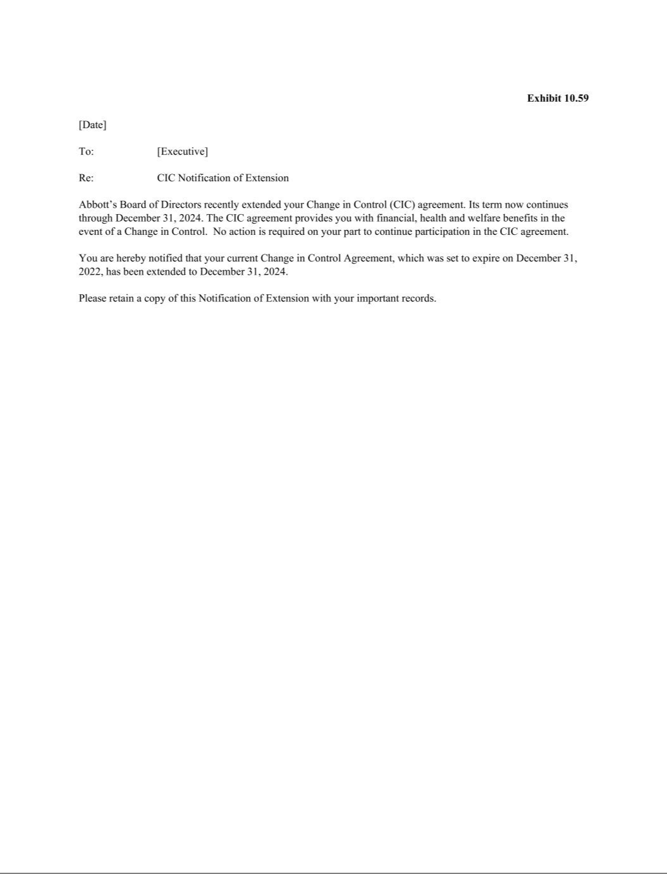

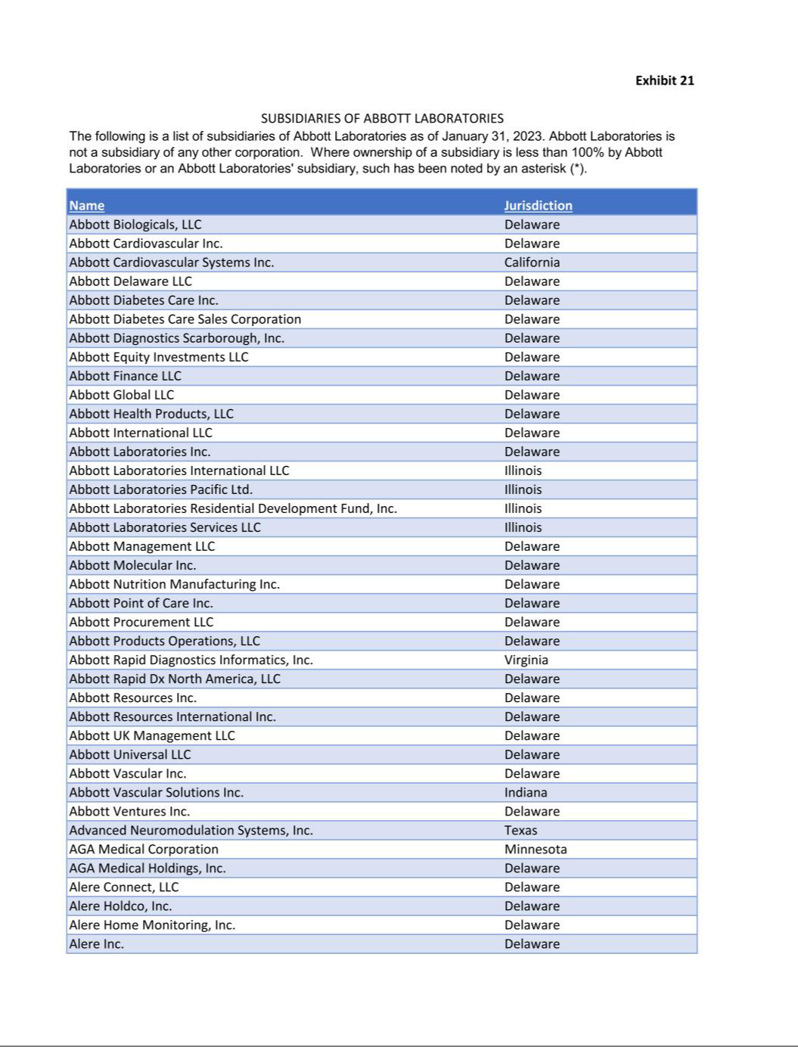

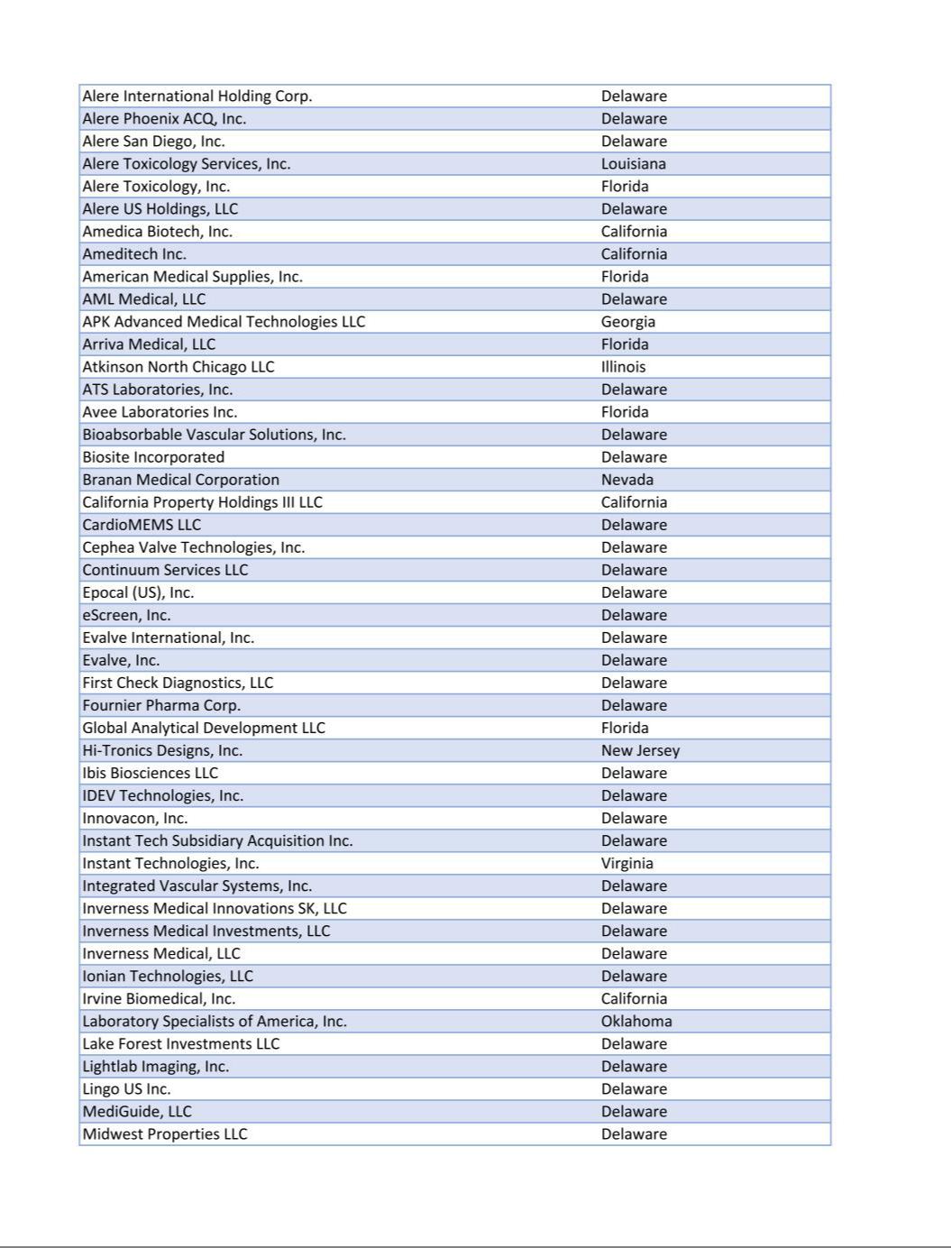

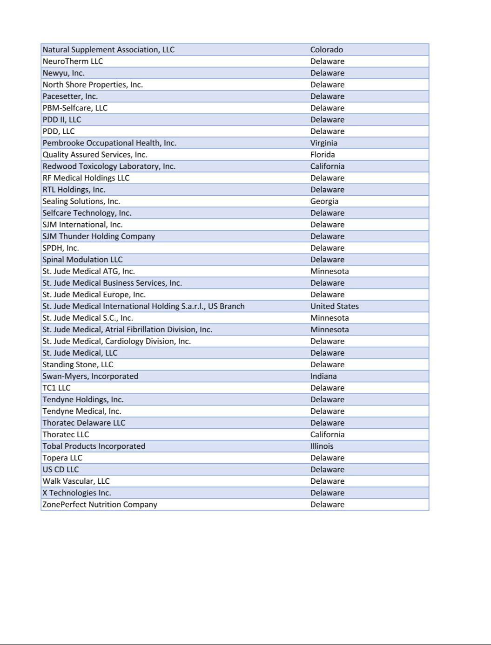

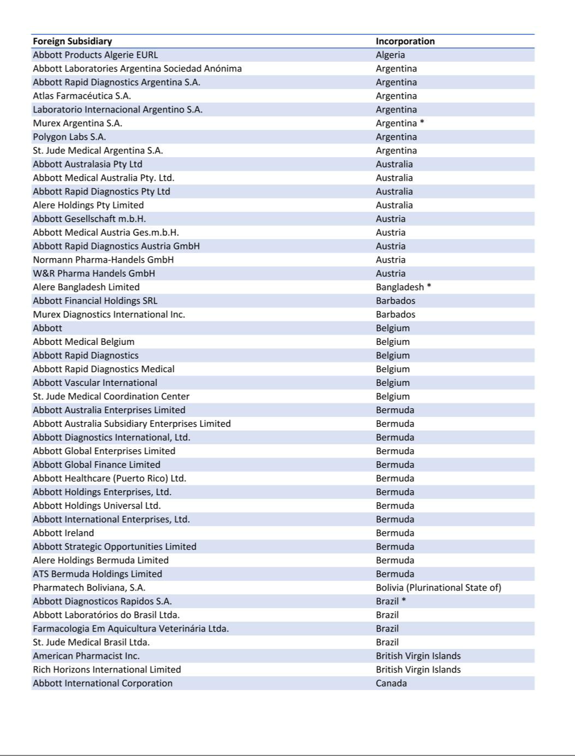

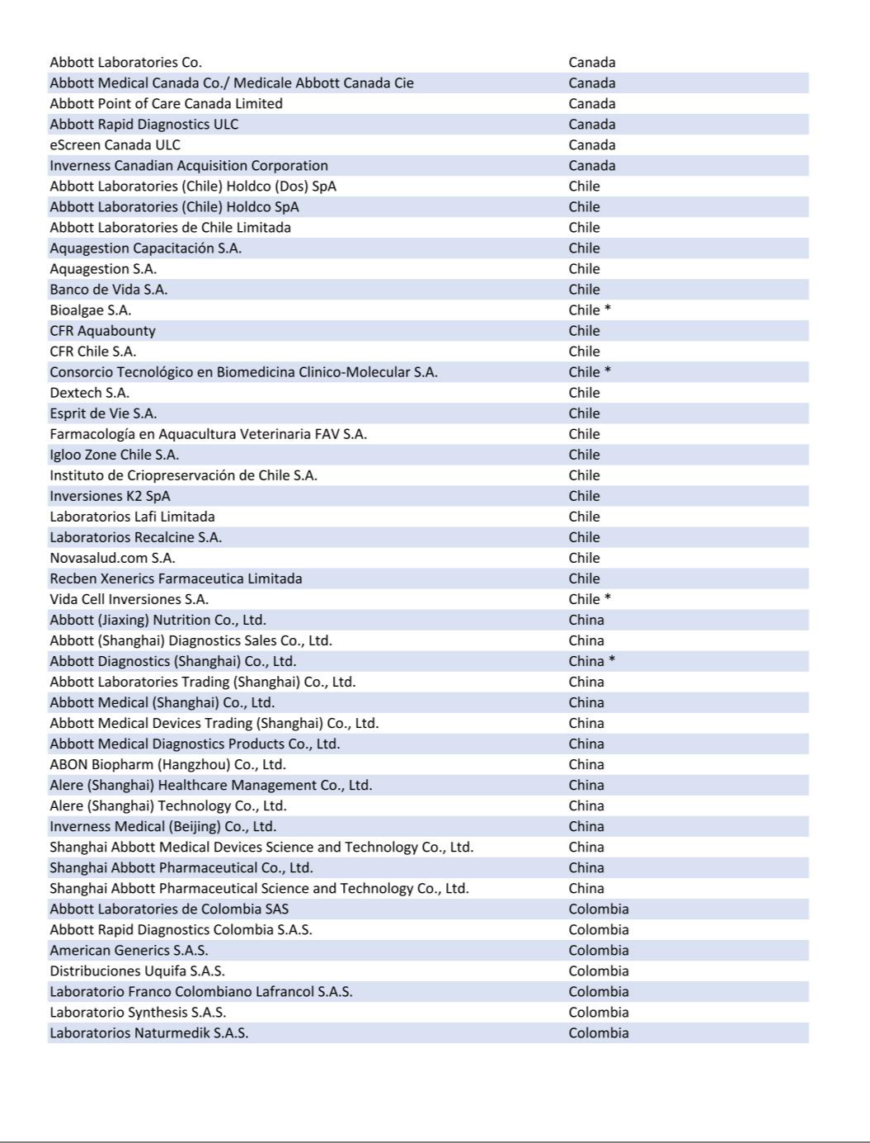

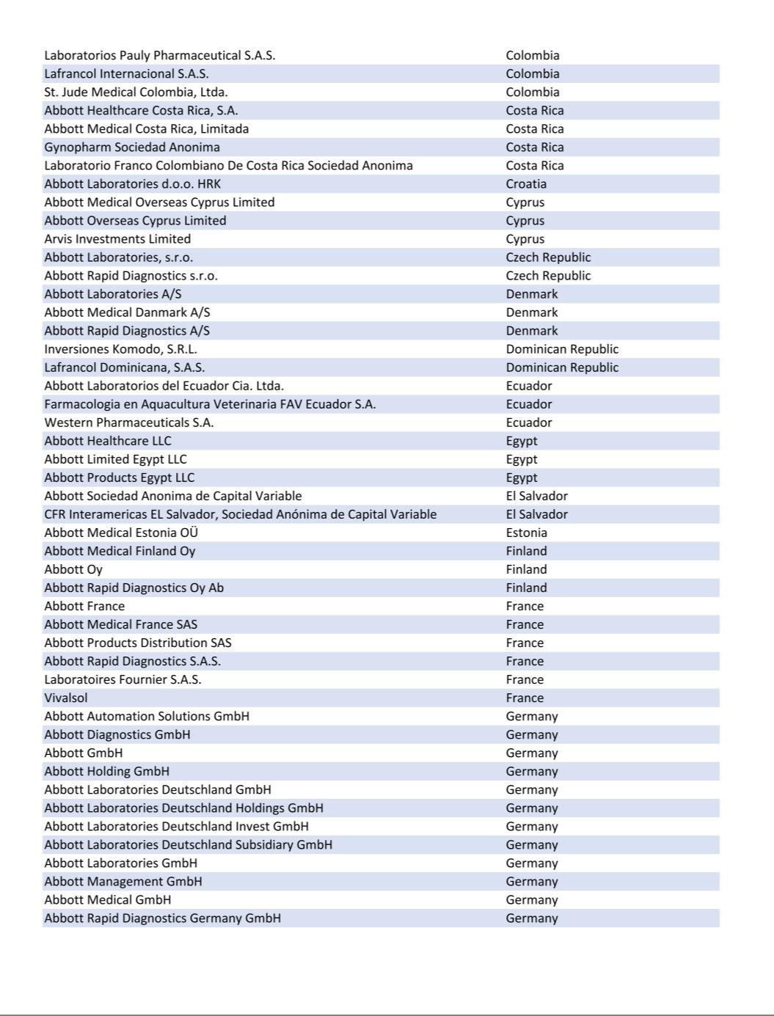

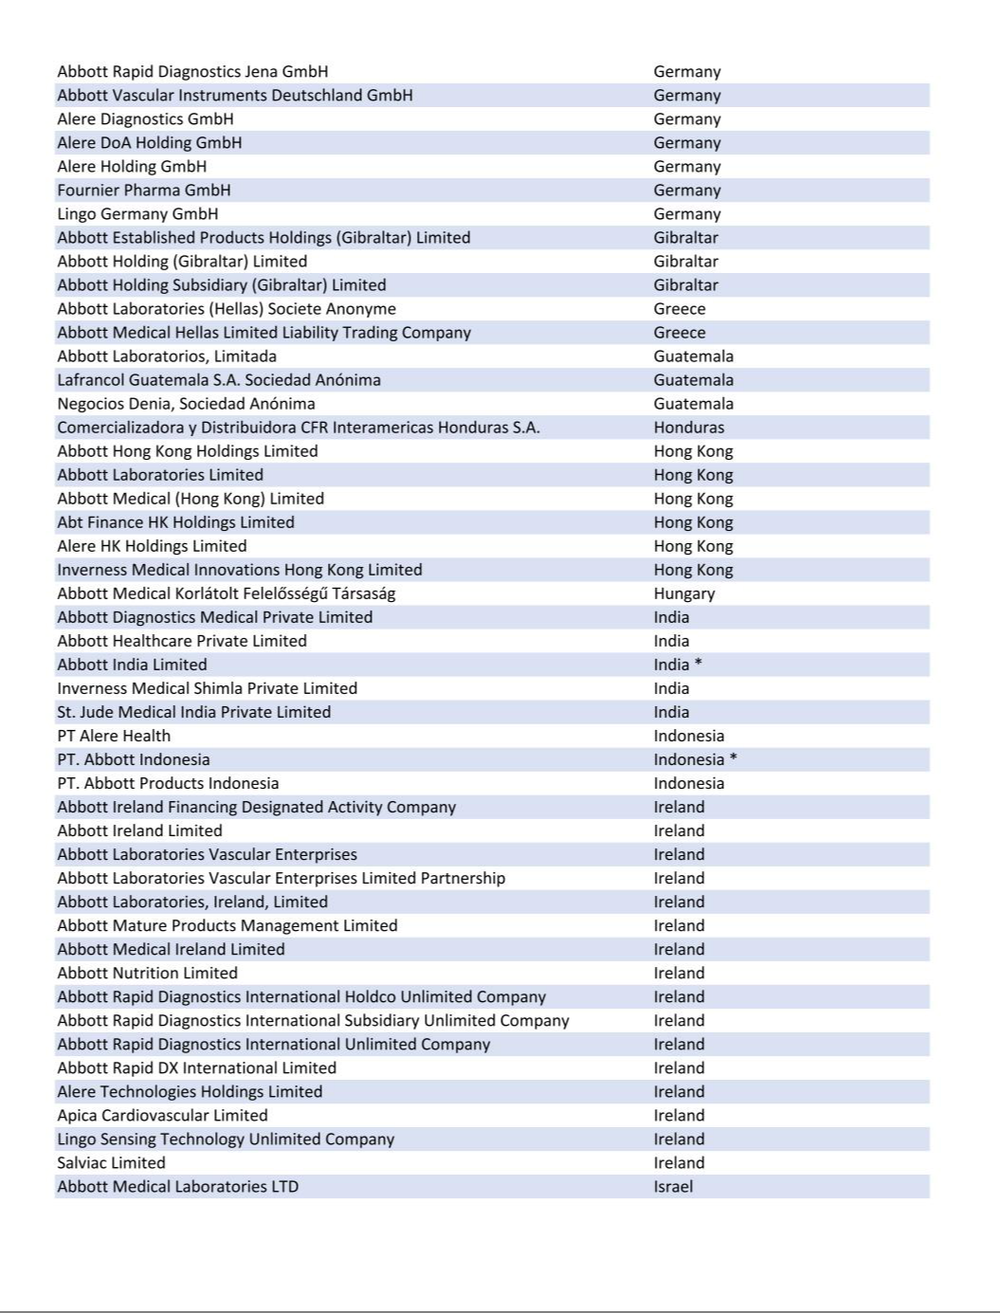

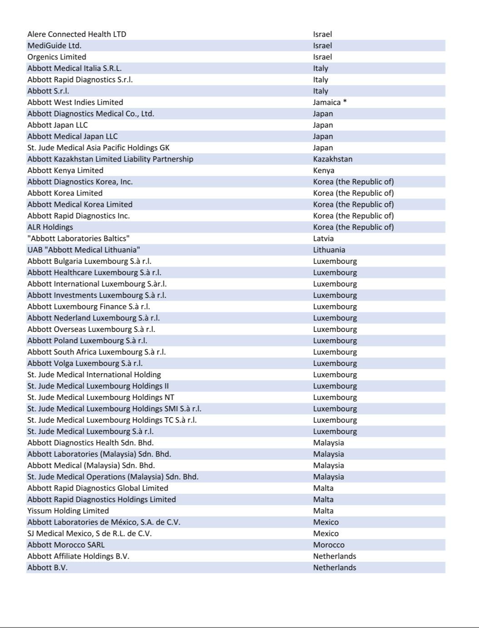

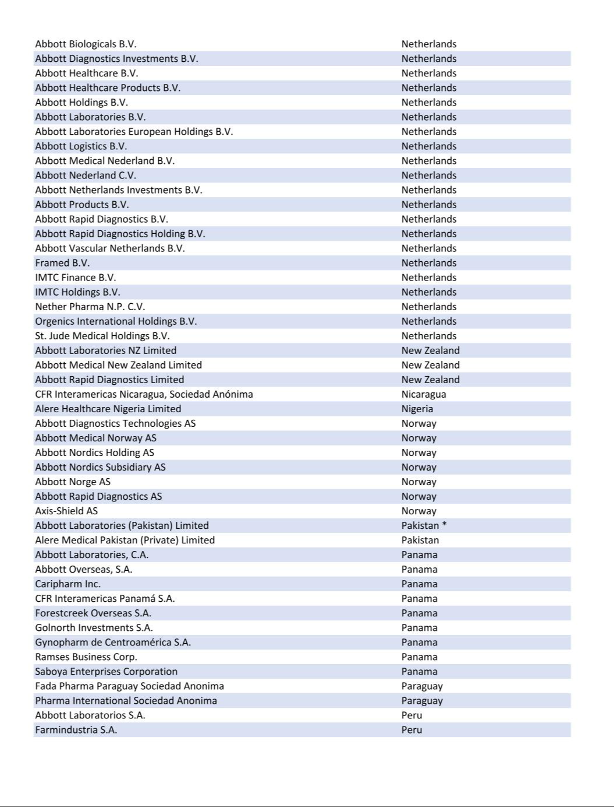

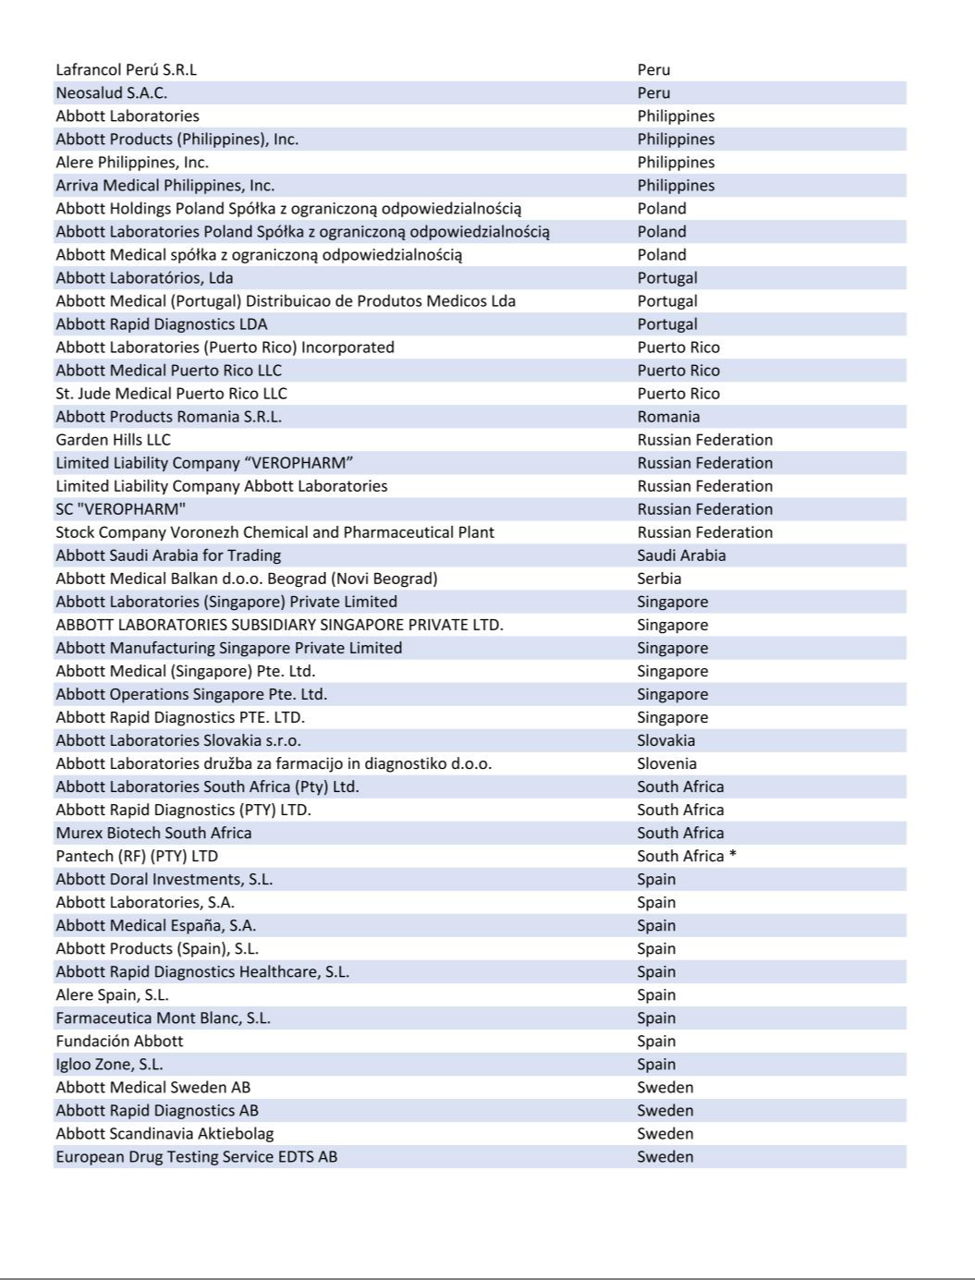

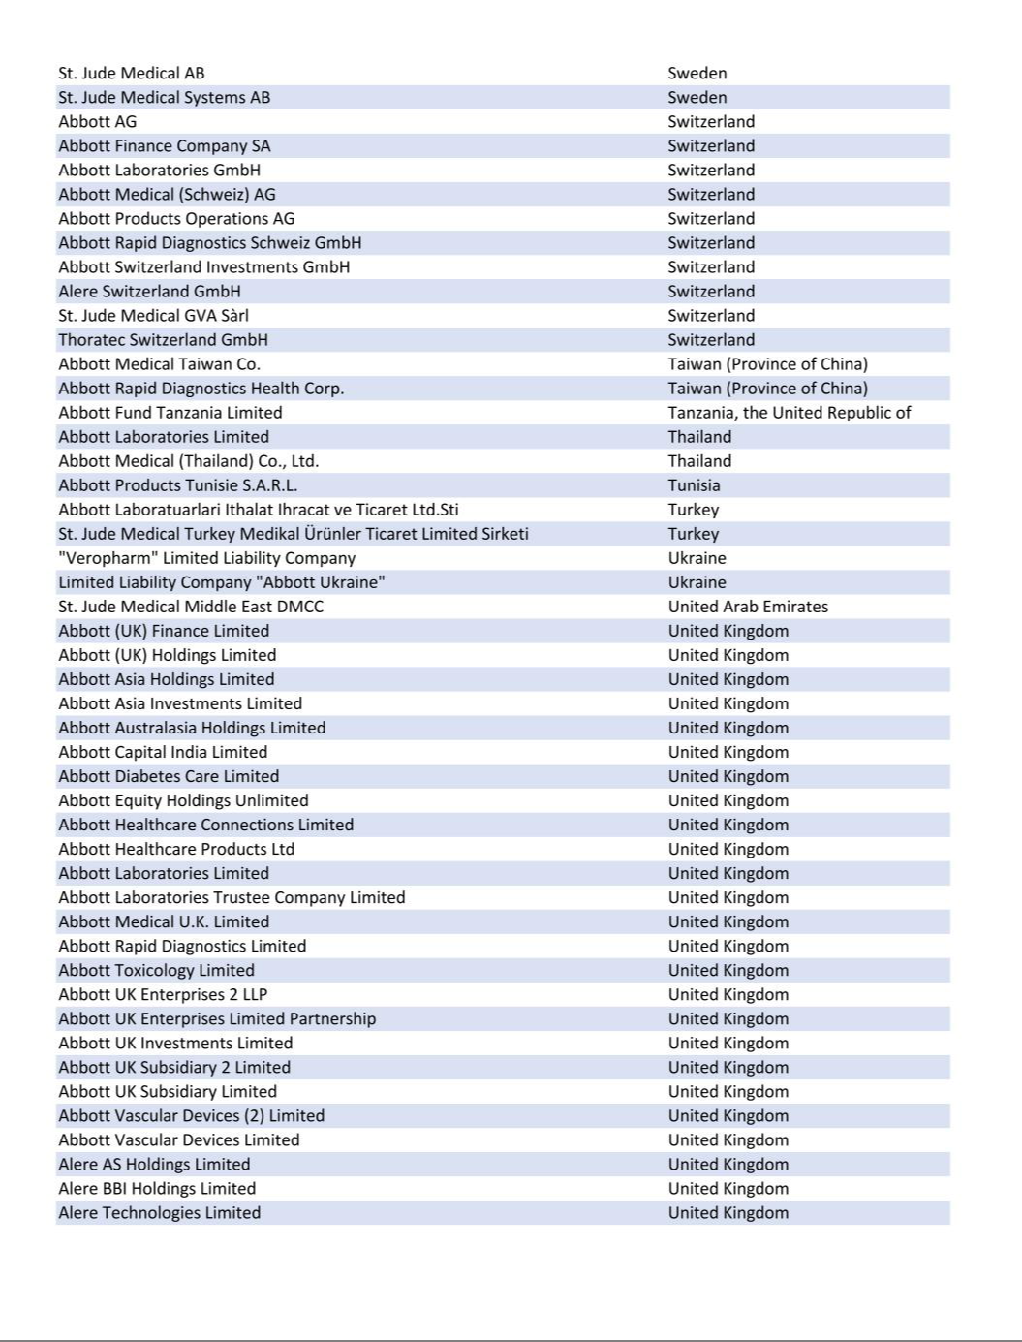

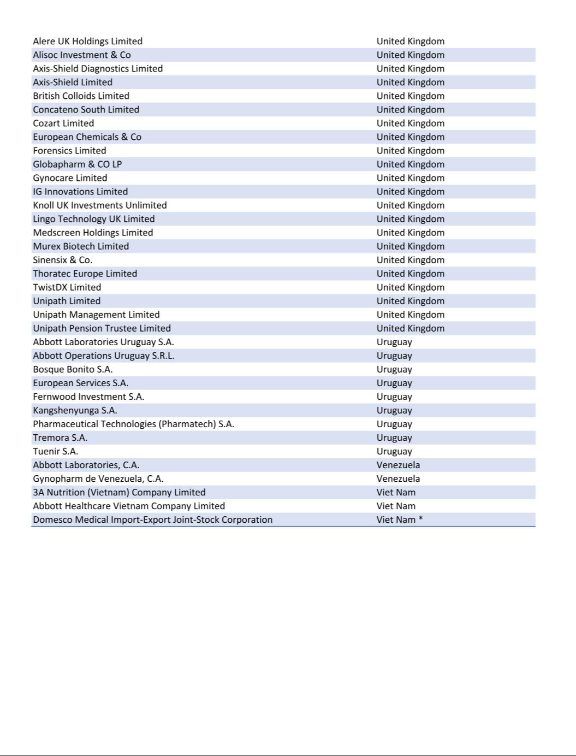

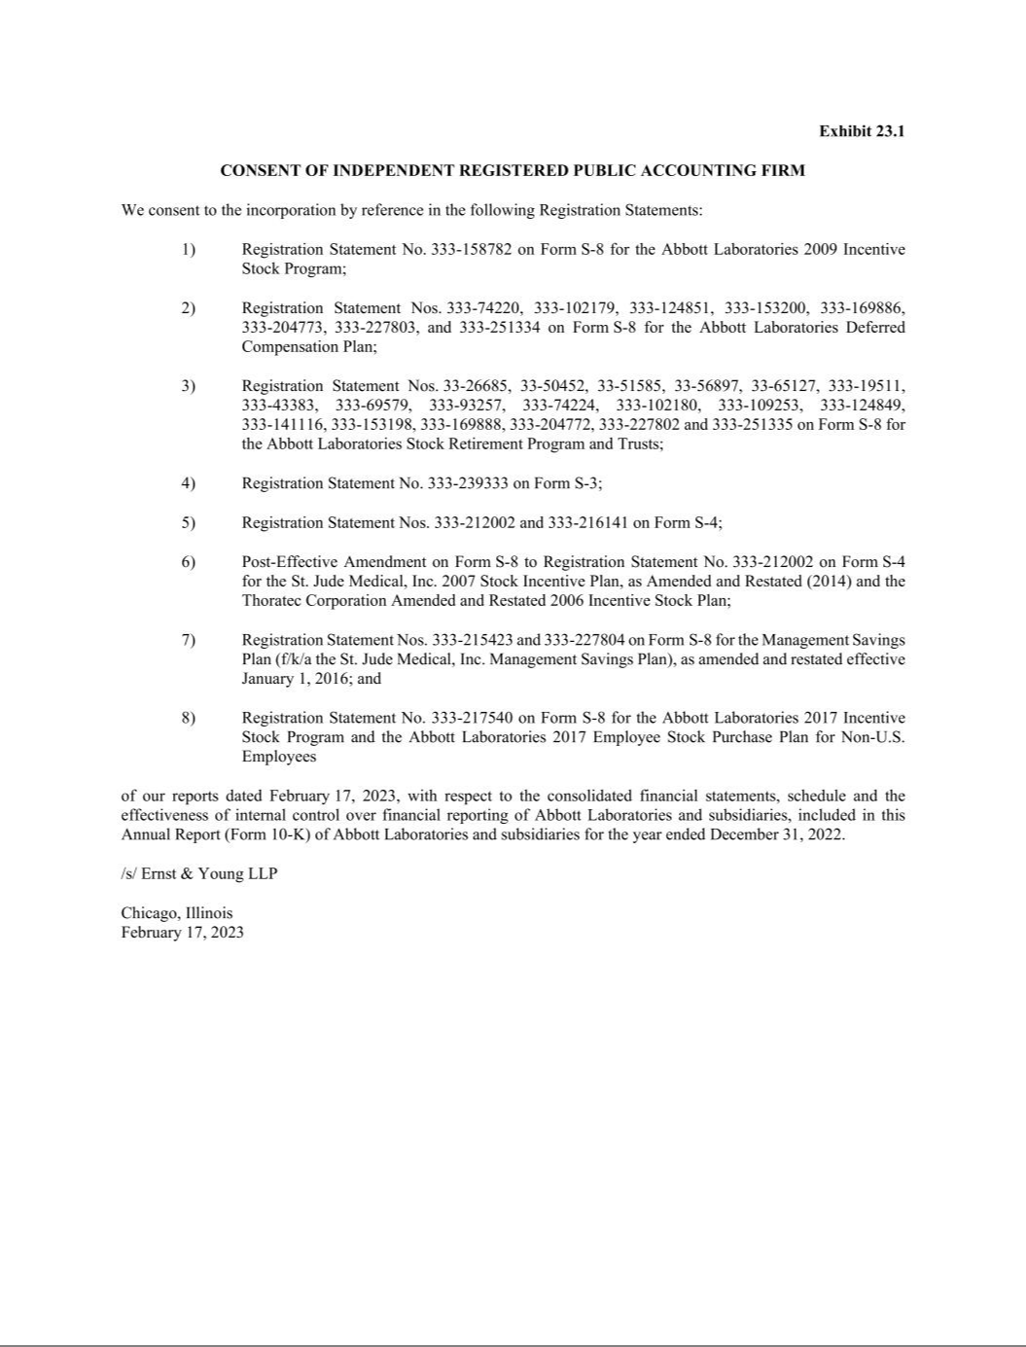

Exhibit 31.1

Certification of Chief Executive Officer

Required by Rule 13a-14(a) (17 CFR 240.13a-14(a))

I, Robert B. Ford, certify that:

- I have reviewed this annual report on Form 10-K of Abbott Laboratories;

- Based on my knowledge, this report does not contain any untrue statement of a material fact or omit to state a material fact necessary to make the statements made, in light of the circumstances under which such statements were made, not misleading with respect to the period covered by this report;

- Based on my knowledge, the financial statements, and other financial information included in this report, fairly present in all material respects the financial condition, results of operations and cash flows of Abbott as of, and for, the periods presented in this report;

- Abbott’s other certifying officer and I are responsible for establishing and maintaining disclosure controls and procedures (as defined in Exchange Act Rules 13a-15(e) and 15d-15(e)) and internal control over financial reporting (as defined in Exchange Act Rules 13a-15(f) and 15d-15(f)) for Abbott and have:

  - Designed such disclosure controls and procedures, or caused such disclosure controls and procedures to be designed under our supervision, to ensure that material information relating to Abbott, including its consolidated subsidiaries, is made known to us by others within those entities, particularly during the period in which this report is being prepared;

  - Designed such internal control over financial reporting, or caused such internal control over financial reporting to be designed under our supervision, to provide reasonable assurance regarding the reliability of financial reporting and the preparation of financial statements for external purposes in accordance with generally accepted accounting principles;

  - Evaluated the effectiveness of Abbott’s disclosure controls and procedures and presented in this report our conclusions about the effectiveness of the disclosure controls and procedures, as of the end of the period covered by this report based on such evaluation; and

  - Disclosed in this report any change in Abbott’s internal control over financial reporting that occurred during Abbott’s most recent fiscal quarter that has materially affected, or is reasonably likely to materially affect, Abbott’s internal control over financial reporting; and

- Abbott’s other certifying officer and I have disclosed, based on our most recent evaluation of internal control over financial reporting, to Abbott’s auditors and the audit committee of Abbott’s board of directors:

  - All significant deficiencies and material weaknesses in the design or operation of internal control over financial reporting which are reasonably likely to adversely affect Abbott’s ability to record, process, summarize and report financial information; and

  - Any fraud, whether or not material, that involves management or other employees who have a significant role in Abbott’s internal control over financial reporting.

/s/ ROBERT B. FORD

Robert B. Ford,

Chairman of the Board and Chief Executive Officer

Date: February 17, 2023

Exhibit 31.2

Certification of Chief Financial Officer

Required by Rule 13a-14(a) (17 CFR 240.13a-14(a))

I, Robert E. Funck, Jr., certify that:

- I have reviewed this annual report on Form 10-K of Abbott Laboratories;

- Based on my knowledge, this report does not contain any untrue statement of a material fact or omit to state a material fact necessary to make the statements made, in light of the circumstances under which such statements were made, not misleading with respect to the period covered by this report;

- Based on my knowledge, the financial statements, and other financial information included in this report, fairly present in all material respects the financial condition, results of operations and cash flows of Abbott as of, and for, the periods presented in this report;

- Abbott’s other certifying officer and I are responsible for establishing and maintaining disclosure controls and procedures (as defined in Exchange Act Rules 13a-15(e) and 15d-15(e)) and internal control over financial reporting (as defined in Exchange Act Rules 13a-15(f) and 15d-15(f)) for Abbott and have:

  - Designed such disclosure controls and procedures, or caused such disclosure controls and procedures to be designed under our supervision, to ensure that material information relating to Abbott, including its consolidated subsidiaries, is made known to us by others within those entities, particularly during the period in which this report is being prepared;

  - Designed such internal control over financial reporting, or caused such internal control over financial reporting to be designed under our supervision, to provide reasonable assurance regarding the reliability of financial reporting and the preparation of financial statements for external purposes in accordance with generally accepted accounting principles;

  - Evaluated the effectiveness of Abbott’s disclosure controls and procedures and presented in this report our conclusions about the effectiveness of the disclosure controls and procedures, as of the end of the period covered by this report based on such evaluation; and

  - Disclosed in this report any change in Abbott’s internal control over financial reporting that occurred during Abbott’s most recent fiscal quarter that has materially affected, or is reasonably likely to materially affect, Abbott’s internal control over financial reporting; and

- Abbott’s other certifying officer and I have disclosed, based on our most recent evaluation of internal control over financial reporting, to Abbott’s auditors and the audit committee of Abbott’s board of directors:

  - All significant deficiencies and material weaknesses in the design or operation of internal control over financial reporting which are reasonably likely to adversely affect Abbott’s ability to record, process, summarize and report financial information; and

  - Any fraud, whether or not material, that involves management or other employees who have a significant role in Abbott’s internal control over financial reporting.

/s/ ROBERT E. FUNCK, JR.

Robert E. Funck, Jr.,

Executive Vice President, Finance

and Chief Financial Officer

Date: February 17, 2023

Exhibit 32.1

Certification Pursuant To

18 U.S.C. Section 1350

As Adopted Pursuant To

Section 906 of the Sarbanes-Oxley Act of 2002

In connection with the Annual Report of Abbott Laboratories (the “Company”) on Form 10-K for the period ended December 31, 2022 as filed with the Securities and Exchange Commission (the “Report”), I, Robert B. Ford, Chairman of the Board and Chief Executive Officer of the Company, certify, pursuant to 18 U.S.C. § 1350, as adopted pursuant to § 906 of the Sarbanes-Oxley Act of 2002, that:

- The Report fully complies with the requirements of section 13(a) or 15(d) of the Securities Exchange Act of 1934; and

- The information contained in the Report fairly presents, in all material respects, the financial condition and results of operations of the Company.

/s/ ROBERT B. FORD

Robert B. Ford,

Chairman of the Board and Chief Executive Officer

Date: February 17, 2023

A signed original of this written statement required by Section 906 has been provided to Abbott Laboratories and will be retained by Abbott Laboratories and furnished to the Securities and Exchange Commission or its staff upon request.

Exhibit 32.2

Certification Pursuant To

18 U.S.C. Section 1350

As Adopted Pursuant To

Section 906 of the Sarbanes-Oxley Act of 2002

In connection with the Annual Report of Abbott Laboratories (the “Company”) on Form 10-K for the period ended December 31, 2022 as filed with the Securities and Exchange Commission (the “Report”), I, Robert E. Funck, Jr., Executive Vice President, Finance and Chief Financial Officer of the Company, certify, pursuant to 18 U.S.C. § 1350, as adopted pursuant to § 906 of the Sarbanes-Oxley Act of 2002, that:

- The Report fully complies with the requirements of section 13(a) or 15(d) of the Securities Exchange Act of 1934; and

- The information contained in the Report fairly presents, in all material respects, the financial condition and results of operations of the Company.

/s/ ROBERT E. FUNCK, JR.

Robert E. Funck, Jr.,

Executive Vice President, Finance

and Chief Financial Officer

Date: February 17, 2023

A signed original of this written statement required by Section 906 has been provided to Abbott Laboratories and will be retained by Abbott Laboratories and furnished to the Securities and Exchange Commission or its staff upon request.

